

|  |
| --- |
| **FPT UNIVERSITY** |
| Capstone Project Document |

**SMART MEDICINE DICTIONARY**

|  |
| --- |
|  |
| |  |  | | --- | --- | | **Smart Medicine Dictionary** | | | **Group Members** | |  |  | | --- | --- | | Lê Thị Xuân | 01913 | | Phạm Huy Khôi | 01888 | | Phạm Minh Tú | 01770 | | Phạm Hà Hải | 01727 | | Ngô Hà Thu | 01522 | |  |  | | | **Supervisor** | Mr. Nguyễn Văn Sang | | **Project code** | SMD |   - Hanoi, 8/2013- |

Table of Contents

1 PROJECT INTRODUCTION 8

1.1 Purposes 8

1.2 Acronym and Definition 8

1.3 Background 8

1.4 Literature review 9

1.5 Proposal 13

1.5.1 The Idea 13

1.5.2 Brief description about system 13

1.5.3 System features 14

1.6 Objectives 14

1.7 Potential risk and limitation 15

1.8 Benefit from project 15

1.8.1 For Pharmacy 16

1.8.2 For our Group 16

1.8.3 For Community 16

1.9 References 16

2 SOFTWARE PROJECT MANAGEMENT PLAN 18

2.1 Project Overview 18

2.1.1 Project Description 18

2.1.2 Scope 18

2.1.3 Milestone and Deliverables 19

2.1.4 Standard Objectives 21

2.2 Project organization 21

2.2.1 Software Process Model 21

2.2.2 Rational Unified Process Model 21

2.2.3 Roles and Responsibilities 27

2.2.4 Tools and Infrastructures 29

2.3 Project Schedule 32

2.3.1 Task Sheet: Assignments and Timetable 32

2.3.2 Meeting Schedule 34

2.4 Effort Estimation 35

2.5 Risk Management 36

3 USER REQUIREMENT SPECIFICATION 41

3.1 Introduction 41

3.1.1 Purpose 41

3.1.2 Definition and Acronyms 41

3.1.3 Overall description 41

3.1.4 Product features 47

3.1.5 User characteristics 48

3.1.6 Functional requirement 48

3.1.7 Non – Functional Requirements 51

3.2 SYSTEM REQUIREMENT SPECIFICATION 51

3.2.1 Introduction 51

3.2.2 System Features 52

3.2.3 Functional Specification 54

3.2.7 Non-functional Specification 112

3.2.8 Entity Relationship Diagram or Data Structures 116

4 Architecture Design 124

4.1 Choice of Architecture Design 124

4.1.1 MVC model overview 124

4.1.2 Three – tier model overview 126

4.2 Architectural Presentation 128

4.2.1 Struts 2 MVC – Presentation Layer 128

4.2.2 Spring 3 – Business Logic Layer 130

4.2.3 Hibernate – Data Access Layer 130

4.2.4 Android – Client Side 132

4.2.5 Web service – Server Side 132

4.3 Component Design 134

4.3.1 Web app Component 134

4.3.2 Mobile app Component 136

4.4 Detailed Design 137

4.4.1 Common Design 137

4.4.2 Search medicine on mobile 138

4.4.3 UC005 - Find the nearest pharmacy on mobile 144

4.4.4 UC006 – Medical Usage Diary 146

4.4.5 UC 007 – Find Nearest Pharmacy (web version) 150

4.4.6 UC 008 – Register 151

4.4.7 UC 009 – Login 155

4.4.8 UC 010 – Logout 156

4.4.9 UC 011 – Reset Password 157

4.4.10 UC 012 – Change Password 159

4.4.11 Search Medicine 160

4.4.12 UC 014 - Advanced Search Medicine 162

4.4.13 Manage Medicine Information 163

4.4.14 UC 016 - Update Medicine 166

4.4.15 UC 017 - Delete Medicine 169

4.4.16 UC 018 - Restore Medicine 171

4.4.17 Search Pharmacy 172

4.4.18 UC 019 – Normal Search Pharmacy 173

4.4.19 UC 020 - Advanced Search Pharmacy 174

4.4.20 Manage Pharmacy information 175

4.4.21 UC 021 – Accept Registered Pharmacy 176

4.4.22 UC 022 - Delete Pharmacy 177

4.4.23 UC 023 - Restore Pharmacy 179

4.4.24 UC 024 – Pharmacy Change Info 180

4.4.25 Manage News 182

4.4.26 UC 026 – Update News 184

4.4.27 UC 027 - Delete News 185

4.4.28 UC 028 – Restore News 187

4.4.29 UC 029 - Search News 188

4.4.30 UC 030 – View News 189

4.4.31 UC 031 – View Detail Medicine Info 190

4.4.32 UC 032 – View Detail Pharmacy Info 193

4.5 Database Design 195

4.5.1 Entity Relationship Diagram 195

4.5.2 Database Diagram 196

4.5.3 Table Descriptions 196

5 SOFTWARE TESTING 206

5.1 Introduction 206

5.1.1 Purpose 206

5.1.2 System Overview 206

5.2 Test plan 207

5.2.1 Scope of testing 207

5.2.2 Requirement for testing 207

5.2.3 Test strategy 208

5.3 Test cases 213

5.4 Checklist 213

5.4.1 Check list about Home page 213

5.4.2 Check list about validation 213

5.4.3 Submission check list 214

5.5 TEST LOGS 216

5.5.1 Defect logs 216

5.5.2 Test report 216

6 Software User’s Manuals 220

6.1 Installation Guide 220

6.1.1 Introduction 220

6.1.2 Environment 220

6.1.3 Application Installation 220

6.2 User’s Guide 227

6.2.1 Purpose 227

6.2.2 Functional Description 227

6.2.3 Detail guidelines 228

7 Project Result Report 247

7.1 Product Judging 247

7.1.1 Advantage of SMD System 247

7.1.2 Current Limitations 247

7.1.3 Expectation in Future 247

7.2 Product Summary 247

7.3 Lesson Learn 248

**Report #1:**

**INTRODUCTION**

# PROJECT INTRODUCTION

## Purposes

This document is prepared as the introduction for project Smart Medicine Dictionary, in scope of Capstone Project at FPT University. It does not only explain the basic concept and idea for our project but also discuss what project’s benefits and threats are, what opportunities it offers and what existing medical problem it solves.

## Acronym and Definition

|  |  |
| --- | --- |
| **Acronym** | **Definition** |

|  |  |
| --- | --- |
| SMD | Smart Medicine Dictionary |
| GPS | Global Positioning System |
| SQL | Structured Query Language |

**Table 1-1:** Acronym and definition

## Background

Medicine is the applied science or practice of the diagnosis, treatment, and prevention of disease. It encompasses a variety of health care practices evolved to maintain and restore health by the prevention and treatment of illness in human beings. Nowadays, it is an important part of our life and get a lot of concern from society.

When you get a prescription medicine from a doctor, you likely know what the medicine is for, but do you know how it is going to work? Learn about common prescription medicines, how they work, and foods, medicines or activities you should avoid while taking them. The more you know about your prescription medicine, the better it will work.

Not only prescription medicines but also over-the-counter medicines can interact with each other or with prescription drugs and cause problems. Supplements, herbal products in teas or tablets, or vitamins may also cause adverse reactions when taken with certain drugs. User should know about the reactions of each medicine they take.

There are some kind of work such as pharmacist, medical students… need to look for more information of medicine, herbal… They have to look up from medical dictionary books, which is so thick, heavy and take a lot of time to find exact medicine. Specially, books cannot automatically be updated so they also have to spend much money to buy a new one.

It might be hard to find out the correctly information about the medicine through the internet. Therefore, with that software, we hope user can surf information of which medicine they interest whenever and wherever through their mobile devices

In the busy life, sometime, we may not remember our medicine taking schedule, doses or prescription. That make it hard to maintain the treatment process

Nowadays, it is time of technology, thus, a lot of pharmacies have demand for public their information in the internet for widely promotion but there is not much software for pharmacy to interact with each other and user. Therefore, looking for a local pharmacy or the way to get there is also a problem. Specially, in case that we get hurt and need medicine or first aid equipment immediately.

The SMD project aims to build a system for medical services that improve and enhance the current state, overcome these weaknesses. In another hand, system displays totally in Vietnamese, therefore, it can easily be used by doctors, pharmacist, medical users… who is Vietnamese people and does not understand English

## Literature review

Currently, there are so many website and android software about medical that help users looking for medicine information, find out pharmacy address such as: Medscape.com, Medical handbook, Thuoc.net…

* **Medical Handbook:**

In overview, that software has only search function with 3 option: search for drug, disease or medical plant. Therefore, it is easy to use. Users can easily learn about the symptoms and various treatments and make decision when choosing a medicine.

* **Advantages:**
* Easy to use
* Have plenty of options to search
* **Disadvantages:**
* Display only in English, not be appropriate with Vietnamese
* Just have search feature

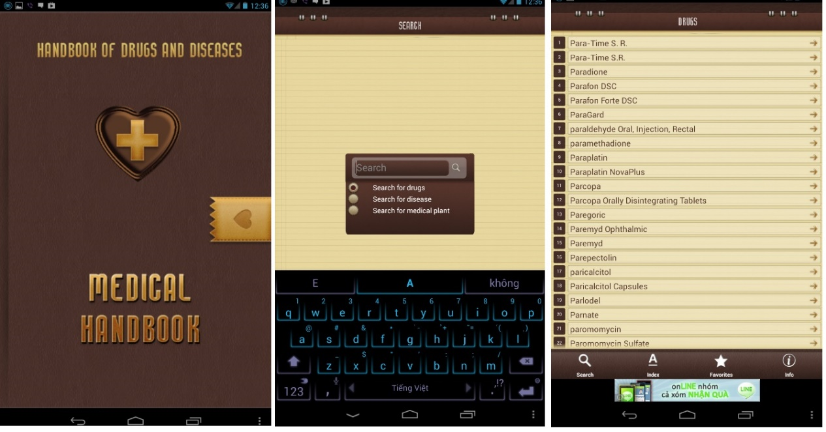

F**igure 1-1:** Medical Handbook interface

* **Medscape.com:**

That software has a very strong and professional tool with two versions: for mobile and for web with multi-function.

* **Advantages:**
* With “Drug” option, user can directly search for drug information by its name. If they have no idea about which medicine they should use, they can look it up by disease. That program default group the medicines by disease
* User can learn about one disease by “Condition” option
* User can also learn about popular procedures
* Another useful function is “interaction”. User can insert the medicine list that they take to see if they conflict each other
* “Direction” list address and contact of the hospital, pharmacy
* In addition, that program also update medical news daily.
* **Disadvantages:**
* Display only in English
* Can only be used after register

However, user can only use these function after they have register an account. Beside it, because of too much function, users might find difficult at first time using it.

* **On Mobile:**

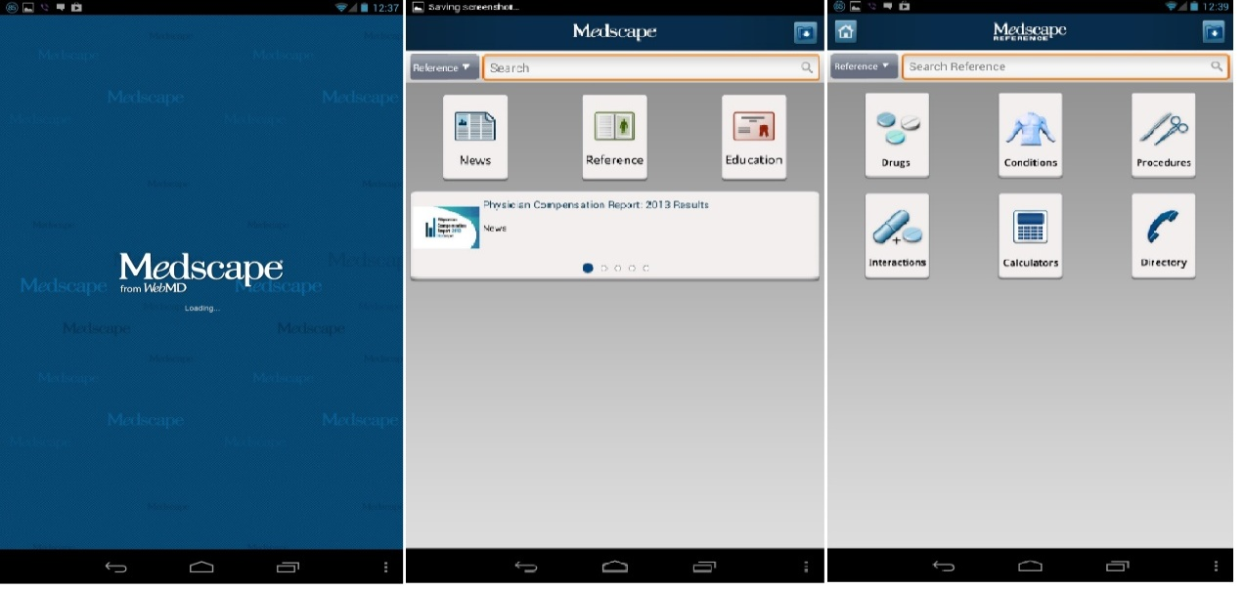

**Figure** **1-2**: Medscape mobile interface

* 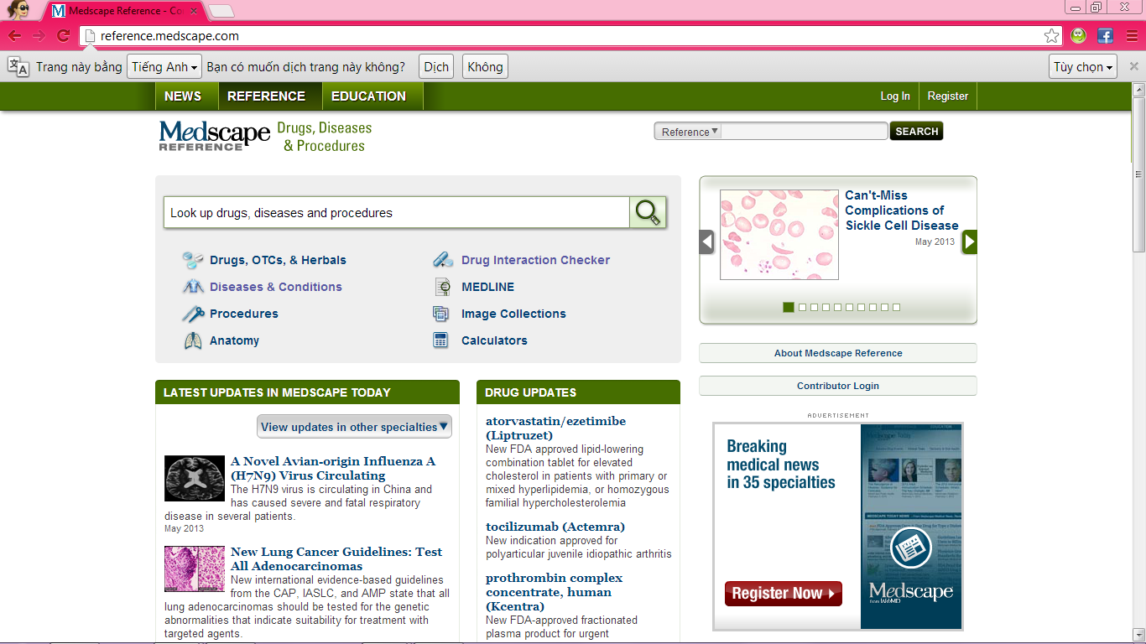**On web:**

**Figure 1-3:** Medscape web interface

* **Thuoc.net**

In overview, that website have supported user quite well with many general feature of a standard medical website:

* **Advantages:**
* User can search medicine by name, number, ingredient, interaction. Beside it, they can also look up for articles, video, images, services of each diseases
* It also contain medical news, services, advisory, market, …
* With advisory function, user will post their question, then the doctor of ThuocNet will answer it
* **Disadvantages:**
* Filter feature works not good, it will search all data by full text search technique. Therefore, it can show so much results. User may find it 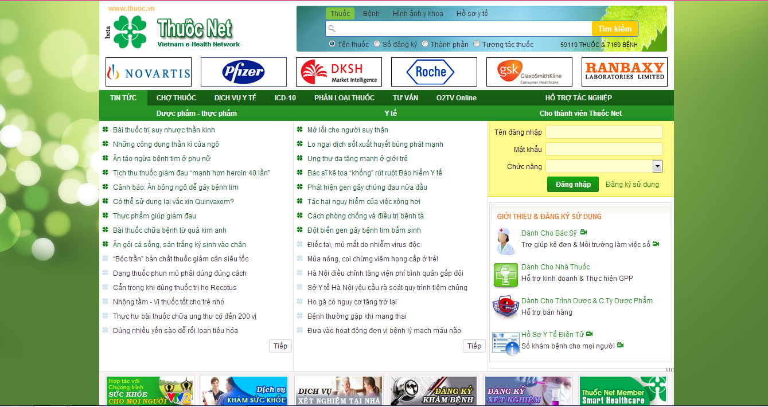is hard to choose the right one.

**Figure 1-4:** Thuoc.net web interface

* **iThuoc:** This software has only search function that is similar to Medical Handbook
* **Advantages**:
* Easily to use
* Can be used without connecting to the internet
* **Disadvantages:** Too simple, with this software, user can only search 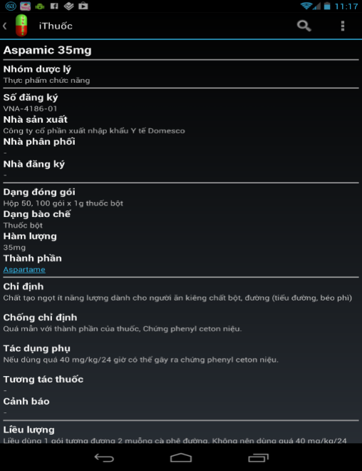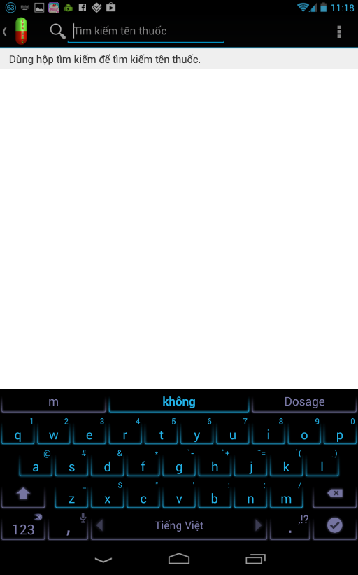medicine by name

**Figure 1-5:** iThuoc mobile interface

In overview, existing systems have supported users well with multi functions. However, they display fully in English. With some Vietnamese applications and websites, their function is too simple but sometime, user might find it hard to use.

## Proposal

### The Idea

The idea of creating SMD software about medical is not new. However, the intended developing SMD will includes almost all fulfill functions of software used English as the main language. Therefore, the project group aims at bringing a better, faster and easier software which displays totally in Vietnamese that is easier for Vietnamese people.

### Brief description about system

That software has two versions for web and for mobile. With friendly interface, user can easily find out what they want without registration. Moreover, user can know more about the interaction between two kinds of medicine. It also displays the appropriate medicine that have similar uses with searched medicine. Therefore, user can reference to make the best choice for themselves. In addition, with pharmacy management function, our software can bring the best trustful pharmacy to users. It is also useful when users are staying at strange location and need to find out the rout to the nearest pharmacy.

Mobile send input to or retrieve information from through Web service, Web service implementation function and send return output to mobile

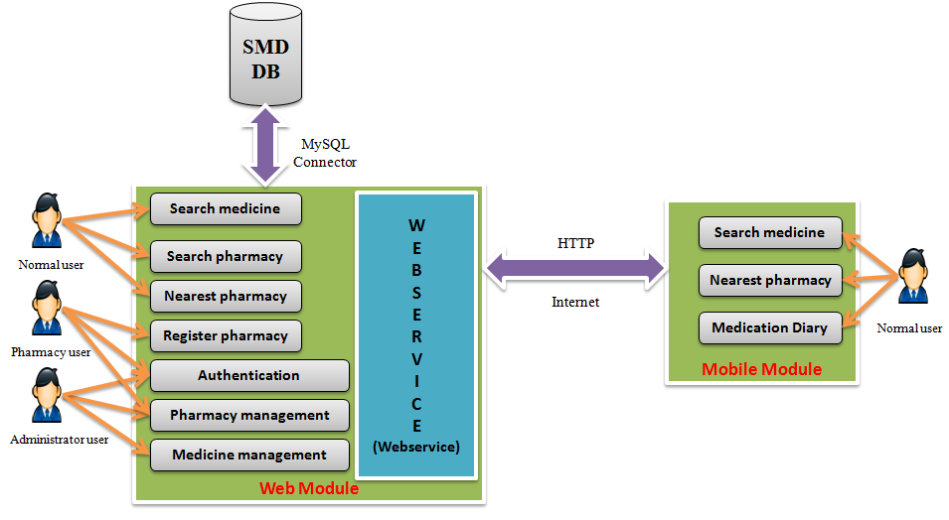

**Figure 1-6:** Global picture

SMD system uses familiar technologies as: JavaScript, Strut 2, Spring 3, Hibernate 3, Android (mobile)… It is support operating systems such as windows and current browsers as IE 9, Firefox 20, Chrome 25 or above.

### System features

* **General feature** (run on both mobile and web module)**:**
* Search medicine by name (auto complete)
* Find pharmacy location on map
* Show the route to the nearest pharmacy
* **Mobile application feature:**
* User can **find the nearest pharmacy** by typing their location or that software will access to their location **through the GPS** satellite. Then it will display the route with the instruction to help user easily reach to that pharmacy
* With **Medical Diary** function, user can save their medicine taking schedule, dosage or set alarm to remind them to take medicine in time.
* **Web application feature:**
* User can do advanced search for medicine with many options such as: medicine name, manufacture, indication, contraindication, ingredient, packaging or where that medicine is sold.
* Advanced search pharmacy
* The register form for pharmacy displays only on web version. It is easy to fill with general information, they can subscribe their location in the map or upload their picture, stock data to help user know more about them.
* Registered pharmacy will be provided an account that has role to edit, update or add new their database.
* Provide management feature for administrator to:
* Medicine management: search, add new, edit, delete, restore medicine
* Pharmacy management: accept or reject pharmacy registration, delete pharmacy information
* News control: Add, edit, delete news
* Provide news about medical and health

In near future, we might add another helpful function for user, that is diagnose the diseases online

## Objectives

This project is registered and implemented as the capstone project for the team members. The first purpose is to fulfill the requirements from FPT University studying program. Our project uses some new technology that we have not studied at the University such as: develop for Android OS, test on simulator, code in strut, spring… technique. And it is also a chance for us to work as a real project team which is nearly to the environment that we will work after graduated. We have to learn how to control our time, our source code, hold a meeting, connect and communicate to other team members. Therefore, after get through that project, we can not only practice what we have studied but also have learned many new things to be ready to our future work

The second purpose is to create a complete product to support pharmacy and people who concern with medical problem. It might not have fulfill function as foreign system but it can response the basic demand like search medicine information, find nearest pharmacy… Specially, that software displays completely in Vietnamese, so that even user does not know English, they can easily use it

## Potential risk and limitation

After studying about this project, we find out some problem that we may be encountered:

* We do not have much experience in exchange information, managing and controlling work so we might be missed the deadline or out of scope
* We have not much knowledge in the framework and technique of both mobile and web (Such as: Strut, Spring, Hibernate… technique). Therefore, we have to study all of these things from the beginning. This work takes a lot of times. The project team may face with the difficult technical problems that may requires long time to resolve so that causes the project be delayed.
* We find it is hard in collecting data and studying the business about medical. If we misunderstand something, we might develop the system in the wrong way
* About testing in device, it also an economic obstacle (because no member in our team have an android device, we need to buy a new one to support testing process)
* Location access through GPS satellite in mobile is depended so much on the infrastructure of the network providers. It takes a lot of time of mobile developer to code and test “Find nearest pharmacy” by GPS function
* In addition, we also have difficulty in using some tools such as Microsoft Project, Eclipse, My SQL, Source code managing… Therefore, our work management may be not good.

Sometime, because of careless, team members can lose data, source code… before uploading to server

## Benefit from project

After implementing this project not only pharmacy have benefit in promotion, develop group and community also have many benefits

### For Pharmacy

Pharmacy uses SMD will save cost to advertise but still gain the effective. With technology power, many people can know about them and easily find way to get there through the direction on map

### For our Group

After developing and implementing that project we will:

* Understand new technology like Android, Eclipse Indigo, Strut, Spring, Hibernate, My SQL, Source code managing…
* Have the opportunity to experience and improve working in group skill
* Know how to manage project, limit risk, control working time more effective
* Know more about the business of pharmacy and have more knowledge in medical

### For Community

Just need to have a device that connect to the internet, user can:

* Search for more information about medicine that they take or concern
* Easily find out the nearest pharmacy and the shortest way to get there
* Have guarantee for trustful pharmacy
* Save their medicine taking schedule, dosage or set alarm to remind them to take medicine in time with their android devices
* Find out which pharmacy sells the rarely kind of pharmacy that they need
* Be up to date with medical news

## References

**[1] Medical Handbook** (Mobile version only): <https://play.google.com/store/apps/details?id=com.itsoftgroup.medicine&feature=search_result>

**[2] Medscape**:

* Website: <http://www.medscape.com/>
* Mobile: <https://play.google.com/store/apps/details?id=com.medscape.android&feature=search_result#?t=W251bGwsMSwxLDEsImNvbS5tZWRzY2FwZS5hbmRyb2lkIl0.>

**[3] iThuoc:** (mobile version only)

<https://play.google.com/store/apps/details?id=com.vm.ithuoc.free&feature=search_result#?t=W251bGwsMSwxLDEsImNvbS52bS5pdGh1b2MuZnJlZSJd>

**[4] Thuoc.net:** <http://www.thuoc.net.vn/>

**Report #2:**

**SOFTWARE PROJECT MANAGEMENT**

**PLAN**

# SOFTWARE PROJECT MANAGEMENT PLAN

## Project Overview

### Project Description

Nowadays, there are few system are using information technology in the medical field and each system still has many disadvantage and limitation. Building this system, our target is to create an entirely new system, improve the limitation of current system and propose some new features that make our system is different with the others. The system has two versions: for mobile and for web. The mobile application will be based and run on smart phone support Android OS. With the integration of Google Map API, the application will be guaranteed with a high rate of reliability in the search and display location and path to nearest pharmacy location. There are some points that make smart medicine dictionary be different from other products:

- Support Vietnamese language.

- Using map to display location and path to the nearest pharmacy location.

- Friendly interface, easy to understand terms.

- No need account for normal users to use product.

- Having interaction between medicine and pharmacy.

- Advanced search with many criteria and accuracy information.

### Scope

Due to the time constraint of a capstone project, scope of our system includes:

- Develop user requirement and software requirement specification

- Develop architecture and detailed design documents

- Coding and unit test

- Develop test case and execute system test

- The developing software will have the following functions

|  |  |  |  |
| --- | --- | --- | --- |
| **No** | **Group of functions** | **Function** | **Description** |
| **1** | **Search Module** | Search Medicine By Name |  |
| Advanced Search Medicine |  |
| Search Pharmacy By Name |  |
| Advanced Search Pharmacy |  |
| Find Nearest Pharmacy Location |  |
| **2** | **Pharmacy Module** | Register new pharmacy information |  |
| Change pharmacy information |  |
| Add new sold medicine |  |
| **3** | **Administration Module** | Search Medicine |  |
| Add new medicine |  |
| Update medicine |  |
| Delete medicine |  |
| Restore medicine |  |
| Copy new medicine |  |
| Search pharmacy |  |
| Accept registered pharmacy |  |
| Reject registered pharmacy |  |
| Delete pharmacy |  |
| Login |  |
| Logout |  |
| Reset password |  |
| Change password |  |
| Count the number of visitors |  |
| Count the number search of a pharmacy |  |
| Medicine censorship |  |
| **4** | **Diary Module** | Medication Diary |  |
| **5** | **News module** | Read News |  |
| Restore News |  |
| Add News |  |
| Edit News |  |
| Delete News |  |
| Copy new News |  |

**Table 2-1:** Functions Group

In the future when having time and other condition we will develop and add function diagnose the diseases online. User can enter symptoms and answer some questions, system will diagnose and give treatments with high accuracy

### Milestone and Deliverables

|  |  |  |  |  |  |  |
| --- | --- | --- | --- | --- | --- | --- |
| **No** | **Stage** | **Deliverable/ Milestone** | **Delivery Date** | **Inspect** | **Final** | **Delivery Location** |
| 1 | Inception | Business Case | 10-May-2013 |  |  | Project team |
| 2 | Inception | Feasibility study | 12-May-2013 |  |  | Project team |
| 3 | Inception | Complete draft screen prototypes | 24-May-2013 |  |  | Supervisor |
| 4 | Inception | Complete draft ERD diagram | 23-May-2013 |  |  | Supervisor |
| 5 | Inception | Complete draft requirements | 27-May-2013 |  |  | Supervisor |
| 6 | Inception | Deliver Report No.1 | 28-May-2013 |  |  | Supervisor |
| 7 | Inception | Project plan | 31-May-2013 |  |  | Supervisor |
| 8 | Inception | Deliver Report No.2 | 6-June-2013 |  |  | Supervisor |
| 9 | Elaboration | User Requirement Specification | 7-June-2013 |  |  | Supervisor |
| 10 | Elaboration | Complete ERD | 10-June-2013 |  |  | Supervisor |
| 11 | Elaboration | Final Prototype | 12-June-2013 |  |  | Supervisor |
| 12 | Elaboration | Database Model | 14-June-2013 |  |  | Supervisor |
| 13 | Elaboration | Software Requirement Specification | 24-June-2013 |  |  | Supervisor |
| 14 | Elaboration | Deliver Report No.3 | 25-June-2013 |  |  | Supervisor |
| 15 | Elaboration | Deliver Report No.4 | 17-July-2013 |  |  | Supervisor |
| 16 | Construction | Coding training Report | 2-July-2013 |  |  | Supervisor |
| 17 | Elaboration | System Architectural Design | 16-July-2013 |  |  | Supervisor |
| 18 | Construction | Complete Coding | 24-July-2013 |  |  | Supervisor |
| 19 | Construction | Component/Code | 26-July-2013 |  |  | Supervisor |
| 20 | Construction | System Test Package | 26-July-2013 |  |  | Supervisor |
| 21 | Construction | Deliver Report No.5 | 5-August-2013 |  |  | Supervisor |
| 22 | Construction | Deliver Report No.6 | 9-August-2013 |  |  | Supervisor |
| 23 | Transition | Project Review-Lessons Learned | 9-August-2013 |  |  | Supervisor |
| 24 | Transition | The last Document and CD source code | 19-August-2013 |  |  | FU |
| 25 | Transition | Project completed | 27-August-2013 |  |  | FU |

**Table 2-2**: Project Milestone and Deliverables

### Standard Objectives

|  |  |  |  |  |
| --- | --- | --- | --- | --- |
| Metrics | Unit | Committed | Actual | Deviation |
| Start Date | dd-mmm-yy | 13-May-13 | 13-May-13 | 0 days |
| End Date | dd-mmm-yy | 10-Aug-13 | 10-Aug-13 | 0 days |
| Duration | elapsed days | 89 days | 89 days | 0 days |
| Maximum Team Size | Person | 5 | 5 | 0 |

**Table 2-3**: Project Standard Objectives

## Project organization

### Software Process Model

The selection of an appropriate development process model with project development schedule is very important. So, our team decided to choose Rational Unified Process model to develop our project.

### Rational Unified Process Model

The Rational Unified Process is a Software Engineering Process. It provides a disciplines approach to assigning tasks and responsibilities within a development organization. Its goal to ensure the production of high-quality software that meets the needs of its end-users, within a predictable schedule and budget.

The Rational Unified Process (RUP) is an interative software development process framework created by the Rational Software Corporation, a division of IBM since 2003. RUP is not a single concrete prescriptive process, but rather an adaptable process framework, intended to be tailored by the development organizations and software project teams that will select the elements of the process that are appropriate for their needs. RUP is a specific implementation of the Unified Process. (<http://en.wikipedia.org/wiki/IBM_Rational_Unified_Process>).

The process diagram can be described in two demensions, or along two axis:

The horizontal axis represents time and shows the dynamic aspect of the process as it is enacted, and it is expressed in terms of cycles, phases, iterations, and milestones.

The vertical axis represents the static aspect of the process: how it is described in terms of activities, artifacts, workers and workflows

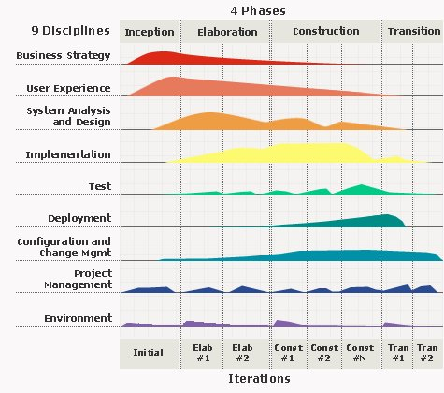

**Figure 2-1:** Rational Unified Process model overview

RUP is based on a set of building blocks, or content elements, describing what is to be produced, the necessary skills required and the step – by – step explanation describing how specific development goals are to be achieved. The main building blocks, or content elements, are the following.

**Workers (who)**:defines the behavior and responsibilities of an individual, or a group of individuals working together as a team.

**Artifacts (what)**: An artifact is a piece of information that is produced, modified, or used by a process. Artifacts are the tangible products of the project, the things the project produces or uses while working towards the final product.

**Activities (how)**:An activity of a specific worker is a unit of work that an individual in that role may be asked to perform.

**Workflows (when)**: is a sequence of activities that produces a result of observable value.

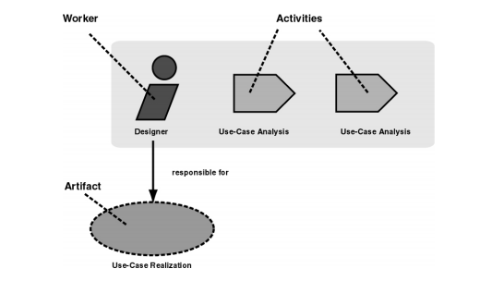

**Figure 2-2:** Workers, activities and artifacts

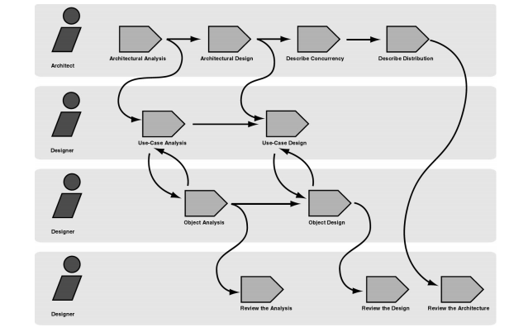

**Figure 2-3:** Example of workflow

RUP comes with six engineering disciplines and three supporting discipline

**- Six “engineering disciplines”:**

* + **Business modeling workflow**: In Business Modeling we document business processes using so called business use cases. This assures a common understanding among all stakeholders of what business process needs to be supported in the organization.
  + **Requirements workflow**: The goal of the Requirements workflow is to describe what the system should do and allows the developers and the customer to agree on that description.
  + **Analysis and design workflow**: The goal of the Analysis & Design workflow is to show how the system will be realized in the implementation phase.
  + **Implementation workflow**: The purpose of implementation is to define the organization of the code, to implement classes and objects in terms of components, to test the developed components as units, to integrate the results produced by individual implementers.
  + **Test workflow**: The purposes of testing are to verify the interaction between objects, to verify the proper integration of all components of the software, to verify that all requirements have been correctly implemented, to identify and ensure defects are addressed prior to the deployment of the software.
  + **Deployment workflow**: The purpose of the deployment workflow is to successfully produce product releases, and deliver the software to its end users. It covers a wide range of activities including.

**- Three supporting disciplines:**

* + **Configuration and change management workflow**: Software Project Management is the art of balancing competing objectives, managing risk, and overcoming constraints to deliver, successfully, a product in which meets the needs of both customers (the payers of bills) and the users.
  + **Project management workflow**: In this workflow we describe how to control the numerous artifacts produced by the many people who work on a common project.
  + **Environment workflow**: The purpose of the environment workflow is to provide the software development organization with the software development environment – both processes and tools – that are needed to support the development team.

#### Why RUP?

The Rational Unified Process provides each team member with the guideline, templates and tool mentors for the entire team to take full advantage of among others the following best practices:

**- Develop iteratively**: It is not possible to sequentially first define the problem upfront, design the entire solution, build the software and then test the product at the end. Each iteration ends with a release. The RUP supports an iterative approach to development that addresses the highest risk items at every stage in the lifecycle, significantly reducing a project’s risk profile. This is very important for our team that is very inexperienced in controlling issues.

**- Manage requirements**: the RUP describes how to elicit, organize and document required functionality and constraints; track and document tradeoffs and decisions; and easily capture and communicate business requirement. The notations of use case and scenarios proscribed in the process has proven to be an excellent way to capture functional requirements and to ensure that these drive the design, implementation and testing of software, making it more likely that the final system fulfills the end user needs.

**- Use Component – based Architectures**: the process focuses on early development and base lining of a robust executable architecture, prior to committing resources for full – scale development. It describes how to design a resilient architecture that is flexible, accommodates change, is intuitively understandable and promotes more effective software reuse.

**- Visually Model Software**: this process allows you to hide the details and write code using “graphical building blocks.” Visual abstractions help you communicate different aspects of your software; see how the elements of the system fit together; make sure that the building blocks are consistent with your code; maintain consistency between a design and its implementation; and promote unambiguous communication.

**- Verify Software Quality**: The Rational Unified Process assists you in the planning, design, implementation, execution, and evaluation of these test types. Quality assessment is built into the process, in all activities, involving all participants, using objective measurements and criteria, and not treated as an afterthought or a separate activity performed by a separate group.

**- Control Changes to Software**: And it brings a team together to work as a single unit by describing how to automate integration and build management

#### Project Life Cycle

The RUP is “use – case driven, architecture – centric, and incremental and iterative”. Each iteration is part of four overall phases: Inception, Elaboration, Construction, and Transition. Iterations occur in each phase. Each phase has one key “*objective*” and “*milestone*” at the end that denotes the objective being accomplished.

**- Inception Phase:** The primary objective is to scope the system adequately as a basis for validating initial costing and budgets.

* + Identify business functions of the system
  + Determining the scope, conditions and limitations of the project
  + List the main functions of the system
  + List one or more suitable architecture for the system
  + Identify project risks
  + Complete Report #1, and Report #2

**- Elaboration Phase:**

* + In this phase of the project team to understand the function of the system, which evaluate the system's architecture and provide a stable system architecture can implement all the requirements is scalable and suitable price..
  + Finally, the plan must provide (including estimates of cost and time) for the construction phase. The plan must ensure proper and accurate based on experience.
  + Complete Report #3 and Report #4

**- Construction Phase:**

* + This is the longest phase of a project life cycle.
  + In this phase, all functions of the system will be installed. The installation will be divided into small stages, each stage of the installation a few functions. The results of each phase will be the release of the module function can be executed.
  + Construction and improvement of products until the final product is ready to deliver to the user. During this phase, all the components and other features of the application is developed and integrated into the product.
  + This phase emphasizes the resource management and control operations to optimize cost, time and quality.
  + Complete software packages and Report #5, Report #6

**- Transition Phase:**

* + This is the final phase in the life cycle of a project.
  + Their products will be deployed to the client. The feedback received during the transfer process will be recorded and put on the new functional requirements or functionality enhancements in the next version of the product.
  + Phase transfer switch also includes the training system and the new system for the user.

### Roles and Responsibilities

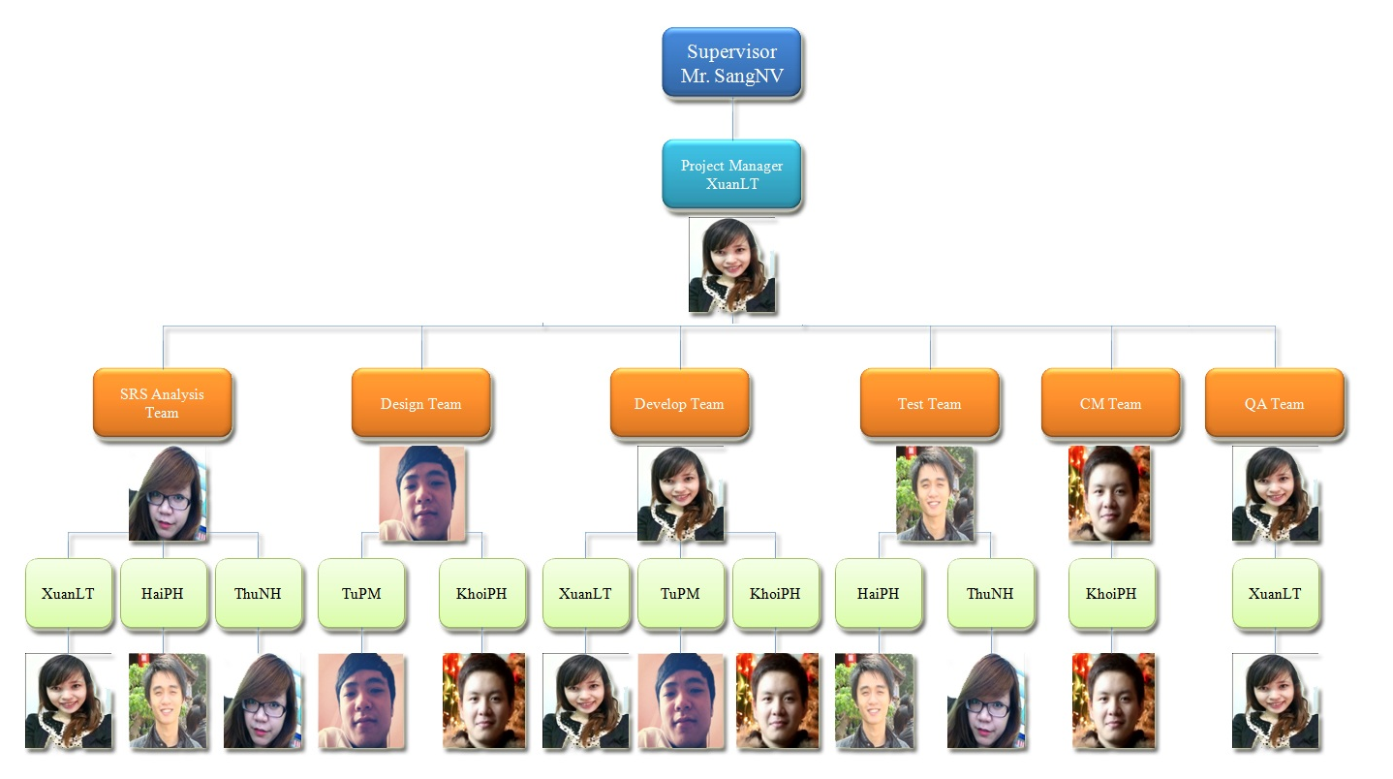

**Figure 2-4**: Project Organization

|  |  |  |
| --- | --- | --- |
| **Member** | **Roles and Responsibilities** | |
| **Roles** | **Responsibilities** |
| **XuanLT** | - Project Manager.  - Developer Leader.  - SRS Analysis. | - PM has responsibilities to develop the project plan and manage project stakeholders, project team, project risk, project schedule, project budget, project conflicts.  - Ensure that the Project Team completes the project.  - Secure acceptance and approval of deliverables from Project Sponsor and Stakeholder.  - Communication with other members and supervisor, including status reporting, making sure the project is delivered in budget, on schedule and within scope.  - Create WBS.  - Provide suitable technology solutions, tools for project development process.  - Conduct research and demo function that related to the project.  - Create coding guidelines, coding convention and standards.  - Co-operate with Developer to create software specification requirement (SRS), architectural design (SAD) and software detailed design (SDD).  - Review document, product, and reports.  - Unit test.  - Support other team members. |
|  | | |
| **HaiPH** | - SRS Analysis  - Tester Leader | - Create software specification requirement (SRS).  - Develop the test plan based on project plan and SRS, SDD documents.  - Delegate testing tasks to testers and manage the rate of progress.  - Create test data for all functions in both mobile and web application.  - Create test cases for the system, both in document and script.  - Write report  - Execute test to ensure all functions fulfil requirements.  - Support other team members. |
|  | | |
| **KhoiPH** | - Designer  - Developer  - CM Leader | - Design and develop mobile interface.  - Draw and complete architectural design on mobile.  - Develop all functions on mobile.  - Create and review SRS, SAD and SDD documents.  - Conduct research and demo function that related to the project.  - Conduct research how to install environment (include test and develop environment) and tools attach guidances.  - Support in every configuration – concerned problems.  - Managing configuration.  - Unit test and assure coding quality.  - Support other team members. |
|  | | |
| **TuPM** | - Designer Leader  - Developer | - Design and develop full web interface.  - Develop a plan to draw and control architectural design.  - Recommend the suitable and effective design.  - Create and review SRS, SAD and SDD documents  - Create Database such as create table, store procedure, transaction.  - Develop functions on web application.  - Unit test and assure coding quality.  - Support other team members. |
|  | | |
| **ThuNH** | - SRS Analysis Leader  - Tester | - Create software specification requirement (SRS).  - Understand business related to project topic.  - Present and explain business information to other members.  - Support the syntax and semantic of English language.  - Create test data for all functions in both mobile and web application.  - Create test cases for the system, both in document and script.  - Write report.  - Execute test to ensure all functions fulfill requirements and make test report.  - Support other team members. |

**Table 2-4** : Roles and Responsibilities

### Tools and Infrastructures

#### Development environment

|  |  |
| --- | --- |
| **Title** | **Detail** |
| **Software and Framework** | **Software:**  - Microsoft® Office, Microsoft® Project (2007, 2010)  - Operating System: Microsoft® Windows 7  - Source Control: Tortoise SVN 1.7.9  - Adobe Photoshop CS5  - Eclipse Indigo  - MySQL 5.6.11.0 and Tomcat 6  - Browser: Chrome 28.0.1500.95 , Firefox 22, IE 9  **Framework:**  - Integrated Struts2, Spring3, Hibernate3  - Java language  - Android OS version 2.3 or higher  - .NET 4.0 ( setup MySQL ) |
| **Hardware** | Notebooks for developing/testing with the minimum configuration:  RAM:2GB Hard disk: 150GB Chipset: Core 2 Dual 2.0 GHz |
| A server computer with the minimum configuration:  RAM: 2GB  Hard disk: 150GB  Chipset: Core 2 Dual 2.0 GHz |
| Smartphone support Android OS 2.3 or higher with GPS and Wi-Fi powered for testing and deploying purposes.  Chipset: 1 GHz  RAM: 1 GB  Memory: 8 GB or higher |

**Table 2-5:** Tools and Techniques

#### Deployment environment

Software Framework: Strut2, Spring3, Hibernate3, .NET 4.0, Android and Java language.

SMD (web) can run on some browsers : Chrome 25 , Firefox 20, IE 9.

SMD application ( mobile ) apply for Smartphone support Android OS version 2.3 or higher.

Server configuration: The server is a place to store data, source code and update all when have request, so it should be required the best equipment.

When equipped servers, it‘s necessary to pay attention to the following element:

- Configuration suggestions on web

* + Client Computer /Laptop: Core dual 2 GB RAM
  + CPU: Core dual 2 GB RAM
  + Operating Systems: Windows 7
  + Free Space: 2Gb

- Configuration suggestion on mobile:

* + Smartphone: 1 GB RAM
  + Memory: 16 GB
  + Chipset: 1.5 GHz
  + OS: Android 2.3 or higher

- Configuration suggestion on database server:

* + Client Computer /Laptop: Core dual 2 GB RAM
  + CPU: Core dual 2 GB RAM
  + Operating Systems: Windows 7
  + Free Space: 2Gb

## Project Schedule

### Task Sheet: Assignments and Timetable

Overall duration of project: 77 days (from 13th May 2013 to 27th August 2013)

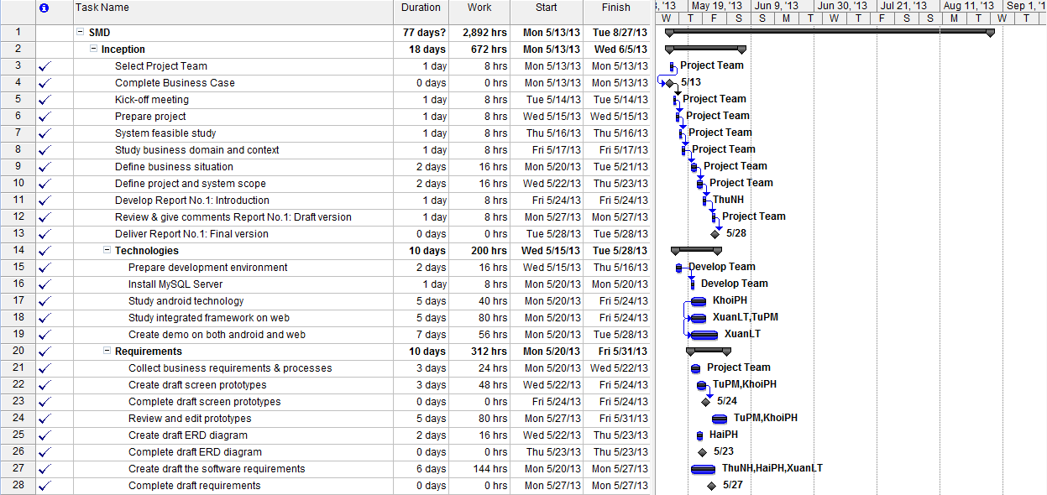

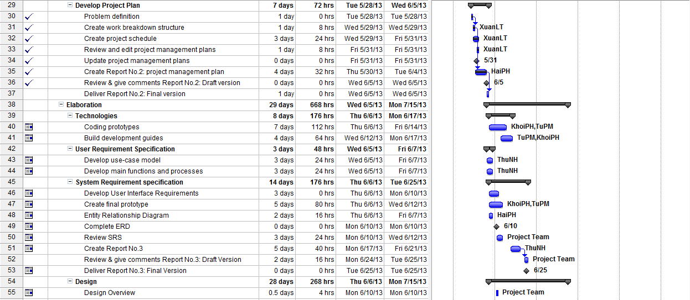

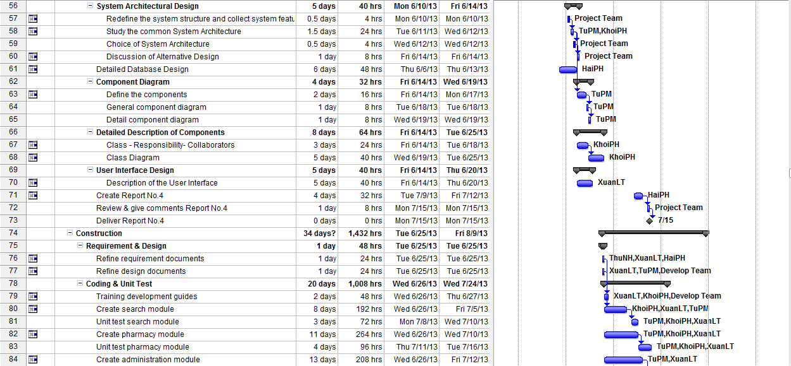

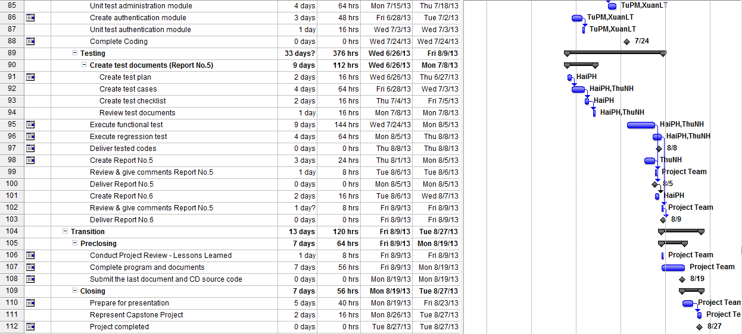

**Figure 2-5:** Work Breakdown Structure and Resource Assignment

### Meeting Schedule

Because of the project doing in the short time, we have to hold the meeting regularly, at least twice a week:

**- Meeting with team members:** In these meetings, each member will report their tasks in previous week to the others. The issues, knowledge and rules will be shared. Moreover, PM conduct the discussion of the plan in next week.

**- Meeting with supervisor:** all the activities, the issues will be discussed and reported with supervisor in last week. With the senior experience, supervisor will instruct the direction for project team to deal with the problems.

Below is a sample meeting minute template used for the project:

|  |  |  |  |
| --- | --- | --- | --- |
| **Subject** | Capstone Project Meeting | **Date** | Every Tuesday |
| **Facilitator** | FPT University | **Time** | 16:00 – 18:00 PM |
| **Location** | Detech Building, Cau Giay Str. | **Scribe** | ThuNH |
| **Attendees** | SangNV(Supervisor), XuanLT(PM), HaiPH, KhoiPH, TuPM, ThuNH | | |
| **Absent** |  | | |

| **Key Points Discussed** | | |
| --- | --- | --- |
| No | Topic | Highlights |
| 1. | Team member problems | * All the activities, the issues will be discussed and reported with supervisor in last week. * Discuss all issues & problems on the job last week * Discuss the working plan next week |
| 2. | Project introduction | * Instruct the direction for project team to deal with the problems * Support & comments the working ​​plans next week |

|  |  |  |  |
| --- | --- | --- | --- |
| **Action Plan** | | | |
| **No** | **Action Items** | **Owner** | **Target Date** |
| 1 | **Report #1**- INTRODUCTION | ThuNH | 28-May-2013 |
| 2 | **Report #2**: SOFTWARE PROJECT  MANAGEMENT DOCUMENTS | HaiPH + XuanLT | 6-June-2013 |
| 3 | **Report #3**: SOFTWARE REQUIREMENTS SPECIFICATION | HaiPH + ThuNH | 25-June-2013 |
| 4 | **Report #4**: SOFTWARE DESIGN  DESCRIPTION | XuanLT + TuPM + KhoiPH | 17-July-2013 |
| 5 | **Report #5**: SOFTWARE TEST  DOCUMENTATIONS | ThuNH | 5-August-2013 |
| 6 | **Report #6**: SOFTWARE USER‘S  MANUALS | HaiPH | 9-August-2013 |

**Table 2-6:** Meeting Schedule

## Effort Estimation

|  |  |  |  |  |
| --- | --- | --- | --- | --- |
| **Task Name** | **Worst Case** | **Best Case** | **Most likely Case** | **Expected Case** |
| **Inception** | **733** | **612** | **672** | **672** |
| Initiation | 104 | 70 | 88 | 88 |
| Technologies | 213 | 180 | 200 | 199 |
| Requirements | 332 | 294 | 312 | 312 |
| Develop Project Plan | 84 | 68 | 72 | 73 |
| **Elaboration** | **730** | **586** | **668** | **665** |
| Technology | 190 | 150 | 176 | 174 |
| User Requirement Specification | 60 | 44 | 48 | 50 |
| System Requirement Specification | 190 | 152 | 176 | 174 |
| Design | 290 | 240 | 268 | 267 |
| **Construction** | **1,536** | **1,344** | **1,432** | **1,435** |
| Requirements & Design | 54 | 40 | 48 | 48 |
| Coding | 1072 | 960 | 1,008 | 1011 |
| Testing | 410 | 344 | 376 | 376 |
| **Transition** | **144** | **106** | **120** | **123** |
| Pre-closing | 74 | 56 | 64 | 65 |
| Closing | 70 | 50 | 56 | 58 |
| **Total** | **3,143** | **2,648** | **2,892** | **2,895** |

**Table 2-7:** Effort Estimation

## Risk Management

|  |  |  |  |  |
| --- | --- | --- | --- | --- |
| **ID** | **Risk Content** | **Propability** | **Effect** | **Solution** |
| **#** | **People Risks** |  |  |  |
| 1 | Team member is not hard working, do not follow deadline. | HIGH | SERIOUS | -Find out reason why?  -Depending on circumstances, may set penalty rule. |
| 2 | Team members are sick, they can not complete task under deadline | HIGH | SERIOUS | -Increase project team’s working effort in “peace period”. -Allow all team members clear about what others do, so that they can cover the tasks when necessary. |
| 3 | Conflictions between team members. | HIGH | SERIOUS | - Setup an open-talk environment in project team. - “*Do not criticize*” is set as a rule. - Organize team-building more often.  - In some cases, manager must use her power to make decisions. |
| 4 | Poor experience makes plan late. Study new technologies have many difficult to apply for project | HIGH | SERIOUS | - List tasks and check continuously. Evaluate quality and progress weekly.  - Send email to other member to ask for help. |
| 5 | Bad communication breakdown can make changing time, work and delay plan | HIGH | SERIOUS | - We need using words more clearly, talk with each other more, note and send email to confirm information. |
| **#** | **Technical Risk** |  |  |  |
| 6 | We have not much knowledge in the framework and technique of both mobile and web. Therefore, we have to study all of these things from the beginning. This work may takes a lot of times or team may not resolve some technical problems. | HIGH | SERIOUS | - Divided into 2 technology research groups: one for mobile and one for web.  - Exchange information and problem.  - Send technical issues to supervisor who has experience to get support. |
| 7 | Eclipse is very error-prone. | HIGH | SERIOUS | - Errors brought up the big technology forum.  - Record the occurred error and how to fix it. |
| **#** | **Structure/ Process Risk** |  |  |  |
| 8 | Underestimate project scope, tasks’ difficulty level and risks’ effectiveness. | HIGH | SERIOUS | - Estimate project scope with supervisor and experience persons.  -Assign task weight value to make task evaluation easier. Discuss in group about tasks’ difficulty level.  -Involve all team members in risk management process and reference to instructor’s opinions. |
| # | **Requirement Risk** |  |  |  |
| 9 | Not understanding the system's process , so we can have mistakes in describing the essential functions | HIGH | SERIOUS | - Receive advice from experts  - Develop prototypes and review prototypes with experts and supervisor |
| # | **Testing Risk** |  |  |  |
| 10 | Location access through GPS satellite in mobile is depended so much on the infrastructure of the network providers. therefore, development & test may get stuck when service is not stable then the progress may be slower than plan. | HIGH | SERIOUS | Use two network providers for testing environment and development environments |
| 11 | Android device problem, because no member in our team have an android device. ( launch application on emulator is very slow, some function can not run on emulator as draw line between two points on map ) | HIGH | SERIOUS | - Borrow someone else’s device.  - Be careful to avoid damage because they are quite expensive. |
| # | **Management Risk** |  |  |  |
| 12 | Poor experience of management so that team makes plan unrealistically | HIGH | SERIOUS | - Team leader will tightly co-operate with team members when planning.  - Project team get advice from supervisor about the planning and the plan need to be reviewed by supervisor. |

**Table 2-8:** Risk Management

**Report #3:**

**USER REQUIREMENT SPECIFICATION**

# USER REQUIREMENT SPECIFICATION

## Introduction

### Purpose

This document will provide the describing of general requirement and non-functional requirements of our SMD system. After reading, project team and the other people can have an overview about the user requirement specification of the system and also know more about the high level requirements of the system. This document also describes the requirement scope of each phase in the project.

### Definition and Acronyms

|  |  |
| --- | --- |
| Term | Description |
| SMD | Smart Medicine Dictionary |
| GPS | Global Positioning System |
| URL | Uniform Resource Locator |
| LOC | Line of code |

**Table 3-1:** Definition and Acronyms

### Overall description

#### Business process overview

SMD is not only an online dictionary about medicine but also a directory to help user find out the nearest pharmacy and the way to get there in need. Therefore, that system will implement the following processes

**NOTE: The meaning of flowchart symbols:**

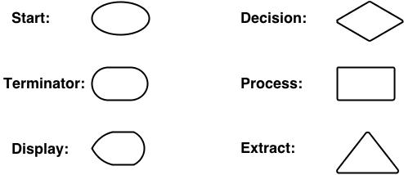

#### Search medicine process workflow

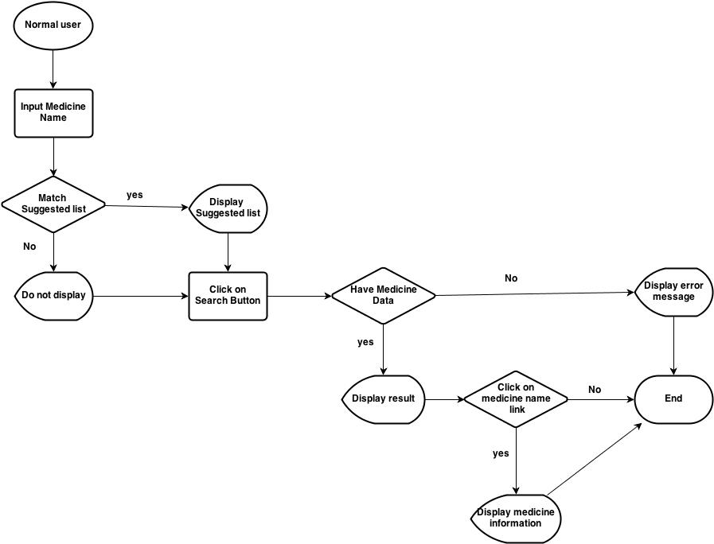

Figure 3-1: Search medicine process workflow

**Brief description**: Everyone can do that search process. It is divided into these steps:

**Step 1**: User inputs medicine name (or information of that medicine) into text box. System has auto-complete feature, therefore, system will list all suggested medicine name that match to what user inserts

**Step 2**: After user click on search button, system will filter from database to find out if that medicine name exist. If it does not exist, system will display error message to inform that data not found. If it exists, system will display result

**Step 3**: User can click on medicine name on table result to see information detail of that medicine

#### Find nearest pharmacy workflow on web module:

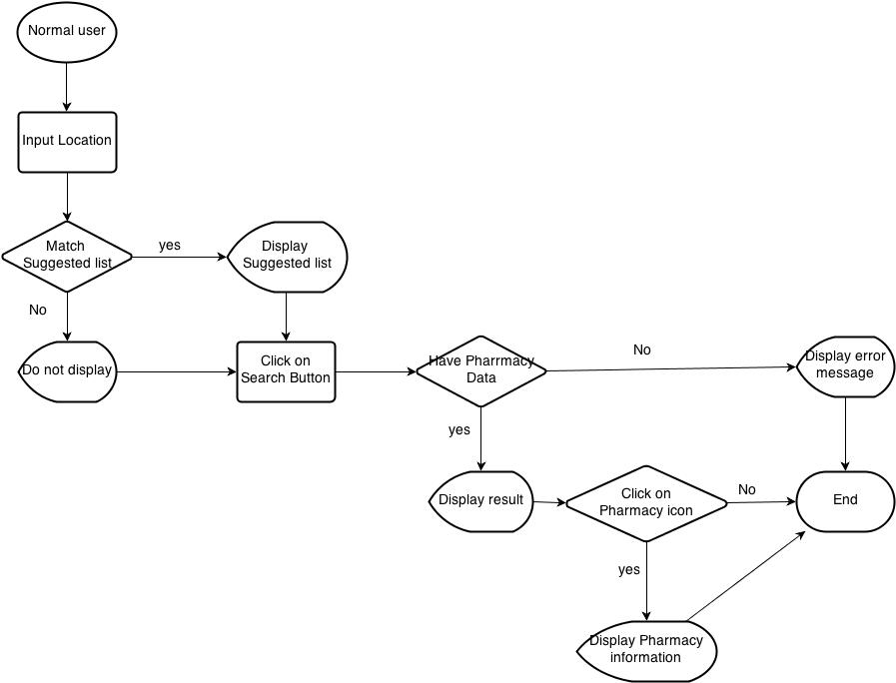

Figure 3-2: Find nearest pharmacy workflow on web module

**Brief description**: Find the nearest pharmacy can also be used by every user.

**Step 1**: User input location name into text box. System has auto-complete feature, therefore, system will list all suggested medicines' name that match to what user input

**Step 2**: After user click on Search button, system will filter to find out which pharmacy has address around that place. If there is no registered pharmacy there, system will display “data not found” message then end process. If system can find pharmacies there, it will display them on Google map as location icon

**Step 3**: User can click on one pharmacy icon on Google map to see that pharmacy detail information

#### Find nearest pharmacy workflow on mobile

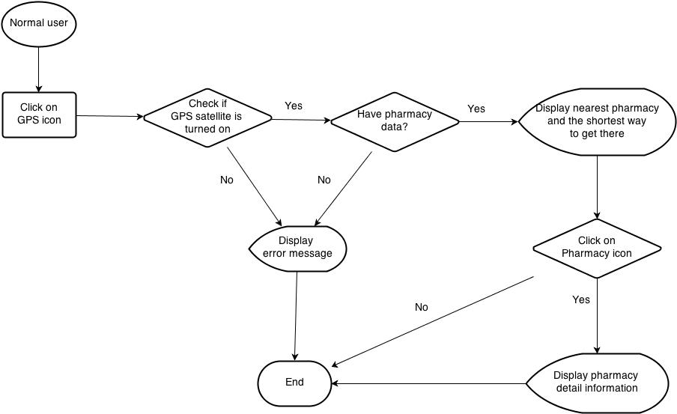

Figure 3-3: Find nearest pharmacy workflow on mobile

**Brief description**: Find the nearest pharmacy can also be used by every user

**Step 1**: To access to that feature on mobile version, after access to that software, user must click on GPS icon. System will access to GPS satellite of their mobile device to find the nearest pharmacy around their location

**Step 2**: System will show the shortest way from their location to the nearest pharmacy. User can click on that pharmacy icon to see that pharmacy detail information

#### Medical Usage Diary workflow

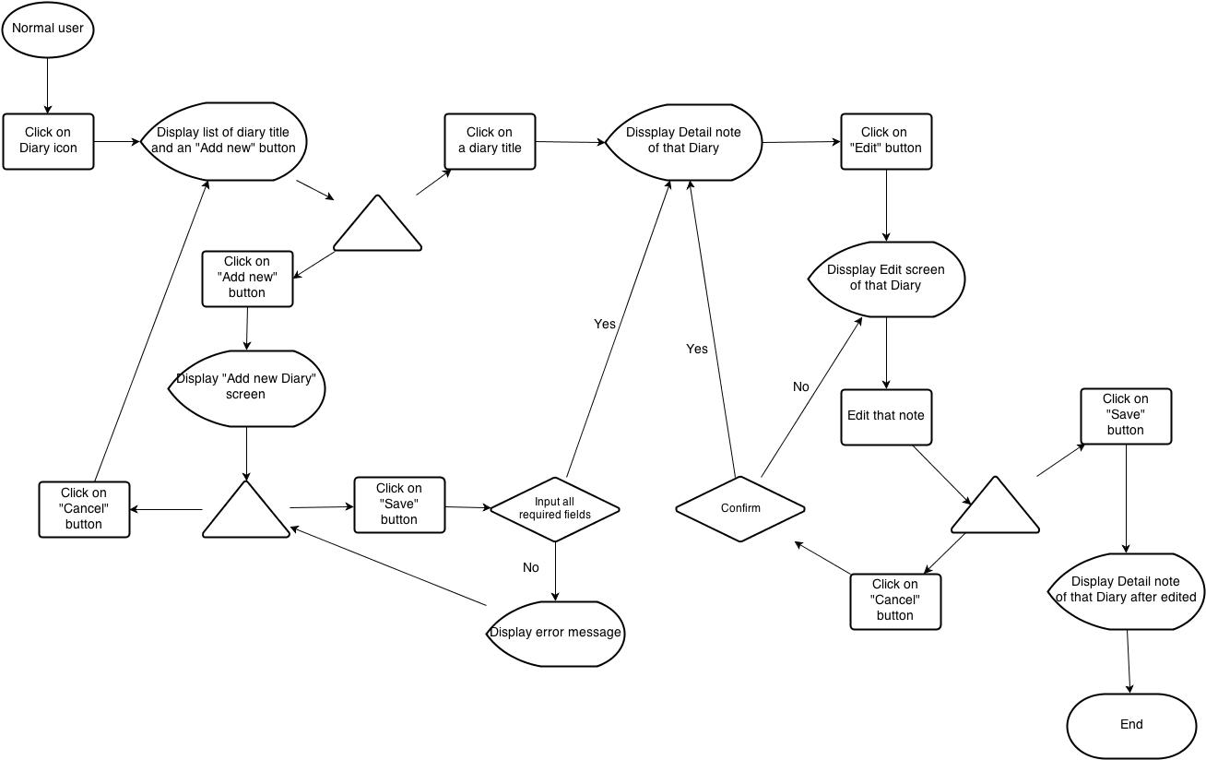

Figure 3-4: Medical Usage Diary workflow

**Brief description**: Medical diary can also be used by every user who use mobile version

**Step 1**: User click on Diary icon after access to that software on their mobile device. System display a list of Diary that has been added and an “Add new” button

**Step 2**: User click on one Diary title on that list. System will display detail note of that Diary with Edit button on the bottom of screen

**Step 3**: After user click on Edit button, system will display Diary Edit screen. User can amend their note then press “Save” button to save edited data. If not, system will return to detail note screen

**Step 4**: User can click on “Add new” button on main Diary screen. System will display Add new diary screen. User can click cancel to back to main Diary screen or fill their note then click “Save” button to save their new note and switch to detail note of that diary

#### Add new and modify workflow

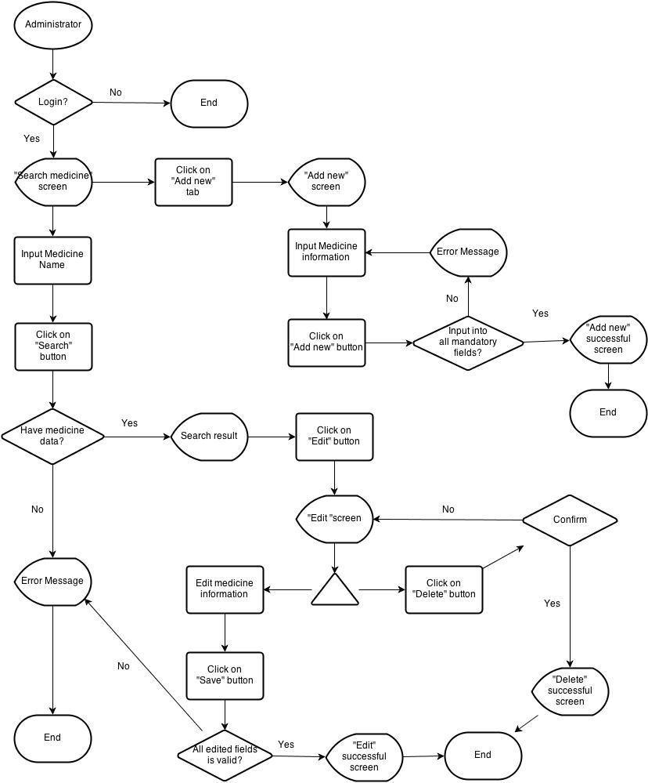

Figure 3-5: Add new and modify workflow

**Brief description**: Only administrator can add new or modify information of medicine and pharmacy.

**Step 1**: System will check if user have logged in as administrator. If the answer is “yes”, system will display “Add new” tab on submenu

**Step 2**: After user click on “Add new” tab, system will display Add new screen

**Step 3**: Administrator must insert all necessary information into all fields then click on “Add new” button. System will check if all fields are validated. Then it will display Successful screen if all fields are valid. If not, return error message

**Step 4**: Administrator click on Search tab on submenu. Insert medicine or pharmacy name then click Search button. System displays result if data can be found

**Step 5**: Administrator click on Edit button beside medicine (pharmacy) name. System display medicine (pharmacy) information

**Step 6**: Administrator amend the information that have to be changed then click “Save” button. System will check the validation of amended information. If it is ok, system will display successful screen

**Step 7**: After accessing into Edit screen, user can also click on “Delete” button on the bottom of that screen to delete that medicine (pharmacy) information

#### Register workflow

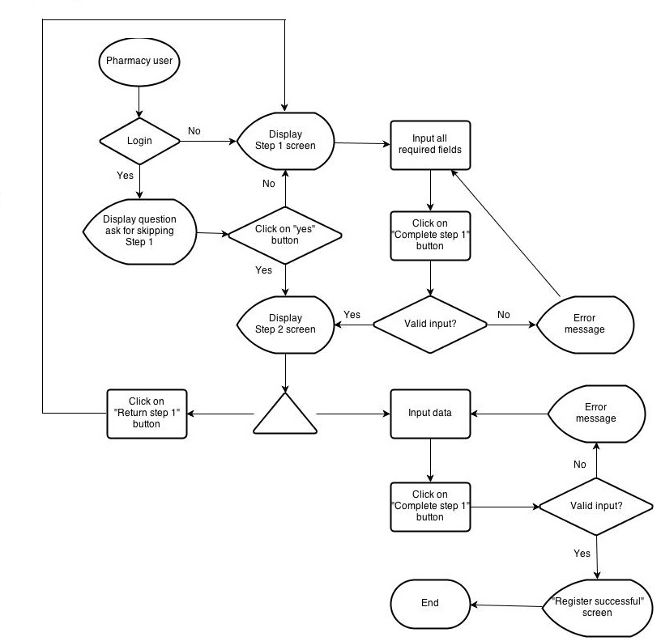

Figure 3-6: Register workflow

**Brief description**:

**Step 1**: System will check if user have logged in system. If user have already logged into that system, system will display question to ask if they continue with their registered information then skip to step 2

**Step 2**: If user choose “yes”, system will skip to step 2 and use their information to auto fill into step 1 screen. If not, continue with step 1 screen

**Step 3**: User insert into all required fields then click on “Complete step 1” button. System will check the validation of all inserted fields. If it is invalid, display error message beside wrong fields. If ok, continue with step 2 screen

**Step 4**: On Step 2 screen, user can choose to return to step 1 to amend information or continue to insert all required data on that screen. After user click on “Complete process” button, system will check the validation of all inserted fields. If it is invalid, display error message beside wrong fields. If ok, system will display success screen

### Product features

SMD is an online system that can run in both web application and Android devices so it is flexible and convenient to use every time and everywhere that can connect to the internet. The system is divided into multiple modules for each specific kind of user. The combination of these modules makes the workflow of the whole system become unified, so that it can work fluently

* **On web module**, that system provides these main functions:
  + **Manage medicine information**

System just allows user who logins as Administrator have permission to manage medicine information. So that they can search/ add new/ edit/ delete/ restore medicine information as they want.

With normal user, they only have permission in add new medicine into the selling list of their pharmacy

* + **Manage pharmacy information**

Administrator user will also have permission to manage pharmacy information. They can accept or reject or delete every pharmacies information which has problem

Normal user can only apply their own pharmacy into system after being accepted by admin

* + **Search medicine**

Everyone who uses that system can make search with medicine information.

* + **Search pharmacy**

Everyone who uses that system can make search with pharmacy information.

* + **Find the nearest pharmacy**

Everyone who uses that system can easily find out the pharmacy that is near by their location by input their position

* + **View news**

Everyone who uses that system can up to date with medical information through that software

* **Mobile module** has these main functions:
  + **Search medicine**

Everyone who uses that system can make search with medicine or pharmacy information.

* + **Find the nearest pharmacy**

Everyone who uses that system can easily find out the pharmacy that is near by their location by accessing their mobile GPS satellite

* + **Diary**

This feature just runs on mobile version. User can save their medicine taking schedule to be alarmed on time

### User characteristics

There are three main actors that system support:

* **Visitor:** Do not have account on system. In general, they should be people who need to search for medicine or pharmacy or they could also people who have few properties and want a fast look up, in short time, a limitation of steps and without registration.
* **Pharmacy User:** Have account on system, they might be pharmacist who has their pharmacy access to our system
* **Administrator:** The full power user of the system who has all functions of normal user and has an Administrator control panel to manage all configuration of system.

### Functional requirement

#### Registration

**Access right: Pharmacy user**

That function displays only on web version and it is used only for pharmacist to subscribe website for their pharmacy. They can access registration form from Pharmacy/ Register submenu.

To register, they have to fill all necessary information such as: Pharmacist name, Pharmacy name, Address, Practicing Certificate number, Business License, Phone number…

#### Pharmacy information management

**Access right: Administrator**

That function displays only on web version and it is used only for Administrator user. User can only be registered successfully after being accepted by Admin. If Administrator find out a pharmacy that has problem or violate some rule, they can reject or delete it from system

#### Search medicine

##### Quick Search

**Access right: Visitor**

The system shall provide facilities on both web and Android smart phone for user to search medicine information by medicine name.

* On web version, this function displays as a bar under sub menu in homepage. User can make a quick search directly from homepage.
* On mobile version, there is only quick search feature. User can access it by tapping on search icon.

##### Advanced Search

**Access right: Visitor**

User can access that function in Medicine/ Advanced Search submenu. This function provides user more option to make search result more precise. It is extremely effective for user who knows exactly what they want to know. They can search by these options:

* Medicine name
* Contraindicated
* Main ingredient
* Manufacture
* Package

#### Search pharmacy

##### Quick Search

**Access right: Visitor**

The system shall provide facilities on both web and Android smart phone for user to search pharmacy information by pharmacy name.

* On web module, this function displays as a bar under sub menu in homepage. User can make a quick search directly from homepage.
* On mobile module, there is only quick search feature. User can access it by tapping on search icon.

##### Advanced Search

**Access right: Visitor**

User can access that function in Pharmacy/ Advanced Search submenu. This function provides user more option to make search result more precise. It is extremely effective for user who knows exactly what they want to know. They can search by these options:

* Pharmacy name
* Representative name
* Address
* GPP

#### Add new medicine

**Access right: Administrator and Pharmacy user**

That function displays only on web version. Administrator can access that function in Medicine/ Add new on submenu. With register user, they can add new medicine if their selling medicine does not exist in system.

#### Modify medicine information

**Access right: Administrator**

That function displays only on web version and it is used only for Admin. They have full permissions on edit/ delete/ restore medicine information as they want.

#### View news

**Access right: Visitor**

That feature will collect information from some trustful medical page and update daily to help user be kept up with medical information

#### News control

**Access right: Administrator**

The administrator will browse the medical news daily then handling update News part by add, edit, delete news feature of the system

#### Medicine Usage Diary

**Access right: Visitor**

This feature just runs on mobile version. User can save their medicine taking schedule on their mobile to be alarmed on time

### Non – Functional Requirements

* Easy to maintain and upgrade
* Ensure data security capabilities, high performance
* GUI is clear, friendly and easy to use.
* System has clear permission for user and can support for user with multi roles.

## SYSTEM REQUIREMENT SPECIFICATION

### Introduction

#### Purpose

This document will provide the describing of general requirement and non-functional requirements of our SMD system. After reading, project team and the other people can have an overview about the user requirement specification of the system and also know more about the high level requirements of the system. This document also describes the requirement scope of each phase in the project.

#### Definition and Acronyms

|  |  |
| --- | --- |
| Term | Description |
| SMD | Smart Medicine Dictionary |
| GPS | Global Positioning System |
| URL | Uniform Resource Locator |
| LOC | Line of code |

**Table 3-1:** Definition and Acronyms

#### Purpose of that system

That system is developed to help two kind of objective users: everyone who cares about medical and pharmacy

* The first purpose of that system is to help users easily find out information about one kind of medicine or pharmacy which they want to know more
* The second purpose is to be a promotion channel for pharmacies. That software can bring pharmacies to be nearer to users

### System Features

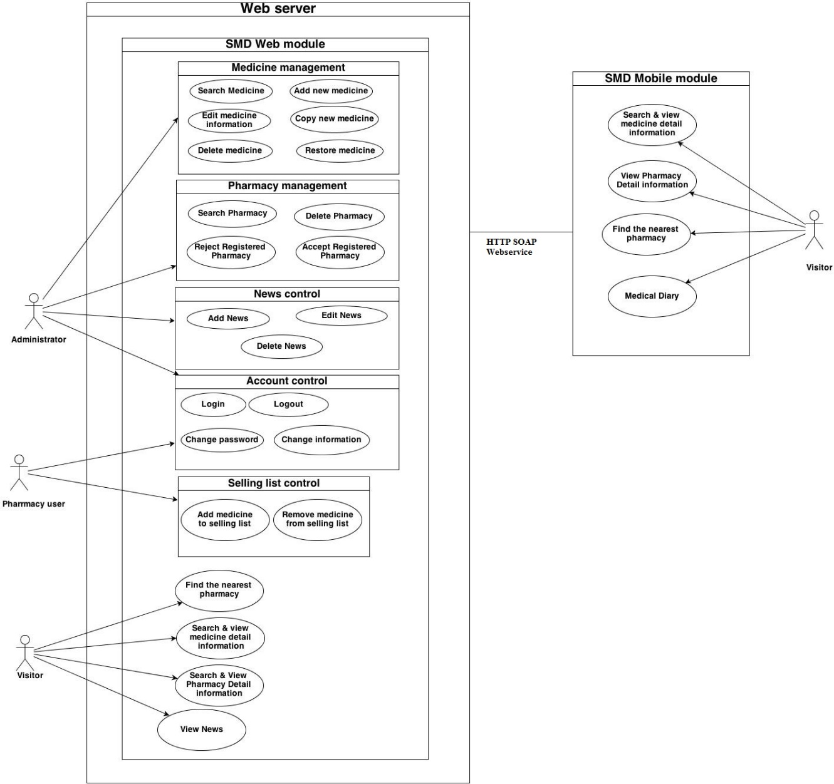

Figure 4-1: System Overview

|  |  |  |  |
| --- | --- | --- | --- |
| **Use Case No.** | **Group of functions** | **Functions** | **Glossary** |
| Mobile module | | |  |
|  | Search Medicine | Normal search | Tìm kiếm thuốc |
| Medicine detail | Thông tin thuốc |
|  | Search Pharmacy | Normal search | Tìm kiếm nhà thuốc |
| Pharmacy detail | Thông tin nhà thuốc |
|  | Medicine selling | Danh sách thuốc |
|  |  | Find the nearest pharmacy | Tìm nhà thuốc gần nhất |
|  |  | Medical Diary | Nhật ký |
| Web module | | |  |
|  | Search medicine | MedicineNormal search | Tìm kiếm thuốc |
|  | Medicine advanced search | Tìm kiếm thuốc nâng cao |
|  | Search pharmacy | Pharmacy Normal search | Tìm kiếm nhà thuốc |
|  | Pharmacy advanced search | Tìm kiếm nhà thuốc nâng cao |
|  | Find the nearest pharmacy | Tìm nhà thuốc gần nhất |
|  | News | View News | Tin tức |
|  | Search News | Tìm kiếm tin tức |
|  | Add News | Thêm mới tin tức |
|  | Edit News | Chỉnh sửa tin tức |
|  | Delete News | Xóa tin tức |
|  | Restore News | Khôi phục |
|  | Account control | Register | Đăng ký |
|  | Login | Đăng nhập |
|  | Logout | Đăng xuất |
|  | <Pharmacy user> Change information | Thay đổi thông tin |
|  | <Pharmacy user> Change password | Thay đổi mật khẩu |
|  | <Pharmacy user> Add new selling medicine | Danh sách thuốc có bán |
|  | Manage pharmacy information | Search registered pharmacy | Tìm kiếm nhà thuốc đã đăng ký |
|  | Accept registered pharmacy | Chấp nhận nhà thuốc đăng ký |
|  | Delete pharmacy | Xóa bỏ nhà thuốc |
|  | Manage medicine information | Search medicine | Tìm kiếm thuốc |
|  | Add new medicine | Thêm mới thuốc |
|  | Copy new medicine | Bản sao thuốc mới |
|  | Edit medicine | Chỉnh sửa thông tin thuốc |
|  | Delete medicine | Xóa bỏ thuốc |
|  | Restore medicine | Khôi phục thuốc |

### Functional Specification

On mobile module, user no need to sign in system, therefore, all features can be used by everyone. However, on web module, use roles are clearly separated for each features as the below table:

|  |  |  |  |  |
| --- | --- | --- | --- | --- |
| **No** | **Use Case** | **Visitor** | **Administrator** | **Pharmacy User** |
|  | Web Module | | | |
|  | Medicine normal search | x | x | x |
|  | Medicine advance search | x | x | x |
|  | Pharmacy normal search |  |  |  |
|  | Pharmacy advance search | x | x | x |
|  | Find the nearest pharmacy | x | x | x |
|  | View News | x | x | x |
|  | Search News |  | x |  |
|  | Add News |  | x |  |
|  | Edit News |  | x |  |
|  | Delete News |  | x |  |
|  | Restore News |  | x |  |
|  | Register |  | x |  |
|  | <Admin> Login |  | x |  |
|  | <Admin> Logout |  | x |  |
|  | <Admin> Search registered pharmacy |  | x |  |
|  | <Admin> Accept registered pharmacy |  | x |  |
|  | <Admin> Delete pharmacy |  | x |  |
|  | <Admin> Search medicine |  | x |  |
|  | <Admin> Add new medicine |  | x |  |
|  | <Admin> Copy new medicine |  | x |  |
|  | <Admin> Edit medicine |  | x |  |
|  | <Admin> Delete medicine |  | x |  |
|  | <Admin> Restore medicine |  | x |  |
|  | <Pharmacy user> Login |  |  | x |
|  | <Pharmacy user> Logout |  |  | x |
|  | <Pharmacy user> Change information |  |  | x |
|  | <Pharmacy user> Change password |  |  | x |
|  | <Pharmacy user> Add new selling medicine |  |  | x |

**Table 2-2:** Table of user’s decent ration

#### UC001: Search medicine on Mobile

##### Use Case Diagram

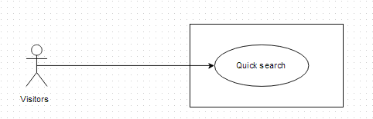

##### Use-Case Specification

|  |  |  |  |  |
| --- | --- | --- | --- | --- |
| **UC001 - Specification** | | | | |
| **Use-case No.** | <UC001> | **Use-case Version** | | <1.0> |
| **Use-case Name** | Search medicine (mobile version) | | | |
| **Author** | Thu NH | | | |
| **Date** | 22/05/2013 | **Priority** | Normal | |
| **Actor:**  Visitor, Pharmacy users, Administrator  **Summary:**  This is one of the main features of that software. On mobile version, user can easily make a quick search to find out information about the medicine they concern by its name everywhere that can connect to the internet  **Preconditions:**  Users have to install that software on their Android devices and it is connecting to the internet  **Post Conditions:**  System displays medicine detail information  **Main Success Scenario:**   |  |  |  | | --- | --- | --- | | **Step** | **User** | **System** | | 1 | Click on that software icon on mobile | Displays home page | | 2 | Click on “Quick Search” tab or Search icon below the screen | Displays search screen including | | 2 | Type medicine name into search box on home page |  | | 3 | Click “Search” button | Display result on the search screen | | 4 | Click on a medicine name | Displays medicine detail information |   **Alternative flows:**   |  |  |  | | --- | --- | --- | | **At Step** | **User** | **System** | | 3 | Click “Search” button | If there is not any medicine matched with the user's input, the system displays an warning message to inform that data not found |     **Business rule**:   * User cannot insert more than 100 characters into medicine name text box * Can only query by medicine name | | | | |

#### UC002: Find the nearest pharmacy on mobile

##### Use Case Diagram

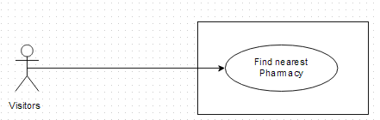

##### Use-case Specification

|  |  |  |  |  |
| --- | --- | --- | --- | --- |
| **UC002 - Specification** | | | | |
| **Use-case No.** | <UC002> | **Use-case Version** | | <1.0> |
| **Use-case Name** | Find nearest pharmacy (mobile version) | | | |
| **Author** | Thu NH | | | |
| **Date** | 22/05/2013 | **Priority** | <High > | |
| **Actor:**  Visitor, Pharmacy users, Administrator  **Summary:**  This is one of the main feature of system. Users only need to insert their location into text box, then press search. All registered pharmacy around their location will display on map with the nearest one is highlighted. Look at the map, users can easily find out the way to get there.  **Triggers**  Users have to install that software in their Android devices and Location Access feature on mobile has been turned on and user clicks on “Find the nearest pharmacy” tab on Home screen  **Preconditions:**  Users have to install that software in their Android devices and Location Access feature on mobile has been turned on  **Post Conditions:**  System displays the nearest pharmacies around user place on map  **Main Success Scenario:**   |  |  |  | | --- | --- | --- | | **Step** | **User** | **System** | | 1 | Click on “Find Nearest Pharmacy” tab on the Home screen | Access their location by GPS satellite of their mobile then display nearest pharmacy around their place on map | | 2 | Click on the nearest pharmacy icon on map | Show that pharmacy information and the direction to get there | | 3 | Typing their location on “Location” text box | Displays nearest pharmacy around the inserted place on map | | 4 | Click on the nearest pharmacy icon on map | Show that pharmacy information and the direction to get there |     **Alternative flows:**   |  |  |  | | --- | --- | --- | | **At Step** | **User** | **System** | | 1 | Click on “Find Nearest Pharmacy” tab | if “Location access” feature is turned off, the system shows Location text box blank. | | 2 | Insert their location on “Location” text box in screen right corner | Displays nearest pharmacy around the inserted place on map |   **Business rule**:   * Cannot input more than 100 characters into Location text box * Just access location in Vietnam | | | | |

#### UC003: Medical Usage Diary

##### Use Case Diagram

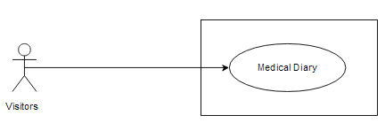

##### Use-case Specification

|  |  |  |  |  |
| --- | --- | --- | --- | --- |
| **UC003 - Specification** | | | | |
| **Use-case No.** | <UC003> | **Use-case Version** | | <1.0> |
| **Use-case Name** | Medical Usage diary | | | |
| **Author** | Thu NH | | | |
| **Date** | 22/05/2013 | **Priority** | <High > | |
| **Actor:**  Visitor, Pharmacy users, Administrator who uses that software on Android devices  **Summary:**  User can use their device as an alarm to take medicine in time or to take note which kinds of medicine they have to use  **Triggers**  Home screen is displayed with available "Medical Diary" tab and user clicks on “Medical Diary” tab on the Home screen  **Preconditions:**  Users have installed that software on their device and Home screen is displayed with available "Medical Diary" tab.  **Post Conditions:**  System must alarm user in time  **Main Success Scenario:**   |  |  |  | | --- | --- | --- | | **Step** | **User** | **System** | | 1 | Click on “Medical Diary” tab on Home screen | Displays Medical diary page with Add new button and list of saved notes | | 2 | Click on Add new button | Displays “New note” screen with these fields:   * “Subject” text box * “Medical list” text box * “Start” text box * “End” text box * “Save” button * “Cancel” button | | 3 | Fill all fields |  | | 4 | Click on “Save” button on "New Note" screen | a. The system validates the input data and then save data into database  b. Displays detail note for each medicine with taking medicine time and dosage then system will automatically alarm user |   **Exceptions:**   |  |  |  | | --- | --- | --- | | **At Step** | **User** | **System** | | 4 | Click on “Cancel” button | These text box will be blank | | | | | |

#### UC004: Medicine Normal Search

##### Use Case Diagram



##### Use-case Specification

|  |  |  |  |  |
| --- | --- | --- | --- | --- |
| **UC004 - Specification** | | | | |
| **Use-case No.** | <UC004> | **Use-case Version** | | <1.0> |
| **Use-case Name** | Medicine Normal Search (web version) | | | |
| **Author** | Thu NH | | | |
| **Date** | 22/05/2013 | **Priority** | High | |
| **Actor:**  Visitor, Pharmacy users, Administrator  **Summary:**  This is one of the main features of that software. User can make a quick search to find out information about the medicine they concern by its name right after entering to website  **Goal:**  Search for medicine by its name directly from home page  **Preconditions:**  The Home page (quick search medicine) screen is displayed  **Trigger**:  The Home page is displayed, the medicine name is entered and Search button is clicked.  **Post Conditions:**  System displays medicine detail information  **Main Success Scenario:**   |  |  |  | | --- | --- | --- | | **Step** | **User** | **System** | | 1 | Type medicine name into search box on Home page | Auto-complete feature will check and gives suggested list bases on characters that user input | | 2 | Click “Search” button | Display result- the list of found medicine | | 3 | Click on a medicine name | Displays medicine detail information |   **Alternative Scenarios:**   |  |  |  | | --- | --- | --- | | **At Step** | **User** | **System** | | 3 | Click on other link on screen Search Screen | Switch to selected page |   **Exception:**   |  |  |  | | --- | --- | --- | | **At Step** | **User** | **System** | | 3 | Click “Search” button but medicine does not exist in the database | Return warning message to inform that data not found |     **Business rule:**   * Quick search can only query by medicine name * User cannot input more than 100 characters into text box | | | | |

#### UC005: Medicine Advance Search

##### Use Case Diagram

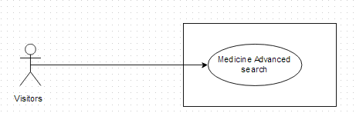

##### Use-case Specification

|  |  |  |  |  |
| --- | --- | --- | --- | --- |
| **UC005 - Specification** | | | | |
| **Use-case No.** | <UC005> | **Use-case Version** | | <1.0> |
| **Use-case Name** | Medicine Advanced Search | | | |
| **Author** | Thu NH | | | |
| **Date** | 22/05/2013 | **Priority** | <High> | |
| **Actor:**  Visitor, Pharmacy users, Administrator  **Summary:**  This is the main function of that system. People have many choices to find out the medicine they concern such as: Medicine name, Contraindicated, Main ingredient, Manufacture, Package  **Goal:**  To search for medicine information  **Triggers**  User click on “Advance search” hyperlink right below “Search” button on Home screen to access “Medicine advanced search” screen. User must input information into the right fields then click “Search” button  **Preconditions:**  The information that user has input must be correctly  **Post Conditions:**  Search medicine must have data information in database  **Main Success Scenario:**   |  |  |  | | --- | --- | --- | | **Step** | **User** | **System** | | 2 | Click on “Medicine/ Medicine Advanced Search” hyperlink on Search Medicine screen | Switch into Advance search page | | 3 | Type the element that they want to filter result by into the right text box |  | | 4 | Click “Search” button | Displays result on the current screen. | | 5 | Click on medicine name on the search result | Displays medicine detail information |   **Alternative Scenario:**   |  |  |  | | --- | --- | --- | | **At** **Step** | **User** | **System** | | 4 | Click another link | Switch to selected page |   **Exceptions:**   |  |  |  | | --- | --- | --- | | **At Step** | **User** | **System** | | 3 | Type the element that they want to filter result by into the right text box (No medicine in database matches these elements) |  | | 4 | Click “Search” button | Return warning message to inform that cannot find matching medicine | | | | | |

#### UC006: Pharmacy Normal Search

##### Use Case Diagram

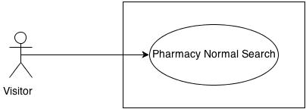

##### Use-case Specification

|  |  |  |  |  |
| --- | --- | --- | --- | --- |
| **UC006 - Specification** | | | | |
| **Use-case No.** | <UC006> | **Use-case Version** | | <1.0> |
| **Use-case Name** | Pharmacy Normal Search | | | |
| **Author** | Thu NH | | | |
| **Date** | 22/05/2013 | **Priority** | <High > | |
| **Actor:**  Visitor, Pharmacy users, Administrator  **Summary:**  With that feature, user can input the element that they have known such as: Brand name, main ingredient, package… into the right element text box on search criteria screen. Basing on what user has input, system will query and find out the appropriate medicine  **Goal:**  Users can find out list of pharmacies that follows their criteria  **Triggers**  User click on “Pharmacy Search” tab on submenu. After input pharmacy name into text box, user must click “Search” button  **Preconditions:**  The information that user has input must be correctly  **Post Conditions:**  System can find out and display detail information of pharmacy which has matched search criteria.  **Main Success Scenario:**   |  |  |  | | --- | --- | --- | | **Step** | **User** | **System** | | 2 | Click on “Pharmacy Search” tab on menu | Displays “Pharmacy Search” with text box to make quick search pharmacy by pharmacy’s name on the current screen. | | 3 | Type pharmacy name into text box then press “Search” button | Displays list of pharmacies that match these criteria | | 4 | Click on pharmacy name | Show that pharmacy information |   **Exceptions:**   |  |  |  | | --- | --- | --- | | **At Step** | **User** | **System** | | 4 | Insert name of an unregistered into text box then press Search button | Return warning message that cannot find data |   **Business rule:** System can only find out pharmacy that has been accepted | | | | |

#### UC007: Pharmacy Advanced Search

##### Use Case Diagram

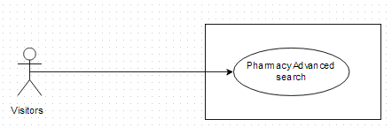

##### Use-case Specification

|  |  |  |  |  |
| --- | --- | --- | --- | --- |
| **UC007 - Specification** | | | | |
| **Use-case No.** | <UC007> | **Use-case Version** | | <1.0> |
| **Use-case Name** | Pharmacy Advanced Search | | | |
| **Author** | Thu NH | | | |
| **Date** | 22/05/2013 | **Priority** | <High > | |
| **Actor:**  Visitor, Pharmacy users, Administrator  **Summary:**  With that feature, user can input the element that they have known such as: Brand name, main ingredient, package… into the right element text box on search criteria screen. Basing on what user has input, system will query and find out the appropriate medicine  **Goal:**  Users can find out list of pharmacies that follows their criteria  **Triggers**  User click on “Pharmacy Search” tab on submenu. Click on “Advanced search” hyperlink below “Search” button. After input information into the right fields, user must click “Search” button  **Preconditions:**  The information that user has input must be correctly  **Post Conditions:**  System can find out and display detail information of pharmacy which has matched search criteria.  **Main Success Scenario:**   |  |  |  | | --- | --- | --- | | **Step** | **User** | **System** | | 1 | Click on “Pharmacy Search” tab on menu | Display “Pharmacy normal search” screen | | 2 | Click on “Pharmacy Advance Search” link beside “Search” button on Search Pharmacy screen | Displays “Search Criteria” screen with these element:   * Pharmacy name * Address * Medicine in store * GPP | | 3 | Insert the criteria they want to filter by into text box then click “Search” button | Displays list of pharmacies that match these criteria | | 4 | Click on pharmacy name | Show that pharmacy information on the Pharmacy Details screen |   **Exceptions:**   |  |  |  | | --- | --- | --- | | **At Step** | **User** | **System** | | 3 | Insert the criteria they want to filter by into text box (No pharmacy match these criteria) then press Search button | Return warning message that cannot find data |   **Business rule:** System can only find out pharmacy that has been accepted | | | | |

#### UC008: Find Nearest Pharmacy (web version)

##### Use Case Diagram

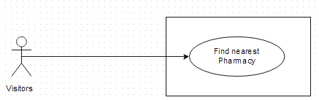

##### Use-case Specification

|  |  |  |  |  |
| --- | --- | --- | --- | --- |
| **UC008 - Specification** | | | | |
| **Use-case No.** | <UC008> | **Use-case Version** | | <1.0> |
| **Use-case Name** | Find Nearest Pharmacy | | | |
| **Author** | Thu NH | | | |
| **Date** | 22/05/2013 | **Priority** | <High > | |
| **Actor:**  Visitor, Pharmacy users, Administrator  **Summary:**  This is one of the main feature of system. Users only need to insert their location into text box, then press search. All registered pharmacy around their location will display on map with the nearest one is highlighted. Look at the map, users can easily find out the way to get there.  **Goal:**  To find the nearest pharmacy around your area or at the location that you want to know  **Triggers**  User click on “Find Nearest Pharmacy” tab on submenu. User must input the right location into “location” text box on “Find nearest pharmacy” screen then click “Search” button  **Preconditions:**  The input location must be in Vietnam  **Post Conditions:**  System still connect to the internet. There must be registered pharmacy at the input location  **Main Success Scenario:**   |  |  |  | | --- | --- | --- | | **Step** | **User** | **System** | | 1 | Click on “Find Nearest Pharmacy” tab | Displays “Find nearest pharmacy” with the text box and search button | | 2 | Insert their location address into text box then press Search button | Displays nearest pharmacy around their place on map | | 3 | Click on the nearest pharmacy icon on map | Show that pharmacy information and the direction to get there |   **Exceptions:**   |  |  |  | | --- | --- | --- | | **At Step** | **User** | **System** | | 3 | Insert location address that do not exist into text box then press Search button | Return error message |   **Business rule:**   * User cannot input more than 250 characters into “Location” text box * Only display accepted pharmacy | | | | |

#### UC009: Register

##### Use Case Diagram

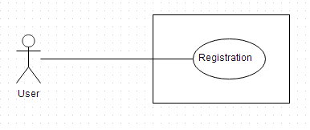

##### Use-case Specification

|  |  |  |  |  |
| --- | --- | --- | --- | --- |
| **UC009 - Specification** | | | | |
| **Use-case No.** | <UC009> | **Use-case Version** | | <1.0> |
| **Use-case Name** | Register | | | |
| **Author** | Thu NH | | | |
| **Date** | 22/05/2013 | **Priority** | <High > | |
| **Actor:**  Pharmacist, who want to use that software for their pharmacies  **Summary:**  Visitor who has pharmacy can create an account to control and public their pharmacy information on that software for another users and visitors know about them. To create account, user must get through 2 steps: insert representative information and insert pharmacy information  **Goal:**  Register an account for representative of a pharmacy  **Triggers**  User click on “Register” tab on submenu. User must have all necessary information of at least one pharmacy to register. After fill all fields of 2 steps, user must click “Complete register” button  **Preconditions:**  All mandatory fields must be filled  **Post Conditions:**  User registers successfully  **Main Success Scenario:**   |  |  |  | | --- | --- | --- | | **Step** | **User** | **System** | | 1 | Click on “Register” tab on submenu | Displays register form | | 2 | Fill all necessary and mandatory information | The system validates the input data | | 3 | Click “Register” button | * The system validates the input data and then save data into database * Go to successful page to inform that user have to confirm it in their email |     **Alternative Scenario:**   |  |  |  | | --- | --- | --- | | **At Step** | **User** | **System** | | 2 | Fill all necessary and mandatory information then click on other feature | Close form and redirect to direct page |   **Exceptions:**   |  |  |  | | --- | --- | --- | | **At Step** | **User** | **System** | | 2 | Insert incorrect information or keep mandatory field blank |  | | 3 | Click “Register” button | Displays Error message beside wrong fields |   **Business rule:**   * User has to input address information as the order: City, District, Street/Village, Number/ Lane * Password must be longer than 8 characters * Mobile number must be longer than 10 numbers | | | | |

#### UC010: View News on web

##### Use Case Diagram

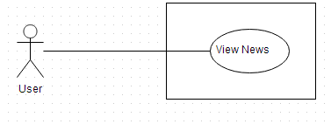

##### Use-case Specification

|  |  |  |  |  |
| --- | --- | --- | --- | --- |
| **UC010 – Specification** | | | | |
| **Use-case No.** | <UC0010> | **Use-case Version** | | <1.0> |
| **Use-case Name** | View news | | | |
| **Author** | Thu NH | | | |
| **Date** | 22/05/2013 | **Priority** | <High > | |
| **Actor:**  Visitor, Pharmacy users, Administrator  **Summary:**  System also supplies medical news to help user be kept up with the newest information about medical. User can view short medical news on News screen of SMD website  **Goal:**  User can up to date medical news directory from that software  **Triggers**  User click on “News” tab on submenu then click on one headline to see the detail of that article  **Preconditions:**  System still connect to the internet  **Post conditions:**  System can display the article in detail  **Main Success Scenario:**   |  |  |  | | --- | --- | --- | | **Step** | **User** | **System** | | 1 | Click on News tab | Displays News screen with some short headline of daily news | | 2 | Clicks on one headline | Shows that article in detail | | | | | |

#### Manage News

##### Use Case Diagram

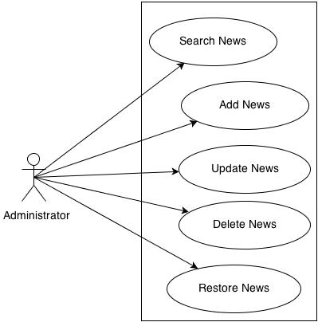

##### Use-case Specification

###### UC0011: Search News

|  |  |  |  |  |
| --- | --- | --- | --- | --- |
| **UC0011 – Specification** | | | | |
| **Use-case No.** | <UC0011> | **Use-case Version** | | <1.0> |
| **Use-case Name** | Search news | | | |
| **Author** | Thu NH | | | |
| **Date** | 22/05/2013 | **Priority** | <High > | |
| **Actor:**  Administrator  **Summary:**  System also supplies medical news to help user be kept up with the newest information about medical. Administrator user can search the list of News to control it  **Goal:**  Administrator can search for the News list  **Triggers**  Administrator click on “Manage News” tab on submenu. User click on “Search News” tab and can input News information into search criteria then click on “Search” button  **Preconditions:**  Input data must be right and it is input into the corrected fields  **Post conditions:**  System can display list of news on search result  **Main Success Scenario:**   |  |  |  | | --- | --- | --- | | **Step** | **User** | **System** | | 1 | Click on “Manage News/ Search News” tab | Displays Search News screen | | 2 | Input data into Search criteria text boxes |  | | 3 | Click on “Search” button | Display the list of corresponding News on search result | | | | | |

#### UC0012: Add News

|  |  |  |  |  |
| --- | --- | --- | --- | --- |
| **UC0012 – Specification** | | | | |
| **Use-case No.** | <UC0012> | **Use-case Version** | | <1.0> |
| **Use-case Name** | Add news | | | |
| **Author** | Thu NH | | | |
| **Date** | 22/05/2013 | **Priority** | <High > | |
| **Actor:**  Administrator  **Summary:**  System also supplies medical news to help user be kept up with the newest information about medical. Administrator user can add medical News into system  **Goal:**  Administrator can add news article to display on News screen successfully  **Triggers**  Administrator click on “Manage News/Add news” tab on submenu. Admin input data into all mandatory field then click “Save” button  **Preconditions:**  Input data must be right and it is input into the corrected fields  **Post conditions:**  System can save new news and display it on News screen  **Main Success Scenario:**   |  |  |  | | --- | --- | --- | | **Step** | **User** | **System** | | 1 | Click on “Manage News/ Add News” tab | Displays “Add News” screen | | 2 | Input data into the correct text boxes |  | | 3 | Click on “Save” button | Save news and display it on News screen | | | | | |

#### UC0013: Update News

|  |  |  |  |  |
| --- | --- | --- | --- | --- |
| **UC0013 – Specification** | | | | |
| **Use-case No.** | <UC0013> | **Use-case Version** | | <1.0> |
| **Use-case Name** | Update News | | | |
| **Author** | Thu NH | | | |
| **Date** | 22/05/2013 | **Priority** | <High > | |
| **Actor:**  Administrator  **Summary:**  System also supplies medical news to help user be kept up with the newest information about medical. To be sure that the information which is provided to customer is the best Administrator user can update medical News if it has some problem  **Goal:**  Administrator can update news article to display on News screen successfully  **Triggers**  Administrator click on “Manage News/Search news” tab on submenu. After find out the news that needs to be edited, admin can click into that article. They can amend data in mandatory field then click “Save” button  **Preconditions:**  Input data must be right and it is input into the corrected fields  **Post conditions:**  System can save updated news and display it on News screen  **Main Success Scenario:**   |  |  |  | | --- | --- | --- | | **Step** | **User** | **System** | | 1 | Click on “Manage News/ Search News” tab | Displays “Search News” screen | | 2 | Search for the news that needs to be edited | Displays list of corresponding news on search result | | 3 | Click into that article | Display “Update News” screen | | 4 | Amend its data in the correct text boxes | Validate the input | | 5 | Click on “Save” button | Save news and display it on News screen | | | | | |

#### UC0014: Delete News

|  |  |  |  |  |
| --- | --- | --- | --- | --- |
| **UC0014 – Specification** | | | | |
| **Use-case No.** | <UC0014> | **Use-case Version** | | <1.0> |
| **Use-case Name** | Delete news | | | |
| **Author** | Thu NH | | | |
| **Date** | 22/05/2013 | **Priority** | <High > | |
| **Actor:**  Administrator  **Summary:**  System also supplies medical news to help user be kept up with the newest information about medical. To be sure that the information which is provided to customer is the best Administrator user can delete medical News if it has some problem  **Goal:**  Administrator can delete news successfully  **Triggers**  Administrator click on “Manage News” tab on submenu. User click on “Search News” tab and can input News information into search criteria then click on “Search” button  **Preconditions:**  Input data must be right and it is input into the corrected fields  **Post conditions:**  System can delete and hide that news on screen  **Main Success Scenario:**   |  |  |  | | --- | --- | --- | | **Step** | **User** | **System** | | 1 | Click on “Manage News/ Search News” tab | Displays “Search News” screen | | 2 | Search for the news that needs to be delete | Displays list of corresponding news on search result | | 3 | Click into that article | Display “Update News” screen | | 4 | Click on “Delete” button | Display popup to ask if user really want to delete that news | | 5 | Click on “Yes” button | Delete news and hide it on News screen |   **Exception:**   |  |  |  | | --- | --- | --- | | **At Step** | **User** | **System** | | 5 | Click on “No” button | Do not delete that news and still display it on News screen | | | | | |

#### UC0015: Restore News

|  |  |  |  |  |
| --- | --- | --- | --- | --- |
| **UC0015 – Specification** | | | | |
| **Use-case No.** | <UC0015> | **Use-case Version** | | <1.0> |
| **Use-case Name** | Restore news | | | |
| **Author** | Thu NH | | | |
| **Date** | 22/05/2013 | **Priority** | <High > | |
| **Actor:**  Administrator  **Summary:**  System also supplies medical news to help user be kept up with the newest information about medical. To be sure that the information which is provided to customer is the best Administrator user can restore medical News  **Goal:**  Administrator can restore news successfully  **Triggers**  Administrator click on “Manage News” tab on submenu. User click on “Search News” tab and can input News information into search criteria, tick on “Deleted” check box then click on “Search” button. Click on “Restore” link beside that news  **Preconditions:**  The news that need to be restored must be deleted before  **Post conditions:**  System can display that news on screen as usual  **Main Success Scenario:**   |  |  |  | | --- | --- | --- | | **Step** | **User** | **System** | | 1 | Click on “Manage News/ Search News” tab | Displays “Search News” screen | | 2 | Tick on “Deleted” check box then search for the news that needs to be restore | Displays list of corresponding news on search result | | 3 | Click on “Restore” link beside the news | Display popup to confirm if user want to restore that news | | 4 | Click on “Yes” button | Restore news and display it on News screen again |   **Exception:**   |  |  |  | | --- | --- | --- | | **At Step** | **User** | **System** | | 4 | Click on “No” button | Do not restore news and still hide it on News screen | | | | | |

#### UC016: Login

##### Use Case Diagram

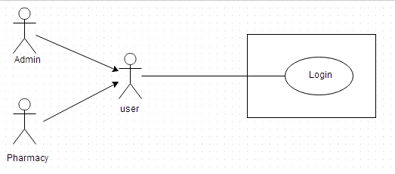

##### Use-case Specification

###### UC016-01: <Admin> Login

|  |  |  |  |  |
| --- | --- | --- | --- | --- |
| **UC016 - Specification** | | | | |
| **Use-case No.** | <UC016> | **Use-case Version** | | <1.0> |
| **Use-case Name** | <Admin> Login | | | |
| **Author** | Thu NH | | | |
| **Date** | 22/05/2013 | **Priority** | <High > | |
| **Actor:**  Administrator  **Summary:**  When Administrator want to do their system controlling work, they must access to system by the username and password that has been set role as admin  **Goal:**  Administrator can log into system successful  **Triggers**  User input username and password correctly in the right text box then click “Login” button  **Preconditions:**  User must have username and password that has been set role as admin to access to system  **Post Conditions:**  User can login successfully as Administrator  **Main Success Scenario:**   |  |  |  | | --- | --- | --- | | **Step** | **User** | **System** | | 1 | Click on “Login” hyperlink on the right top corner | Displays a pop up for Administrator fill their User Name and Password | | 2 | Fill right User Name and Password | The system validates the input data | | 3 | Click “Login” button | Close the pop up and log into system as an Administrator user |     **Alternative Scenario:**   |  |  |  | | --- | --- | --- | | **At** **step** | **User** | **System** | | 3 | Click on Close icon of the pop up | Close the pop up and do not log into system |   **Exceptions:**   |  |  |  | | --- | --- | --- | | **At Step** | **User** | **System** | | 2 | Fill wrong User Name or Password | The system validates the input data | | 3 | Click on “Login” button | Return Error message |   **Business Rule:**   * Username must be input as email full format * Password must be longer than 8 characters | | | | |

###### UC016-02: <Pharmacy user> Login

|  |  |  |  |  |
| --- | --- | --- | --- | --- |
| **UC016-02 - Specification** | | | | |
| **Use-case No.** | <UC0016> | **Use-case Version** | | <1.0> |
| **Use-case Name** | <Pharmacy user> Login | | | |
| **Author** | Thu NH | | | |
| **Date** | 22/05/2013 | **Priority** | <High > | |
| **Actor:**  Pharmacy user  **Summary:**  When pharmacy user wants to log into system to control their data information, they must have username and password that has been set role as pharmacy user to login  **Goal:**  User can log into system successful  **Triggers**  User input username and password correctly in the right text box then click on “Login” button  **Preconditions:**  User must have username and password that has been set role as pharmacy user  **Post Conditions:**  User can login as Pharmacy user and system displays user’s information management screen  **Main Success Scenario:**   |  |  |  | | --- | --- | --- | | **Step** | **User** | **System** | | 1 | Click on “Login” tab | Displays a pop up for user fill their User Name and Password | | 2 | Fill right User Name and Password | The system validates the input data | | 3 | Click “Login” button | Close the pop up and log into system as a Pharmacy user. Display user information management screen |     **Alternative Scenario:**   |  |  |  | | --- | --- | --- | | **At Step** | **User** | **System** | | 3 | Click on Close icon of the pop up | Close the pop up and do not log into system |   **Exceptions:**   |  |  |  | | --- | --- | --- | | **At Step** | **User** | **System** | | 2 | Fill wrong User Name or Password |  | | 3 | Click on “Login” button | Return Error message |   **Business rule:**   * Username must be input as email full format * Password must be longer than 8 characters | | | | |

#### UC017: Log out

##### Use Case Diagram

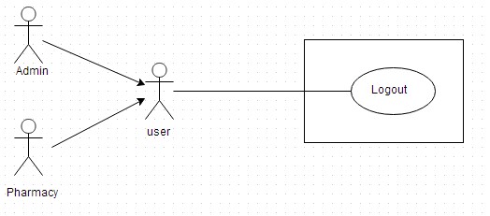

##### Use-case Specification

|  |  |  |  |  |
| --- | --- | --- | --- | --- |
| **UC017 - Specification** | | | | |
| **Use-case No.** | <UC017> | **Use-case Version** | | <1.0> |
| **Use-case Name** | Log out | | | |
| **Author** | Thu NH | | | |
| **Date** | 22/05/2013 | **Priority** | <High > | |
| **Actor:**  Administrator and Pharmacy user  **Summary:**  When users want to finish their system controlling work, they must log out system by click into hyperlink in the right top corner of screen  **Goal:**  Users can log out system successful  **Triggers**  Click on “Log out” hyperlink on right top corner of the page  **Preconditions:**  User has logged in successfully  **Post Conditions:**  Users logout system completely  **Main Success Scenario:**   |  |  |  | | --- | --- | --- | | **Step** | **User** | **System** | | 1 | Have logged into system |  | | 2 | Click on “Log out” link on right top corner of the page | Displays a pop up to confirm if they really want to log out | | 3 | Click “Yes” button | Close the pop up and log out system |   **Alternative Scenario:**   |  |  |  | | --- | --- | --- | | **At Step** | **User** | **System** | | 3 | Click “Close” icon of the pop up | Close the pop up and do not log out system |   **Exceptions:**   |  |  |  | | --- | --- | --- | | **At Step** | **User** | **System** | | 3 | Click “Cancel” button | Close the pop up and do not log out system | | | | | |

#### Manage pharmacy information

##### Use Case Diagram

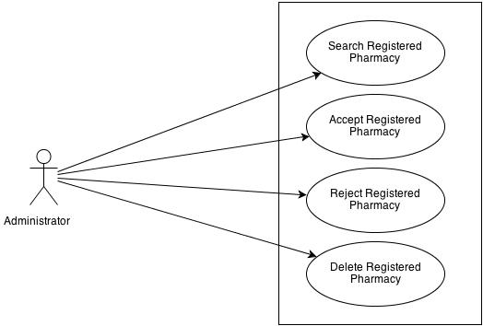

##### Use-case Specification

###### UC0018: <Admin> Search Registered Pharmacy

|  |  |  |  |  |
| --- | --- | --- | --- | --- |
| **UC018 - Specification** | | | | |
| **Use-case No.** | <UC0018> | **Use-case Version** | | <1.0> |
| **Use-case Name** | <Admin> Search registered pharmacy | | | |
| **Author** | Thu NH | | | |
| **Date** | 22/05/2013 | **Priority** | <High > | |
| **Actor:**  Admin  **Summary:**  When Administrator want to look for registered pharmacy information, they have the separate search screen to control pharmacy user data  **Goal:**  Administrator can search pharmacy information successfully if it has been registered  **Triggers**  Click on “Management/ Pharmacy manage” tab, fill pharmacy name into text box then click “Search” button  **Preconditions:**  Input data must be correctly and User has to login as Administrator user  **Post Conditions:**  System must have data of searched pharmacy and can displays detail information of that pharmacy  **Main Success Scenario:**   |  |  |  | | --- | --- | --- | | **Step** | **User** | **System** | | 1 | Have logged into system as an admin |  | | 2 | Click on “Management/ Pharmacy manage” tab | Displays criteria search screen | | 3 | Fill the name of the pharmacy that they want to find into these fields then click “Search” button | Displays search result as a table | | 4 | Click on that pharmacy name | Display “Pharmacy information” screen that contains the information of chosen pharmacy with these elements:   * Pharmacy name * Representative * Phone * Email * Address |   **Alternative Scenario:**   |  |  |  | | --- | --- | --- | | **At Step** | **User** | **System** | | 3 | Fill the name of the pharmacy that they want to find into these fields then click on another link | Switch to selected page |   **Exceptions:**   |  |  |  | | --- | --- | --- | | **At Step** | **User** | **System** | | 3 | Fill the name of the pharmacy that they want to find into these fields (that pharmacy has not registered) then click “Search” button | Return Error message to inform that pharmacy cannot be found | | | | | |

###### UC0019: <Admin> Accept Registered Pharmacy

|  |  |  |  |  |
| --- | --- | --- | --- | --- |
| **UC019 - Specification** | | | | |
| **Use-case No.** | <UC0019> | **Use-case Version** | | <1.0> |
| **Use-case Name** | <Admin> Accept registered pharmacy | | | |
| **Author** | Thu NH | | | |
| **Date** | 22/05/2013 | **Priority** | <High > | |
| **Actor:**  Admin  **Summary:**  When Administrator want to accept for registered pharmacy displays their information on the system  **Goal:**  Pharmacy can register successfully into system  **Triggers**  Click on “Management/ Pharmacy management” tab then search for a pharmacy then tick the check box beside that pharmacy name and click on “Accept” button  **Preconditions:**  Input data must be correctly and User has to login as Administrator user  **Post Conditions:**  Registered pharmacy has been accepted  **Main Success Scenario:**   |  |  |  | | --- | --- | --- | | **Step** | **User** | **System** | | 1 | Have logged into system as an admin |  | | 2 | Click on “Management/ Pharmacy management” tab | Displays criteria search screen | | 3 | Fill the name of the pharmacy that they want to find into these fields then click “Search” button | Displays search result as a table | | 4 | Tick on check box beside the pharmacies that they want to accept |  | | 5 | Click Accept button | Accept these registered pharmacies to have permission to promote their information on that software |     **Alternative Scenario:**   |  |  |  | | --- | --- | --- | | **At Step** | **User** | **System** | | 5 | Click on another link | Switch to selected page. These selected pharmacy has not been accepted |   **Reference:**  UC018 - <Admin> Search Registered Pharmacy | | | | |

###### UC020: <Admin> Delete Registered Pharmacy

|  |  |  |  |  |
| --- | --- | --- | --- | --- |
| **UC020 - Specification** | | | | |
| **Use-case No.** | <UC0020> | **Use-case Version** | | <1.0> |
| **Use-case Name** | <Admin> Delete registered pharmacy | | | |
| **Author** | Thu NH | | | |
| **Date** | 22/05/2013 | **Priority** | <High > | |
| **Actor:**  Admin  **Summary:**  When Administrator want to delete registered pharmacy from the system  **Goal:**  Pharmacy cannot register into system  **Triggers**  Click on “Management/ Pharmacy management” tab then search for a pharmacy then tick the check box beside that pharmacy name and click on “Delete” button  **Preconditions:**  Input data must be correctly and User has to login as Administrator user  **Post Conditions:**  Registered pharmacy has been deleted  **Main Success Scenario:**   |  |  |  | | --- | --- | --- | | **Step** | **User** | **System** | | 1 | Have logged into system as an admin |  | | 2 | Click on “Pharmacy/ Pharmacy management” tab | Displays criteria search screen | | 3 | Fill the name of the pharmacy that they want to find into these fields then click “Search” button | Displays search result as a table | | 4 | Tick on text box beside the pharmacies that they want to delete |  | | 5 | Click Delete button | Delete these pharmacy from system then they do not have permission to promote their information on that software anymore |     **Alternative Scenario:**   |  |  |  | | --- | --- | --- | | **At Step** | **User** | **System** | | 5 | Click on another link | Switch to selected page. These selected pharmacy has not been deleted |   **Reference:**  UC018 - <Admin> Search Registered Pharmacy | | | | |

#### Manage medicine information

##### Use Case Diagram

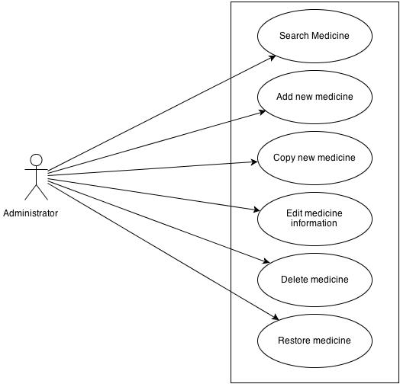

##### User Case Specification

###### UC021: <Admin> Search medicine

|  |  |  |  |  |
| --- | --- | --- | --- | --- |
| **UC021 - Specification** | | | | |
| **Use-case No.** | <UC0021> | **Use-case Version** | | <1.0> |
| **Use-case Name** | <Admin> Search medicine | | | |
| **Author** | Thu NH | | | |
| **Date** | 22/05/2013 | **Priority** | <High > | |
| **Actor:**  Admin  **Summary:**  When Administrator want to search a medicine on database  **Goal:**  Administrator can search medicine information in database successfully if it is existed  **Triggers**  Click on “Management/ Medicine management” tab, input medicine information in the right text box then click “Search” button  **Preconditions:**  Input data must be correctly and User has to login as Administrator user  **Post Conditions:**  Displays medicine detail information  **Main Success Scenario:**   |  |  |  | | --- | --- | --- | | **Step** | **User** | **System** | | 1 | Have logged into system as an admin |  | | 2 | Click on “Medicine/ Medicine Advanced Search ” tab | Displays criteria search screen | | 3 | Fill information of the medicine that they want to find into these fields then click “Search” button | Displays search result as a table | | 4 | Click on that medicine name | Display “Medicine information” screen that contains the information of chosen medicine with these elements:   * Medicine name * Contraindicated * Dosing and Using * Ingredient * Manufacture * Package |     **Alternative Scenario:**   |  |  |  | | --- | --- | --- | | **At Step** | **User** | **System** | | 3 | Fill information of the medicine that they want to find into these fields then click on another link | Switch to selected page |   **Exceptions:**   |  |  |  | | --- | --- | --- | | **At Step** | **User** | **System** | | 3 | Fill information of the medicine that they want to find (that do not exited in database) into these fields then click “Search” button | Return Error message to inform that medicine cannot be found | | | | | |

###### UC022: <Admin> Add New medicine

|  |  |  |  |  |
| --- | --- | --- | --- | --- |
| **UC022 - Specification** | | | | |
| **Use-case No.** | <UC0022> | **Use-case Version** | | <1.0> |
| **Use-case Name** | <Admin> Add new medicine | | | |
| **Author** | Thu NH | | | |
| **Date** | 22/05/2013 | **Priority** | <High > | |
| **Actor:**  Admin  **Summary:**  When Administrator want to add a medicine into database. They have to insert all necessary data of medicine into “Medicine add new” screen  **Goal:**  Administrator can add new medicine information in database successfully  **Triggers**  User must click on “Medicine/ Add new” tab and input all necessary information of medicine into the right fields then click on “Save” button  **Preconditions:**   * User have logged into system as an admin. * All mandatory fields have been filled * All input data must be valid and have not existed in system   **Post Conditions:**  New medicine has been saved into system database successfully  **Main Success Scenario:**   |  |  |  | | --- | --- | --- | | **Step** | **User** | **System** | | 1 | Have logged into system as an admin |  | | 2 | Click on “Medicine/ Add new” tab | Display “Add New” screen that contains these elements:   * Medicine name * Contraindicated * Dosing and Using * Ingredient * Manufacture * Package | | 3 | Fill medicine information into all necessary or mandatory fields |  | | 4 | Click “Save” button | The system validates the input data and then save new medicine data into database |     **Alternative Scenario:**   |  |  |  | | --- | --- | --- | | **At Step** | **User** | **System** | | 4 | Click on another link | Do not save new medicine data into database then redirect to selected page |   **Exceptions:**   |  |  |  | | --- | --- | --- | | **At Step** | **User** | **System** | | 4 | Click “Save” button | Return Error message beside invalid value and do not save data into database | | | | | |

###### UC023: <Admin> Copy New medicine

|  |  |  |  |  |
| --- | --- | --- | --- | --- |
| **UC023 - Specification** | | | | |
| **Use-case No.** | <UC0023> | **Use-case Version** | | <1.0> |
| **Use-case Name** | <Admin> Copy new medicine | | | |
| **Author** | Thu NH | | | |
| **Date** | 22/05/2013 | **Priority** | <High > | |
| **Actor:**  Admin  **Summary:**  When Administrator want to add a medicine on database which has some similar information to an existed medicine  **Goal:**  Administrator can add new medicine information in database successfully  **Triggers**  User must click on “Medicine/ Medicine Advanced Search ” then search for the medicine that they want to copy and amend necessary information of medicine in the right fields then click on “Save” button  **Preconditions:**   * User have logged into system as an admin. * All mandatory fields have been filled * All input data must be valid and have not existed in system   **Post Conditions:**  New medicine has been saved into system database successfully  **Main Success Scenario:**   |  |  |  | | --- | --- | --- | | **Step** | **User** | **System** | | 1 | Have logged into system as an admin |  | | 2 | Click on “Medicine/ Medicine Advanced Search ” then search for the medicine that they want to copy | Displays search result as a table | | 3 | Click on “Copy New” button beside that medicine row | Display “Add New” screen that contains the information of chosen medicine with these elements:   * Medicine name * Contraindicated * Dosing and Using * Ingredient * Manufacture * Package | | 4 | Edit medicine information |  | | 5 | Click “Save” button | The system validates the input data and then save data into database |     **Alternative Scenario:**   |  |  |  | | --- | --- | --- | | **At Step** | **User** | **System** | | 4 | Edit medicine information then click to another link | Do not save edited data then redirect to selected page |   **Exceptions:**   |  |  |  | | --- | --- | --- | | **At Step** | **User** | **System** | | 4 | Edit medicine information to be similar to another existed medicine |  | | 5 | Click “Save” button | The system validates the input data and return Error message and do not save edited data into database |   **Reference:**  UC021 - <Admin> Search Medicine | | | | |

###### UC024: <Admin> Edit medicine

|  |  |  |  |  |
| --- | --- | --- | --- | --- |
| **UC024 - Specification** | | | | |
| **Use-case No.** | <UC0024> | **Use-case Version** | | <1.0> |
| **Use-case Name** | <Admin> Edit medicine | | | |
| **Author** | Thu NH | | | |
| **Date** | 22/05/2013 | **Priority** | <High > | |
| **Actor:**  Admin  **Summary:**  When Administrator want to edit a medicine on database  **Goal:**  Administrator can change that medicine information in database successfully  **Triggers**  User must click on “Medicine/ Medicine Advanced Search ” then search for the medicine that they want to edit and amend necessary information of medicine in the right fields then click on “Save” button  **Preconditions:**   * User have logged into system as an admin. * All mandatory fields have been filled * All input data must be valid and have existed in system   **Post Conditions:**  Changed information of medicine has been saved into system database successfully  **Main Success Scenario:**   |  |  |  | | --- | --- | --- | | **Step** | **User** | **System** | | 1 | Have logged into system as an admin |  | | 2 | Click on “Medicine/ Medicine Advanced Search ” then search for the medicine that they want to edit | Displays search result as a table | | 3 | Click on Edit button beside that medicine row | Display “Medicine information” screen that contains the information of that medicine with these elements:   * Medicine name * Contraindicated * Dosing and Using * Ingredient * Manufacture * Package | | 4 | Edit medicine information |  | | 5 | Click “Save” button | The system validates the input data and then save edited data into database |     **Alternative Scenario:**   |  |  |  | | --- | --- | --- | | **At Step** | **User** | **System** | | 4 | Edit medicine information then click to another link | Do not save edited data then redirect to selected page |   **Exceptions:**   |  |  |  | | --- | --- | --- | | **At Step** | **User** | **System** | | 4 | Edit medicine information to be similar to another existed medicine |  | | 5 | Click “Save” button | The system validates the input data and then return Error message and do not save edited data into database |   **Reference:**  UC0021 - <Admin> Search Medicine | | | | |

###### UC025: <Admin> Delete medicine

|  |  |  |  |  |
| --- | --- | --- | --- | --- |
| **UC025 - Specification** | | | | |
| **Use-case No.** | <UC0025> | **Use-case Version** | | <1.0> |
| **Use-case Name** | <Admin> Delete medicine | | | |
| **Author** | Thu NH | | | |
| **Date** | 22/05/2013 | **Priority** | <High > | |
| **Actor:**  Admin  **Summary:**  When Administrator want to delete a medicine on database  **Goal:**  Administrator can change that medicine’s delete flag to “1”in database successfully  **Triggers**  User must click on “Medicine/ Medicine Advanced Search ” then search for the medicine that they want to delete and tick on check box beside medicine name then click on “Delete” button  **Preconditions:**   * User have logged into system as an admin. * All mandatory fields have been filled * All input data must be valid and have existed in system   **Post Conditions:**  Medicine has been deleted from system database successfully  **Main Success Scenario:**   |  |  |  | | --- | --- | --- | | **Step** | **User** | **System** | | 1 | Have logged into system as an admin |  | | 2 | Click on “Medicine/ Medicine Advanced Search ” then search for the medicine that they want to edit | Displays search result as a table | | 3 | Click on “Delete” button beside that medicine row | Displays pop up to confirm if they really want to remove that medicine | | 4 | Click “Yes” button on popup | Closes the popup then remove that medicine name from medicine list |     **Alternative Scenario:**   |  |  |  | | --- | --- | --- | | **At Step** | **User** | **System** | | 4 | Click close icon of the popup | Only closes the popup, does not remove that medicine |   **Exceptions:**   |  |  |  | | --- | --- | --- | | **At Step** | **User** | **System** | | 4 | Click “Cancel” button on popup | Only closes the popup, does not remove that medicine |   **Reference:**  UC021 - <Admin> Search Medicine | | | | |

###### UC026: <Admin> Restore medicine

|  |  |  |  |  |
| --- | --- | --- | --- | --- |
| **UC026 - Specification** | | | | |
| **Use-case No.** | <UC0026> | **Use-case Version** | | <1.0> |
| **Use-case Name** | <Admin> Restore medicine | | | |
| **Author** | Thu NH | | | |
| **Date** | 22/05/2013 | **Priority** | <High > | |
| **Actor:**  Admin  **Summary:**  When Administrator want to restore a deleted medicine on database  **Goal:**  Administrator can change that medicine’s delete flag to “0”in database successfully  **Triggers**  User must click on “Medicine/ Medicine Advanced Search”. Tick on “Deleted” check box then search for the medicine that they want to restore and tick on check box beside medicine name then click on “Restore” button  **Preconditions:**   * User have logged into system as an admin. * All mandatory fields have been filled * All input data must be valid and have been deleted from system   **Post Conditions:**  Deleted medicine has been restored in system database successfully  **Main Success Scenario:**   |  |  |  | | --- | --- | --- | | **Step** | **User** | **System** | | 1 | Have logged into system as an admin |  | | 2 | Click on “Medicine/ Medicine Advanced Search ” tab | Displays “Medicine Advanced Search” page | | 3 | Tick on Delete flag then search for the medicine that they want to edit | Displays search result as a table | | 3 | Click on “Restore” button beside that medicine row | Displays pop up to confirm if they really want to restore that medicine | | 4 | Click “Yes” button on popup | Closes the popup then restore that medicine name in medicine list |     **Alternative Scenario:**   |  |  |  | | --- | --- | --- | | **At Step** | **User** | **System** | | 4 | Click close icon of the popup | Only closes the popup, does not remove that medicine |   **Exceptions:**   |  |  |  | | --- | --- | --- | | **At Step** | **User** | **System** | | 4 | Click “Cancel” button on popup | Only closes the popup, does not remove that medicine |   **Business Rule:**  Medicine can only be restored if there is no similarly medicine existed  **Reference:**  UC0025 - <Admin> Delete medicine | | | | |

#### Account control

##### Use Case Diagram

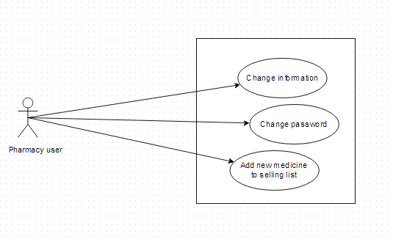

##### Use-case Specification

###### UC027: <Pharmacy user> Change Information

|  |  |  |  |  |
| --- | --- | --- | --- | --- |
| **UC027 - Specification** | | | | |
| **Use-case No.** | <UC0027> | **Use-case Version** | | <1.0> |
| **Use-case Name** | <Pharmacy user> Change information | | | |
| **Author** | Thu NH | | | |
| **Date** | 22/05/2013 | **Priority** | <High > | |
| **Actor:**  Pharmacy user  **Summary:**  When user want to change their registered information  **Goal:**  User can change the information that have permission to change  **Triggers**  Click on User name link on right top corner of page. System displays User information screen. Click on “Change information” button then amend information. Click “Save” button  **Preconditions:**  All mandatory fields must be filled and User have logged into system as a pharmacy user  **Post Conditions:**  The new information has been saved successfully  **Main Success Scenario:**   |  |  |  | | --- | --- | --- | | **Step** | **User** | **System** | | 1 | Have logged into system as an user |  | | 2 | Click on User name link on right top corner of page | Displays User information screen | | 3 | Click on “Change information” button | Display Change information screen | | 4 | Type new information into text fields (validate) |  | | 5 | Click on “Save” button | The system validates the input data and then save new information into database |   **Exceptions:**   |  |  |  | | --- | --- | --- | | **At Step** | **User** | **System** | | 4 | Type new information into text fields (invalidate) |  | | 5 | Click on “Save” button | The system validates the input data and then displays error message beside wrong fields | | | | | |

###### UC028: <Pharmacy user> Change password

|  |  |  |  |  |
| --- | --- | --- | --- | --- |
| **UC028 - Specification** | | | | |
| **Use-case No.** | <UC0028> | **Use-case Version** | | <1.0> |
| **Use-case Name** | <Pharmacy user> Change password | | | |
| **Author** | Thu NH | | | |
| **Date** | 22/05/2013 | **Priority** | <High > | |
| **Actor:**  Pharmacy user  **Summary:**  When user want to change their register password or when they forgot their password, they can offer to a new one right after access to login feature  **Goal:**  User can change their password successfully  **Triggers**  1. User has accessed to SMD website. Click on “Login” tab then click on “Do not remember password”. Insert their registered email then click “Send” button  2. User login to system then click on “Change password” link on the right top corner of the page. Insert current password then insert new password that is validate then click “Save” button  **Preconditions:**   * Users have to remember their registered email * If user change password after login, new password must be valid   **Post Conditions:**  Password has been changed successfully  **Main Success Scenario:**   |  |  |  | | --- | --- | --- | | **Step** | **User** | **System** | | 1 | Have logged into system as an user |  | | 2 | Click on “Change password” link on the right top corner of the page | Switches to “Change password” page | | 3 | Insert current password then insert new password that is validate | The system validates the input data | | 4 | Click “Finish” button | Display successful page with message to inform user that new password can be used after being confirm by admin |     **Alternative Scenario:**   |  |  |  | | --- | --- | --- | | **At Step** | **User** | **System** | | 1 | Click on “Login” hyperlink on the right top corner |  | | 2 | Click on “Forget password” link | Switches to “Change password” page | | 3 | Insert their registered email then click “Send” button | The system validates the input data and sends new password to that email | | 4 | Use that new email to login system | Login successfully |     **Exceptions:**   |  |  |  | | --- | --- | --- | | **At Step** | **User** | **System** | | 1 | Have logged into system as an user |  | | 2 | Click on “Change password” link on the right top corner of the page | Switches to “Change password” page | | 3 | Insert current password then insert new password that is invalid | The system validates the input data and then displays error message beside wrong value | | 4 | Click “Finish” button | Displays successful page with message to inform user that new password can be used after being confirm by admin | | | | | |

###### UC029: <Pharmacy user> Add new medicine into pharmacy’s sell list

|  |  |  |  |  |
| --- | --- | --- | --- | --- |
| **UC0029 - Specification** | | | | |
| **Use-case No.** | <UC0029> | **Use-case Version** | | <1.0> |
| **Use-case Name** | <Pharmacy user> Add new medicine into pharmacy’s selling list | | | |
| **Author** | Thu NH | | | |
| **Date** | 22/05/2013 | **Priority** | <High > | |
| **Actor:**  Pharmacy user  **Summary:**  When user want to add a new medicine into their selling list, they can control their selling list right in their manage information tab  **Goal:**  User can add medicine information into database  **Triggers**  After login system, user click on “Manage” tab on submenu then click on “Selling list” tab and click on “Add new” button. User search for a medicine then tick on check box beside it and click on “Add” button  **Preconditions:**   * Medicine in selling list must have data information in SMD system * User have logged into system as a pharmacy user   **Post Conditions:**  Medicine can be added into pharmacy selling list successfully  **Main Success Scenario:**   |  |  |  | | --- | --- | --- | | **Step** | **User** | **System** | | 1 | Have logged into system as a pharmacy user |  | | 2 | Click on Manage tab on submenu | Display Manage screen with representative information and pharmacy list of that user | | 3 | Click on one pharmacy name | Display screen with 2 tabs: Pharmacy information and “Selling list” | | 4 | Click on “Selling list” tab | Display screen that is similar to advanced search screen to look for list of medicine which are selling in that pharmacy. On the bottom of screen, there is “add new” button | | 5 | Click on “Add new” button | Display new screen with 2 tabs: Search medicine, add new | | 6 | Click on Search medicine | Display tab content that has similar format to Quick search screen to look for the existed medicine on system | | 7 | Search for the medicine that need to be added. Tick on the check box beside it then click on “Add” button | Add that medicine name into Selling list of that pharmacy |     **Alternative Scenario:**   |  |  |  | | --- | --- | --- | | **At Step** | **User** | **System** | | 6 | Click on “Add new” tab | Display Add new screen that has similar format to admin’s screen | | 7 | Fill all necessary information then click “Save” button | The system validates the input data and then save that medicine information into database and add its name into Selling list of that pharmacy |   **Exception**:   |  |  |  | | --- | --- | --- | | **At Step** | **User** | **System** | | 6 | Click on “Search medicine” tab | Display the screen that have similar format to Quick search screen | | 7 | Search for the medicine that need to be added (That medicine name does not exist in database) | Return warning message that data not found and display “Add brand new” button |   **Reference:**  UC005 - Quick search  UC016 - <Admin> Add new medicine | | | | |

### Non-functional Specification

#### User interface

**a. Arrangement**

SDM will have 4 areas: Banner, Submenu, Content, Contact and information

* The banner will display on the top of the page and contain: SDM icon and name of the program
* Elements in Submenu will change as role of user
* Content displays below submenu and change interface as feature users have chosen
* Contact and information will display on the bottom of page and contain necessary information to help user to contact administrators in need

**b. Color**

The system has been designed to use less and simple color to make the page be fresh and clearly to user. Users can easily notice what they want

**c. Text**

All text bases on Tahoma style. Their size and font style will rely on their type, their function. The text style will be divided into some specific types to make the website be unified

#### Hardware Requirements

All data and applications installed at the servers, so it should be required the best equipment. When equipped servers, it is necessary to pay attention to the following element:

* **Configuration suggestions:**

|  |  |  |  |
| --- | --- | --- | --- |
| **#** | **Name** | **Configuration** | **Description** |
| **1** | **Application Server** | RAM: 2GB  Hard disk: 150GB  Chipset: Core 2 Dual 2.0 GHz | Server for application server to deploy web application with the minimum configuration |
| **2** | **Client** | RAM:2GB Hard disk: 150GB Chipset: Core 2 Dual 2.0 GHz | Notebooks for developing/testing with the minimum configuration |
| **3** | **Mobile device** | RAM: 1 GB  Hard disk: 32GB  Chip 1.5GHz Core 4-PLUS-1 Quad | Mobile installed application with configuration |

* **Configured transmission line:** Depending on the actual topography of each deployment environment that function setting up the network will be able to use copper cable, optical cable or wireless.

#### Software Requirements

|  |  |  |
| --- | --- | --- |
| **Software name** | **Version** | **Source** |
| Firefox | 20 | Mozilla |
| Chrome | 28.0.1500.72 | Google |
| Internet explore | 9 | Microsoft |
| Android | Upper from 2.3 | Google |
| Operating System: Microsoft® Windows 7 | 2007 | Microsoft |
| .Net Framework | 4.0 | Microsoft( used to setup MySQL) |
| DBMS: MySQL Workbench | 5.6.11.0 | Oracle |
| IDE: Eclipse Indigo | indigo-SR1-win32 | Eclipse |
| Strut | 2 | Apache |
| Spring | 3 | Spring |
| Hibernate | 3 | Hibernate |

**Table 4-1:** Software requirement

#### Reliability

* The database must be backed up daily and can be recovered if necessary
* Mean time between failures (MTBF): The mean time between each failure is expected to be about 480 hours (20 days) of using.
* Mean time to repair (MTTR): Immediately when Administrator finds out problem or website is attacked by someone. Average 1 day.
* The maximum bugs per function are 2 bugs/a function when user uses software within 2 months. The average number of bugs in the software during system testing is about to be around 0.5 bugs/1000LOC.

| **Bug** | **Definition** |
| --- | --- |
| Minor | Bugs related to GUI |
| Significant | Bugs related to minor business logic |
| Critical | Function can’t execute correctly, completely loss of data, disconnect to the server |

**Table 4.1 –** Bugs or Defect Rate

#### Availability

The available time is approximately 99% and must be available 24 hours a day, 7 days a week, besides user must have the ability to access website by any web browser in his or her computers or mobile devices.

#### Security

In order to avoid unwanted access by strangers, the security implemented in various ways:

* **User layer:** Each pharmacy representative must be distributed system access and manipulate the individual parts. To edit information, user must declare their usename and password before the operation. Functions will be shown after users login dependencies user’s role and permission of each user.
* **Manage Data Layer:** Only Administrator can modify database system.
* **Stored Data:** All data about information of user, medicine, pharmacy, and news will be saved in My SQL Server, and be easy for data classification or backup.

#### Maintainability

* **Coding standards and naming conventions**
  + Output of the project must include coding standards and naming conventions documentations. Implementation code must be easy to maintain.
  + All code must be clearly commented, including class, method documentations.
  + If some components are reused, the documentations of those components must also be included.
* **Design**
  + The design of the system must be loosely coupled that chances on some module will not affect others.
* **Logging**
  + All the errors should be logged, supporting for bug fixing and maintenance.
  + All strange or sensitive situations should also be logged.

#### Portability

* Website can be deployed on Windows.
* Mobile version can be used in all devices which run on Android version 2.3 or higher

#### Performance

In term of response time, the maximum time for accessing any page will be 2 to 5 seconds when the processing of search function will not exceed 5 seconds. However, it also depends on the internet bandwidth the network coverage‘s condition.

The internet band width is 10 GB/month

The configuration of application servers and clients meets the defined requirements in section 4.4.2.

And the are about 100,000 medicines and 20,000 pharmacy in database.

### Entity Relationship Diagram or Data Structures

#### Entity Relationship Diagram

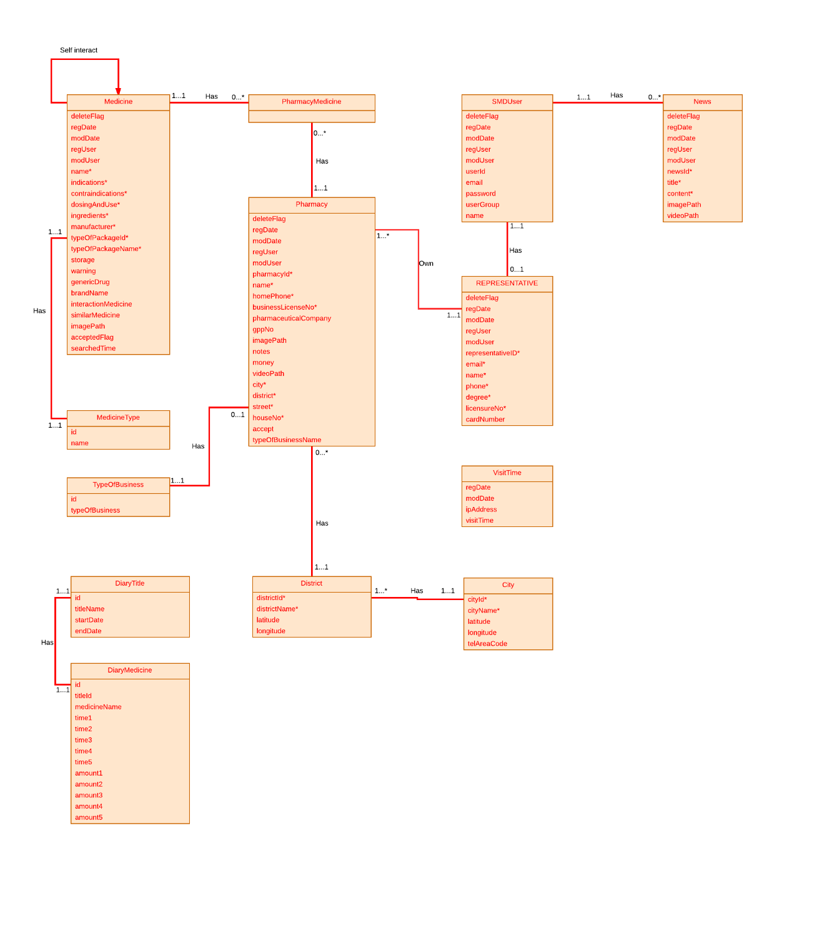

**Figure 4-2:** Entity relationship diagram

#### Entity Detail

##### Medicine

|  |  |  |  |
| --- | --- | --- | --- |
| Attribute | Type | Mandatory | Description |
| Medicine ID | Number | PK, Y | The primary key auto generated by the system |
| Delete Flag | String | Y | Marked deleted |
| Register Date | Date | Y | Date register medicine |
| Modify Date | Date | Y | Date modify medicine |
| Register User | String | Y | User register medicine |
| Modify User | String | N | User modify medicine |
| Pharmacy ID | Number | Y (FK) | Number of pharmacy |
| Name | String | Y | Name of medicine |
| Indications | String | Y | Indication of medicine |
| Contraindications | String | Y | Contraindications of medicine |
| Dosing And Use | String | Y | Dosing and use of medicine |
| Ingredients | String | Y | Ingredients of medicine |
| Manufacturer | String | Y | Manufacturer of medicine |
| TypeOfPackageID | Number | Y | Type of package id of medicine |
| TypeOfPackageName | String | Y | Type of package name of medicine |
| Storage | String | N | Storage medicine |
| Warning | String | N | Warning of medicine |
| Generic Drug | String | N | Name generic of medicine |
| Brand Name | String | N | Brand name of medicine |
| Interaction Medicine | String | N | Interaction of medicine |
| Similar Medicine | String | N | Name of similar medicine |
| Image Path | String | Y | Path to image of medicine |
| Accepted Flag | String | N | Marked accepted |
| Search Time | String | N | Time to search |

##### Pharmacy

|  |  |  |  |
| --- | --- | --- | --- |
| Attribute | Type | Mandatory | Description |
| Pharmacy ID | Number | PK, Y | The primary key auto generated by the system |
| Delete Flag | String | Y | Marked deleted |
| Register Date | Date | Y | Date register medicine |
| Modify Date | Date | Y | Date modify medicine |
| Register User | String | Y | User register medicine |
| Modify User | String | N | User modify medicine |
| Name | String | Y | Name of pharmacy |
| Home Phone | Number | Y | Home phone number of pharmacy |
| Business License No | String | Y | Number business license of pharmacy |
| Pharmaceutical Company | String | N | Name of pharmaceutical company |
| Gpp No | String | N | Number of GPP |
| Notes | String | N | Notes about pharmacy |
| Money | String | N | Money of pharmacy |
| Image Path | String | Y | Path to image of pharmacy |
| Video Path | String | Y | Path to video of pharmacy |
| Representative ID | Number | Y | ID of representative |
| City | String | Y | City of pharmacy |
| District | String | Y | District of pharmacy |
| City ID | Number | Y | ID of city |
| District ID | Number | Y | ID of district |
| Street | String | Y | Street of pharmacy |
| House No | String | Y | Number house of pharmacy |
| Latitude | String | N | Latitude of pharmacy |
| Longitude | String | N | Longitude of pharmacy |
| Accepted Flag | String | N | Marked accepted |
| Searched Time | String | N | Time to search |
| TypeOfBusinessName | String | Y | Name of type business |

##### PharmacyMedicine

|  |  |  |  |
| --- | --- | --- | --- |
| Attribute | Type | Mandatory | Description |
| Pharmacy ID | Number | Y | ID of pharmacy |
| Medicine ID | Number | Y | ID of medicine |

##### SMD User

|  |  |  |  |
| --- | --- | --- | --- |
| Attribute | Type | Mandatory | Description |
| Delete Flag | String | Y | Marked deleted |
| Register Date | Date | Y | Date register medicine |
| Modify Date | Date | Y | Date modify medicine |
| Register User | String | Y | User register medicine |
| Modify User | String | N | User modify medicine |
| Email | String | Y | Email of User |
| Password | String | Y | Password of User |
| User Group | String | Y | Group of User |

##### Representative

|  |  |  |  |
| --- | --- | --- | --- |
| Attribute | Type | Mandatory | Description |
| Delete Flag | String | Y | Marked deleted |
| Register Date | Date | Y | Date register medicine |
| Modify Date | Date | Y | Date modify medicine |
| Register User | String | Y | User register medicine |
| Modify User | String | N | User modify medicine |
| Representative ID | Number | Y | Id of representative |
| Email | String | Y | Email of representative |
| Name | String | Y | Name of representative |
| Phone | Number | Y | Phone of representative |
| Degree | String | Y | Degree of representative |
| Licensure No | Number | Y | Licensure number of representative |
| Card Number | String | Y | Number card of representative |

##### Medicine Type

|  |  |  |  |
| --- | --- | --- | --- |
| Attribute | Type | Mandatory | Description |
| ID | Number | Y | Id of medicine type |
| Name | String | Y | Name of medicine type |

##### City

|  |  |  |  |
| --- | --- | --- | --- |
| Attribute | Type | Mandatory | Description |
| City ID | Number | Y | Id of City |
| City Name | String | Y | Name of city |
| Latitude | String | Y | Latitude of city |
| Longitude | String | Y | Longitude of city |
| Tel area code | String | y | Tel area code of city |

##### District

|  |  |  |  |
| --- | --- | --- | --- |
| Attribute | Type | Mandatory | Description |
| District ID | Number | Y | Id of District |
| District Name | String | Y | Name of District |
| Latitude | String | Y | Latitude of district |
| Longitude | String | Y | Longitude of district |
| City ID | Number | Y | ID of City |

##### News

|  |  |  |  |
| --- | --- | --- | --- |
| Attribute | Type | Mandatory | Description |
| Delete Flag | String | Y | Marked deleted |
| Register Date | Date | Y | Date register medicine |
| Modify Date | Date | Y | Date modify medicine |
| Register User | String | Y | User register medicine |
| Modify User | String | N | User modify medicine |
| News ID | Number | Y | Id of News |
| Title | String | Y | Title of News |
| Content | String | Y | Content of News |
| Image Path | String | Y | Path to image of News |
| Video Path | String | Y | Path to video of News |

##### Type Of Business

|  |  |  |  |
| --- | --- | --- | --- |
| Attribute | Type | Mandatory | Description |
| ID | Number | Y | ID of type |
| Type Of Business | String | Y | Type of business |

##### Visit Time

|  |  |  |  |
| --- | --- | --- | --- |
| Attribute | Type | Mandatory | Description |
| Register Date | Date | Y | Date register |
| Modify Date | Date | Y | Date modify |
| IP Address | String | Y | IP of address |
| Visit Time | String | Y | Time to visit |

##### Diary Title

|  |  |  |  |
| --- | --- | --- | --- |
| Attribute | Type | Mandatory | Description |
| ID | Number | Y | ID of diary |
| Title Name | String | Y | Name of title diary |
| Start Date | Date | N | Start Date of diary |
| End Date | Date | N | End Date of diary |

##### Diary Medicine

|  |  |  |  |
| --- | --- | --- | --- |
| Attribute | Type | Mandatory | Description |
| Medicine ID | Number | Y | ID of medicine |
| Title ID | Number | Y | ID of title |
| Time1 | String | N | Time use medicine |
| Time2 | String | N | Time use medicine |
| Time3 | String | N | Time use medicine |
| Time4 | String | N | Time use medicine |
| Time5 | String | N | Time use medicine |
| Amount1 | String | N | Amount medicine to use |
| Amount2 | String | N | Amount medicine to use |
| Amount3 | String | N | Amount medicine to use |
| Amount4 | String | N | Amount medicine to use |
| Amount5 | String | N | Amount medicine to use |

**Report #4:**

**SOFTWARE DESIGN DOCUMENT**

# Architecture Design

## Choice of Architecture Design

The main function of SMD system provides users the ability to search medicine, pharmacy by name even advanced search by many criteria. SMD system needs to listen to user’s request and retrieve appropriate data from the data storage and display it for the user. The system is structured basing on MVC combined with multi-tier layers architecture. In addition, the system is built based on the integration of three frameworks: Struts2, Spring3 and Hibernate3. The all functions on the mobile are made through web server that is built by integrate JAX – WS standard and Spring framework. Therefore, the most suitable architecture model for this system is combined by the MVC model and three – tier model.

### MVC model overview

#### What is the MVC

MVC stands for model – view – controller pattern. Trygve Reenskaug introduced MVC into Smalltalk-76 while visiting Xeroc Parc, in the 70s; next, in the 80s, Jim Althoff and others implemented a version of MVC for the Smalltalk-80 class library. Only later MVC was expressed as a general concept, in a 1988 article.

MVC is a software architecture pattern which separates the representation of information from user’s interaction with it. The model consists of application data, business rules, logic and functions. A view can be any output representation of data, such as a chart or a diagram. Multiple views of the same data are possible, such as bar chart for management and a tabular view for accountants. The controller mediates input, converting it to commands for the model or view. The central ideas behind MVC are code reusability and separation of concerns.

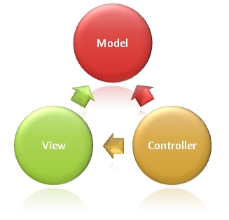

**Figure 4-1:** MVC Model

In addition to dividing the application into three kinds of components, the MVC design defines the interactions between them:

* **A controller:** can send commands to its associated view to change the view's presentation of the model (e.g., by scrolling through a document). It can also send commands to the model to update the model's state (e.g., editing a document).
* **A model:** notifies its associated views and controllers when there has been a change in its state. This notification allows the views to produce updated output, and the controllers to change the available set of commands. A *passive* implementation of MVC omits these notifications, because the application does not require them or the software platform does not support them.
* **A view:** requests from the model the information that it needs to generate an output representation to the user.

#### Advantages and disadvantages

* **Advantages:** the MVC model demonstrates professionalism in programming and design analysis. It is divided into independent components to help develop applications faster, simpler, easier upgrades and maintenance.
* **Disadvantages:** for small projects applying MVC model caused cumbersome, time consuming in development process. Time consuming to transits data between components.

#### The reason of choosing MVC model

* The first thing is that it fits the pattern of SMD systems: receive request from the user, call appropriate action, retrieve data and display on view for the user.
* Easily manage the complexity of application by dividing the application into three components: model, view and controller.
* Better support for test driven development.
* SMD system uses struts 2 framework.
* SMD system is not complete system, now. We built the system that towards extensibility and maintainability in the future.
* It is good support for application built by project team has many developers and designers but still managed application features.

### Three – tier model overview

#### What is the three – tier model

A three – tier architecture is a client-server architecture in which the functional process logic, data access, computer data storage and user interface are developed and maintained as independent modules on separate platforms. Three-tier architecture is a software design pattern and a well – established software architecture. Its three tiers are the presentation tier, application tier and data tier.

It was developed by John J. Donovan in Open Environment Corporation (OEC), a tools company he founded in Cambridge, Massachusetts.

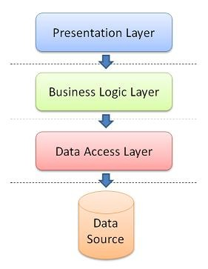

**Figure 4-2:** Three – tier model

* **Presentation Tier:** This is the topmost level of the application. The presentation tier displays information related to services. It communicates with other tiers by outputting results to the browser/client tier and all other tiers in the network. (In simple terms it's a layer which users can access directly such as a web page, or an operating systems GUI).
* **Business Logic Tier:** Also called the middle tier, logic tier or application tier, this tier is pulled from the presentation tier. It controls application functionality by performing detailed processing.
* **Data tier:** This tier consists of database servers. Here information is stored and retrieved. This tier keeps data neutral and independent from application servers or business logic. Giving data its own tier also improves scalability and performance.

#### Advantages and disadvantages

**Advantages:**

* Managing data is independent from the physical storage.
* Migration to new graphical environments is faster.
* It is possible to make changes on the presentation level without affecting the other two (business or data access layer).
* As each tier is independent it is possible to use different sets of developers.
* Since the client doesn’t have direct access to the database business logic is more secure.
* When one tier fails there is no data loss, because you are always secure by accessing the other tier.

**Disadvantages:**

* It is more complex structure.
* More difficult to set up and maintain it as well.
* The physical separation of the tiers may affect the performance between the three.
* It is more difficult to build a 3-tier application.

#### The reason of choosing three – tier model

* The SMD system is integrated by three frameworks Struts 2, Spring 3 and Hibernate 3. Struts 2 presents presentation layer, Spring presents business logic layer and Hibernate presents data access layer.
* Some modules need to reuse shared business logic layer.
* Functions on mobile are performed through webserver based on client – server model.
* Need to make the application that is easy to maintain. So, presentation can change without affecting the other two.

## Architectural Presentation

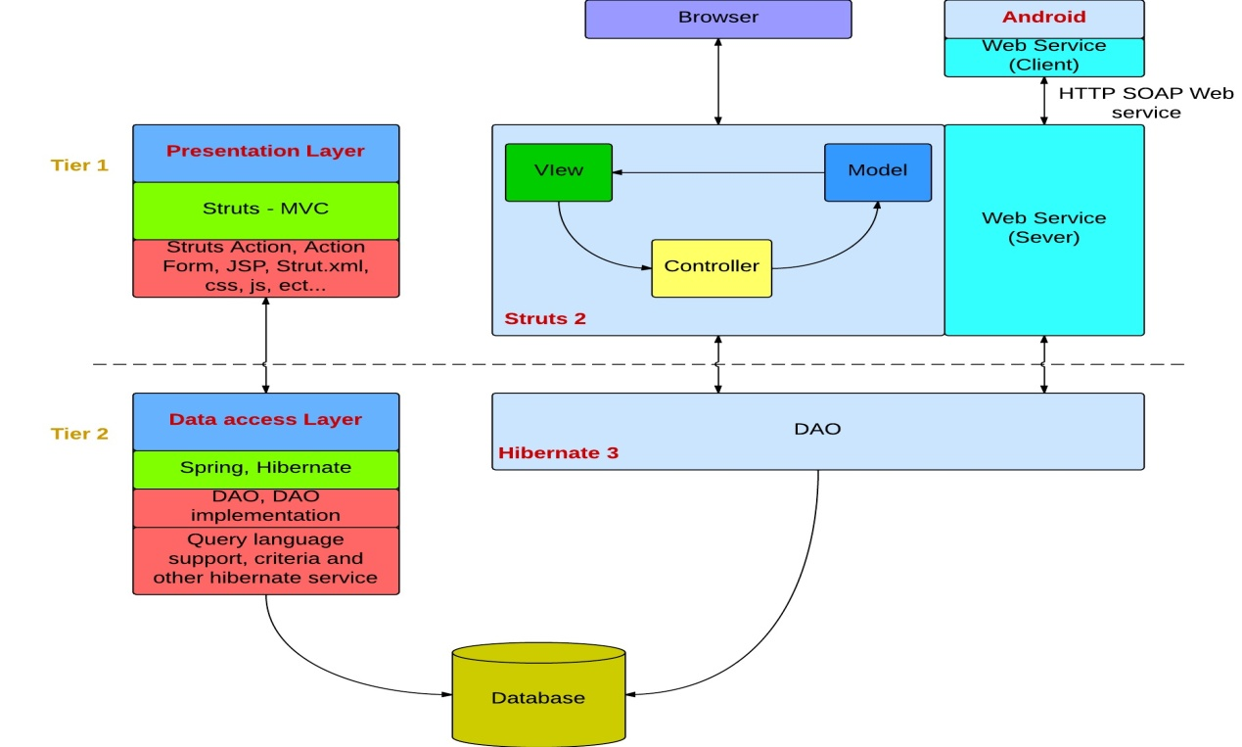

**Figure 4-3:** System overview

### Struts 2 MVC – Presentation Layer

In the overall architecture of the SMD system, struts2 acts as the presentation layer. Action Form receiving web form submission data to be processed, struts.xml is configured to call corresponding action, and then through the result to the appropriate web page.

Struts 2 Architecture is based on Web Work 2 framework. It leverages the standard JEE technologies such as Java Filters, JavaBeans, Resource Bundles, Locales, and XML etc… in its architecture. Following is its framework diagram.

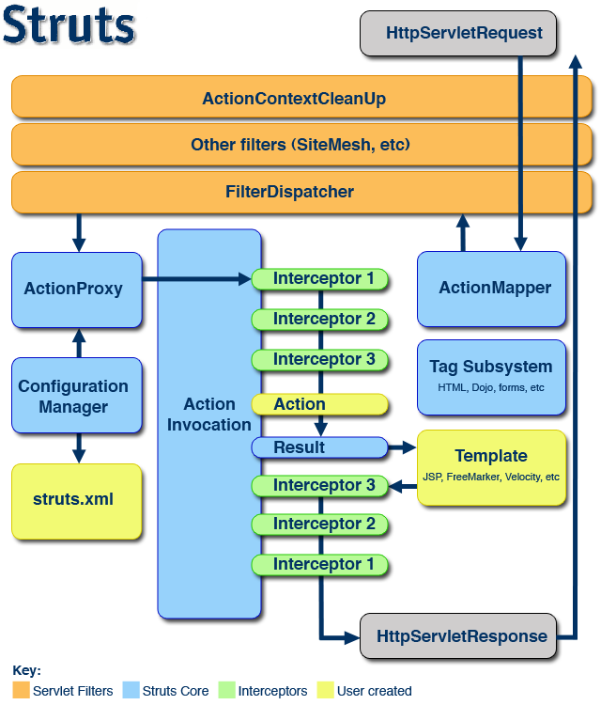

**Figure 4-4:** Struts2 architecture

**The view** in struts MVC is the user interface that is created with JSP files and does not contain any business logic. SMD user uses SMD interface (JSP files include CSS and JS, other techniques such as tilts, velocity, free maker, etc…) to submit request. The lifecycle of struts begins when the request is send from client.

**The interceptors** are responsible for most of the request processing. They are invoked by the controller before and after invoking action, thus they sit between the controller and action. Interceptors perform tasks such as Logging, Validation, File Upload, Double-submit guard etc. In SMD system, the interceptor is used to check authentication and count the number of visit time.

**The Filter Dispatcher** is configured in web.xml. It is called which consults the action mapped to determine whether an Action should be invoked.

**The Controller**‘s job is to map incoming HTTP requests to actions. Those mapping are defined by using XML-based configuration (**struts.xml**) or Java annotations. Forms and hyperlinks in the user interface that require business logic to be executed are submitted to a request URI that is mapped to an action. One instance of this class exists and receives and processes all requests that change the state of a user's interaction with the application. This component represents

**The Model** in Struts 2 is actions. Each action is defined and implemented by following the framework defined contract. Model component consist the data storage and business logic. Each action is an encapsulation of requests and is placed Value Stack.

### Spring 3 – Business Logic Layer

**Spring** is a solution to many J2EE development FAQ and powerful lightweight framework that can replace the EJB technology. The core of the Spring Framework controls flip IoC (Inversion of Control) / Dependency Injection the DI (Dependence Injection) mechanism. IoC is the relationship between the components (controlled by the container, the container is a standardized component provides a specific service and technical support runtime environment) rather than the traditional implementation of direct manipulation by the program code, this will control the right to transfer to the outer container by the program code.

**Spring responsible** for the management of the business layer in SMD system. SpringBeans.xml is used to configure database connection, Hibernate session factory, mapping resources, action beans and DAO. Spring integrates with JAX-WS standard to create Web service.

The service statistics for action call interface encapsulates the DAO persistence layer. We write some of our own business methods.

Declarative transaction management and integrated hibernate.

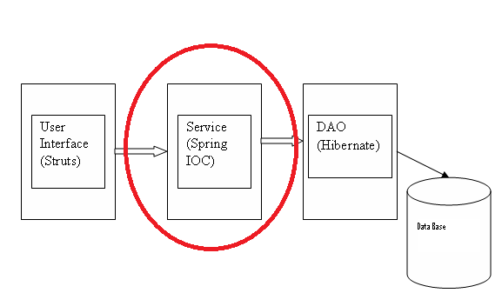

**Figure 4-5:** Spring in SSH architecture

### Hibernate – Data Access Layer

**Hibernate** is the most popular O / R mapping framework, an automatic mapping between relational database and Java objects, so that the operation of the database programmers can achieve in a very simple way.

Hibernate is responsible for the persistence layer to complete the database CRUD operations. It has a set of hbm.xml files and POJO corresponding with appearances in the database. And then define the DAO, these classes dealing with the database, they will use the PO.

Programmers to access the database needs to be done is the preparation for the persistent object xml mapping file. For example City table in MySQL is represented by City.hbm.xml file. City table has the following attributes: city name, city code, latitude, longitude, telephone area code. Then, programmer needs to create getter and setter method for all of these attributes.

The underlying database changes simply change the initial configuration file (database.properties). It not has an impact on the application.

Has its own object-oriented query language HQL in Hibernate HQL features powerful support most of the major databases, such as Oracle, DB2, MySQL, Microsoft SQL.

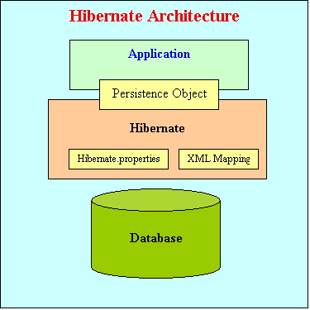

**Figure 4-6:** Hibernate architecture

Hibernate architecture has three main components:

* **Connection Management**: Hibernate Connection management service provide efficient management of the database connections. Database connection is the most expensive part of interacting with the database as it requires a lot of resources of open and close the database connection.
* **Transaction management**: Transaction management service provides the ability to the user to execute more than one database statements at a time.
* **Object relational mapping**: Object relational mapping is technique of mapping the data representation from an object model to a relational data model. This part of hibernate is used to select, insert, update and delete the records form the underlying table. When we pass an object to a Session.save() method, Hibernate reads the state of the variables of that object and executes the necessary query.

### Android – Client Side

It base on android platform with the kSOAP2 library to send/receive data from web service.

* The ksoap2-android project provides a lightweight and efficient SOAP client library.
* The ksoap2-android has been consistently enhanced and expanded with more features. It is actively maintained and we welcome bug fixes and contributions. Releases are done semi regularly with community contributions in the form of enhancements and more.

Application is not only storage and query data from server on Internet. But also, it saves data to client by SQLite

* SQLite is a relational database management system contained in a small programming library.
* In contrast to other database management systems, SQLite is not a separate process that is accessed from the client application, but an integral part of it.
* SQLite is ACID-compliant and implements most of the SQL standard, using a dynamically and weakly typed SQL syntax that does not guarantee the domain integrity.
* SQLite is a popular choice as embedded database for local/client storage in application software such as web browsers. It is arguably the most widely deployed database engine, as it is used today by several widespread browsers, operating systems, and embedded systems, among others. SQLite has many bindings to programming languages.

### Web service – Server Side

System combined JAX-WS with spring to create web service. Spring provides remoting support for web services via JAX-WS. The server and client communicate using XML to send messages or use remote procedure calls to exchange data between client and service provider. JAX-WS has many advantages to use:

* JAX-WS is typically used in conjunction with other technologies.
* JAX-WS represents remote procedure calls or messages using XML-based protocols such as SOAP, but hides Soap's innate complexity behind a Java-based API.
* The JAX-WS runtime system converts API calls and matching replies to and from SOAP messages.
* Invoking Web services asynchronously.
* The platform independence of the Java programming language.
* JAX-WS is not restrictive: a JAX-WS client can access a web service that is not running on the Java platform and vice versa.
* This flexibility is possible because JAX-WS uses technologies defined by the World Wide Web Consortium (W3C): HTTP, SOAP, and the Web Service Description Language (WSDL).
* WSDL specifies an XML format for describing a service as a set of endpoints operating on messages.

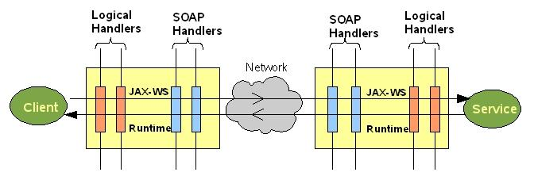

**Figure 4-7:** JAX-WS

## Component Design

### Web app Component

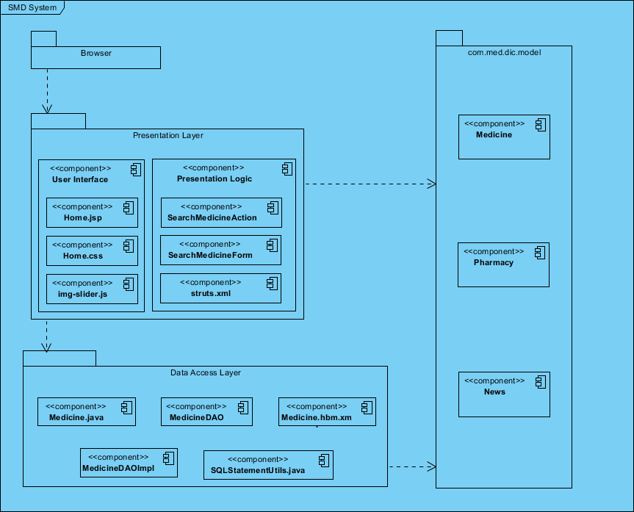

**Figure 4-8:** Web app Component Architecture

* **Browser:** We would like to mention all people who use the services of SMD on web application such as normal user, pharmacy user or administrator. Refers to report 1 to have more information about those types of users.
* **Presentation layer:** It covers the entire architecture of struts2. As mentioned in the previous section, our team used struts2 to develop presentation layer based on MVC model.
  + **User interface** is the view component in MVC model. It is expressed by combination of JSP, CSS and JS. UI is the only part visible to the users. Users can use button, link to send desired request to server.
  + **Presentation logic** contains Struts Action, Action Form, struts xml file. The struts.xml file contains the configuration information that you will be modifying as actions are developed. The action class contains business logic, retrieve resource bundle, hold the data, validation, and select the view result page that should send back to the user. It’s the heart of the Struts 2. Action Form contains getter, setter methods for all fields in view and extends from Base Action.
* **Data Access layer:**
* **Configuration:** It is represented by SpringBeans.xml. This is the actual container which instantiates, configures, and manages a number of beans. These beans typically collaborate with one another, and thus have dependencies between themselves. These dependencies are reflected in the configuration data.
* **Transaction:** Comprehensive transaction support is among the most compelling reasons to use the Spring Framework. The Spring Framework provides a consistent abstraction for transaction management. Transaction management is required to ensure the data integrity and consistency in database such as rollback, committed or timeout.
* **Hibernate session management:** Sessions are a Hibernate construct used to mediate connections with the database. The session opens a single database connection when it is created, and holds onto it until the session is closed. Every object that is loaded by Hibernate from the database is associated with the session, allowing Hibernate to automatically persist objects that are modified, and allowing Hibernate to implement functionality such as lazy-loading. The session opens a single database connection when it is created, and holds onto it until the session is closed. Every object that is loaded by Hibernate from the database is associated with the session, allowing Hibernate to automatically persist objects that are modified, and allowing Hibernate to implement functionality such as lazy-loading.
* **DAO Interface:** DAO is Data Access Object that is an object provides an abstract interface to some type of database of SMD system. Based on user’s request, appropriate DAO will be called. DAOs provide some specific data operations without exposing details of the database.
* **DAO Implementation:** This component implements above interface. This component is responsible to get data from the SMD data source.
* **Model or Value Object:** This object is simple POJO containing get/set methods to store data retrieved using DAO class.
* **HBM file:** It is Hibernate XML mapping file contains the mapping relationship between Java class and database table. This is always named “xx.hbm.xml” and declared in the “SpringBeans.xml” configuration file.

### Mobile app Component

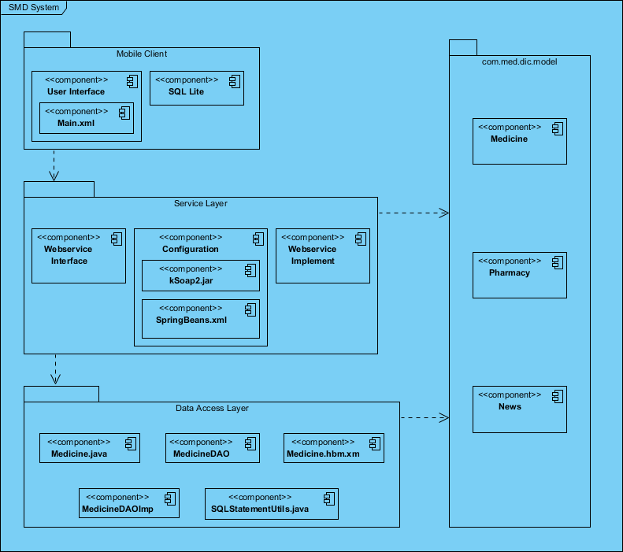

**Figure 4-9:** Hibernate architecture

* **Mobile Client:** We would like to mention all people who use the services of SMD on mobile application such as normal user. Refers to report 1 to have more information about those types of users.
* **Services layer**: web service is built based on JAX-WS standard integrated to Spring3. A web service operation invocation is represented by an XML – based protocol (**SOAP**). The SOAP specification defines the envelope structure, encoding rules, and conventions for representing web service invocations and responses. These calls and responses are transmitted as SOAP messages over HTTP.
* **SMD web service interface:** define all web method with return type, name and parameters using SOAP binding with style RPC.
* **SMD web service implementation:** implement the above SMD web service interface (end point interface refers to web service interface package). All methods in web service interface will be implemented to call appropriate action through business logic layer and retrieve data from data sources to return to clients through hibernate.
* **Technologies:** HTTP, SOAP, WSDL.

## Detailed Design

### Common Design

#### Class Diagram

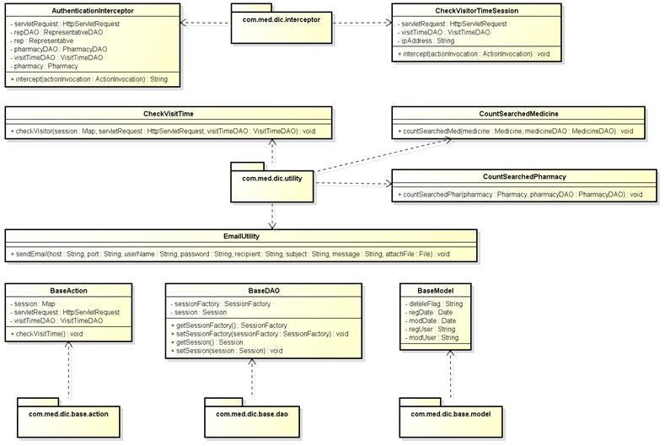

**Figure 4-10:** Class diagram- Common design

#### Utilities

|  |  |
| --- | --- |
| Name | Description |
| AuthenticationInterceptor.java | Intercept the authentication illegal. |
| CheckVisitorTimeSession.java | Check the visitor’s session is lives or dies. |
| CheckVisitTime.java | Count the number of visits to website. |
| CountSearchedMedicine.java | Count the number of data queries in medicine |
| CountSearchedPharmacy.java | Count the number of data queries in pharmacy |
| EmailUtility.java | Auto sends email to user when the information changes need to confirm. |
| BaseAction.java | Build object base for all action class. |
| BaseDAO.java | Build object base for all data access object class |
| BaseModel.java | Build object contain common attributes for all object class |
| struts.properties | Define the value of parameter can override in struts.xml |
| ApplicationResources.properties | Define the name of message throw and name of label in JSP page |

### Search medicine on mobile

#### Class Diagram

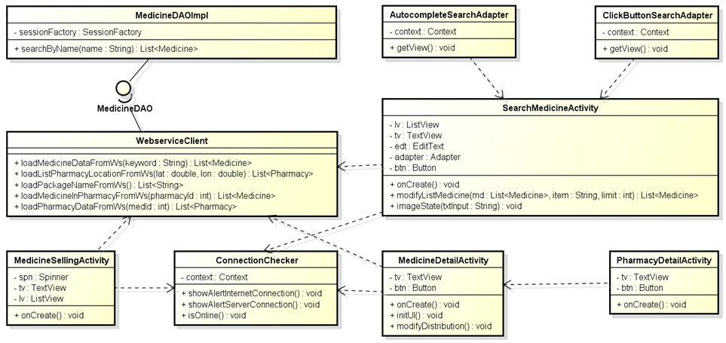

**Figure 4-11:** Class diagram- Search medicine on mobile

#### UC001-Search Medicine Home on Mobile

##### Screen Design

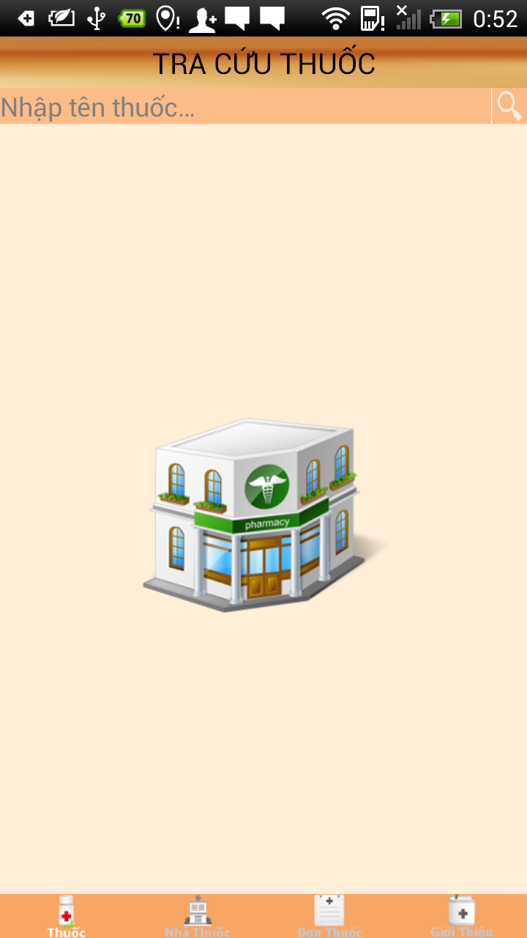

**Figure 4-12:** Search medicine home

**Table 4-1:** Search medicine home

|  |  |  |  |  |  |  |
| --- | --- | --- | --- | --- | --- | --- |
| **No** | **Object/ Control Name** | **Object/ Control Name in English** | **Type** | **Required** | **Length** | **Description** |
| 1 | Nhập tên thuốc | Medicine input | EditText (autocomplete) | N | 50 | Search bar with text hint |
| 2 | Tra cứu thuốc | Search medicine | TextView | N | N/A | Search medicine title bar |
| 3 | Tìm kiếm | Search | Button | Y | N/A | Search button for medicine |
| 4 | Quảng cáo | Advertise | Image | N | N/A | Advertising on first screen |

##### Sequence Diagram

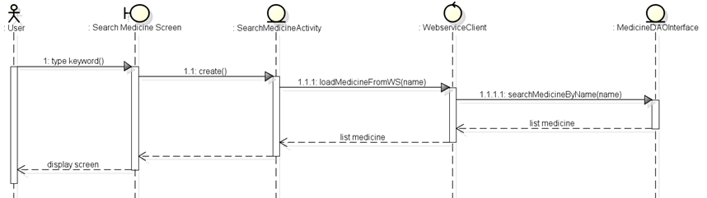

**Figure 4-13:** Sequence diagram- Search medicine on mobile

#### UC002 - Medicine Detail on Mobile

##### Screen Design

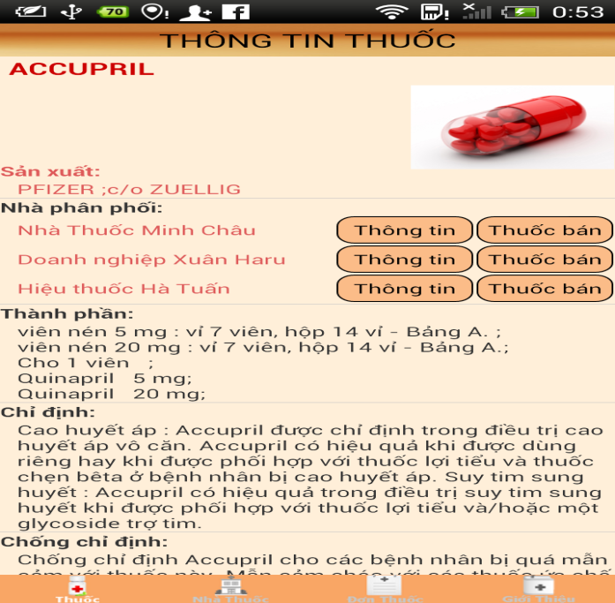

**Figure 4-14:** Medicine detail on mobile

**Table 4-2:** Medicine detail on mobile

|  |  |  |  |  |  |  |
| --- | --- | --- | --- | --- | --- | --- |
| **No** | **Object/ Control Name** | **Object/ Control Name in English** | **Type** | **Required** | **Length** | **Description** |
| 1 | Thông tin thuốc | Medicine information | TextView | Y | N/A | Medicine detail title bar |
| 2 | Ảnh thuốc | Medicine image | Image | Y | N/A | Medicine’s image |
| 3 | Sản xuất | Manufacture | TextView | Y | N/A | Medicine’s manufacture |
| 4 | Nhà phân phối | Distribution | TextView | Y | N/A | Medicine’s distribution |
| 5 | Thành phần | Ingredient | TextView | Y | N/A | Medicine’s ingredient |
| 6 | Chỉ định | Indication | TextView | Y | N/A | Medicine’s indication |
| 7 | Chống chỉ định | Contraindication | TextView | Y | N/A | Medicine’s contraindication |
| 8 | Liều lượng và cách dung | Dosing and use | TextView | Y | N/A | Medicine’s dosing and use |
| 9 | Dạng bao gói | Type of package | TextView | Y | N/A | Medicine’s type |
| 10 | Cảnh báo | Warning | TextView | Y | N/A | Medicine’s warning |
| 11 | Bảo quản | Storage | TextView | Y | N/A | Medicine’s storage |
| 12 | Tương tác | Interaction | TextView | Y | N/A | Medicine’s interaction |

##### Sequence Diagram

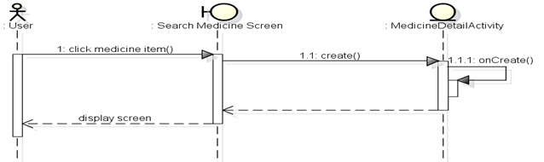

**Figure 4-15:** Sequence diagram- detail medicine on mobile

#### UC003 – Pharmacy Detail on Mobile

##### Screen Design

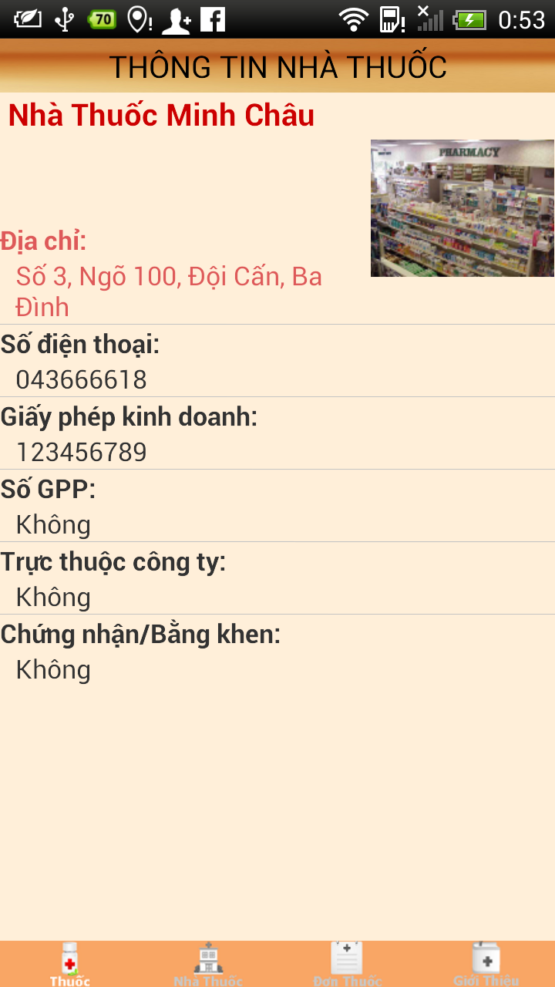

**Figure 4-16:** Pharmacy detail on mobile

**Table 4-3:** Pharmacy detail on mobile

|  |  |  |  |  |  |  |
| --- | --- | --- | --- | --- | --- | --- |
| **No** | **Object/ Control Name** | **Object/ Control Name in English** | **Type** | **Required** | **Length** | **Description** |
| 1 | Thông tin nhà thuốc | Pharmacy information | TextView | Y | N/A | Pharmacy detail title bar |
| 2 | Ảnh nhà thuốc | Pharmacy image | Image | Y | N/A | Pharmacy’s image |
| 3 | Địa chỉ | Address | TextView | Y | N/A | Pharmacy’s address |
| 4 | Số điện thoại | Phone number | TextView | Y | N/A | Pharmacy’s phone number |
| 5 | Giấy phép kinh doanh | Business license | TextView | Y | N/A | Pharmacy’s business license |
| 6 | Số GPP | GPP no | TextView | Y | N/A | Pharmacy’s GPP no |
| 7 | Trực thuộc công ty | Pharmaceutical company | TextView | Y | N/A | Pharmacy’s group |
| 8 | Chứng nhận /Bằng khen | Notes | TextView | Y | N/A | Pharmacy’s notes |
| 9 | Vị trí | Location | TextView | Y | N/A | Pharmacy’s location |

##### Sequence diagram

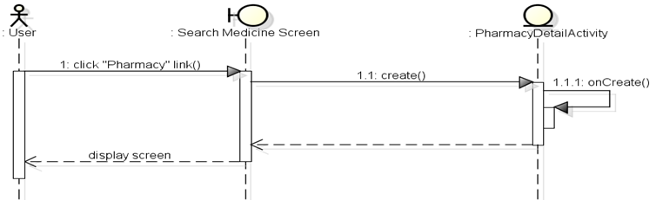

**Figure 4-17:** Sequence diagram- Pharmacy detail on mobile

#### UC004 – Medicine Selling on Mobile

##### Screen Design

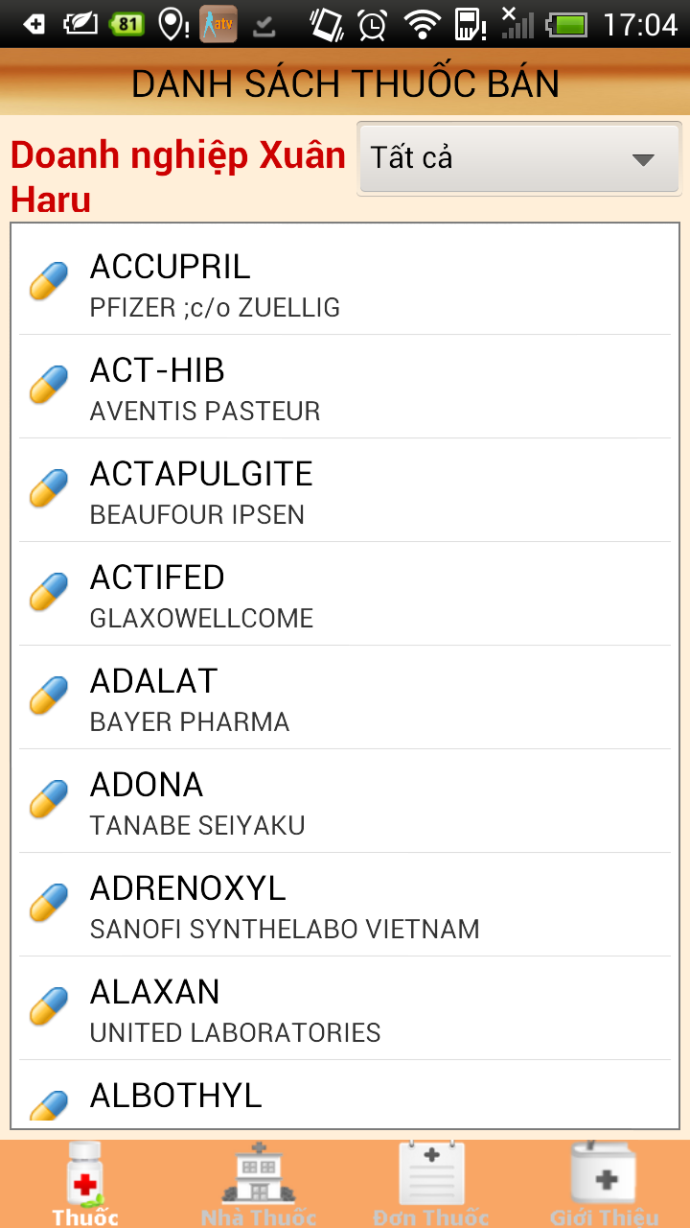

**Figure 4-18:** Medicine selling

**Table 4-4:** Medicine selling

|  |  |  |  |  |  |  |
| --- | --- | --- | --- | --- | --- | --- |
| **No** | **Object/ Control Name** | **Object/ Control Name in English** | **Type** | **Required** | **Length** | **Description** |
| 1 | Danh sách thuốc bán | Medicine selling on pharmacy | TextView | Y | N/A | Medicine selling title bar |
| 2 | Tên nhà thuốc | Pharmacy name | TextView | Y | N/A | Pharmacy’s name |
| 3 | Dạng bao gói | Type of package | Spinner | Y | N/A | Pharmacy’s type |
| 4 | Danh sách thuốc | Medicine list | ListView | Y | N/A | Medicine on pharmacy |

##### Sequence Diagram

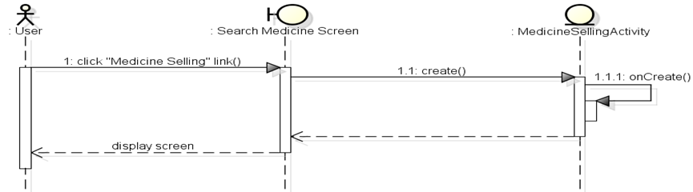

**Figure 4-19:** Sequence diagram- Medicine selling

### UC005 - Find the nearest pharmacy on mobile

#### Class Diagram

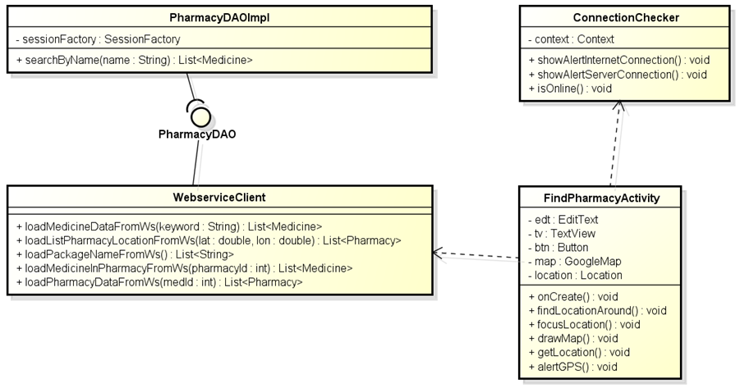

**Figure 4-20:** Class diagram- Find pharmacy on mobile

#### Screen Design

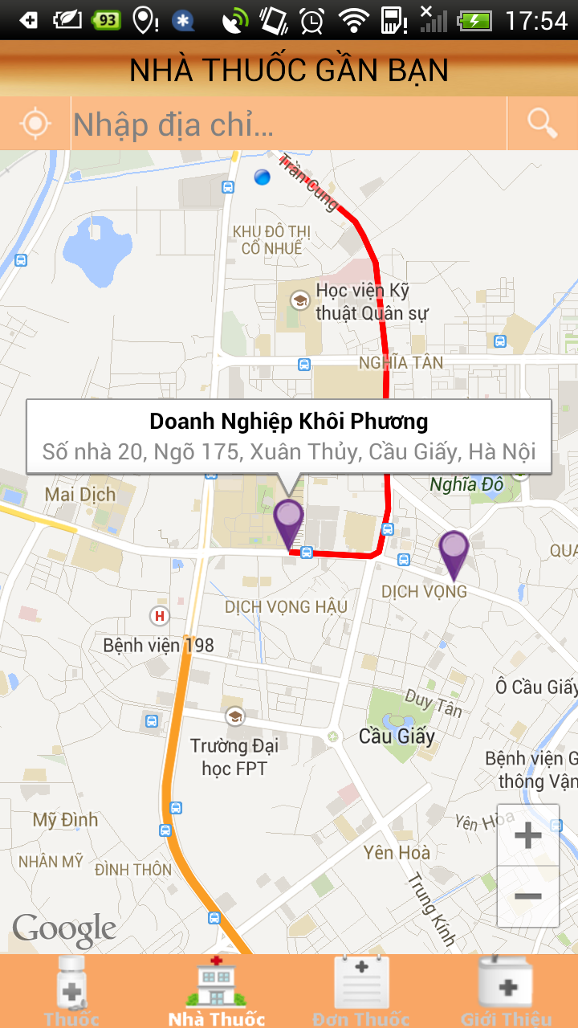

**Figure 4-21:** Find the nearest pharmacy on mobile

**Table 4-5:** Find the nearest pharmacy on mobile

|  |  |  |  |  |  |  |
| --- | --- | --- | --- | --- | --- | --- |
| **No** | **Object/ Control Name** | **Object/ Control Name in English** | **Type** | **Required** | **Length** | **Description** |
| 1 | Nhà thuốc gần bạn | Nearest pharmacy | TextView | Y | N/A | Nearest pharmacy title bar |
| 2 | Nhập địa chỉ | Address input | TextView | Y | 100 | User input address |
| 3 | Tìm kiếm | Search | Button | Y | N/A | Search button for pharmacy |
| 4 | Vị trí của tôi | My location | Button | Y | N/A | Show the current location |

#### Sequence Diagram

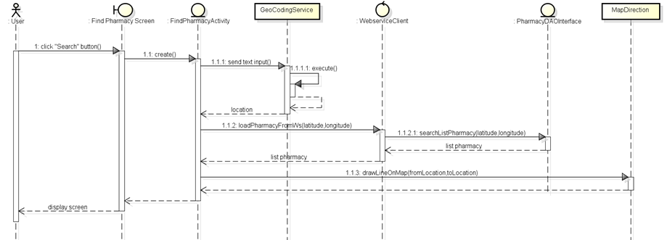

**Figure 4-22:** Sequence diagram- Find the nearest pharmacy on mobile.

### UC006 – Medical Usage Diary

#### Class Diagram

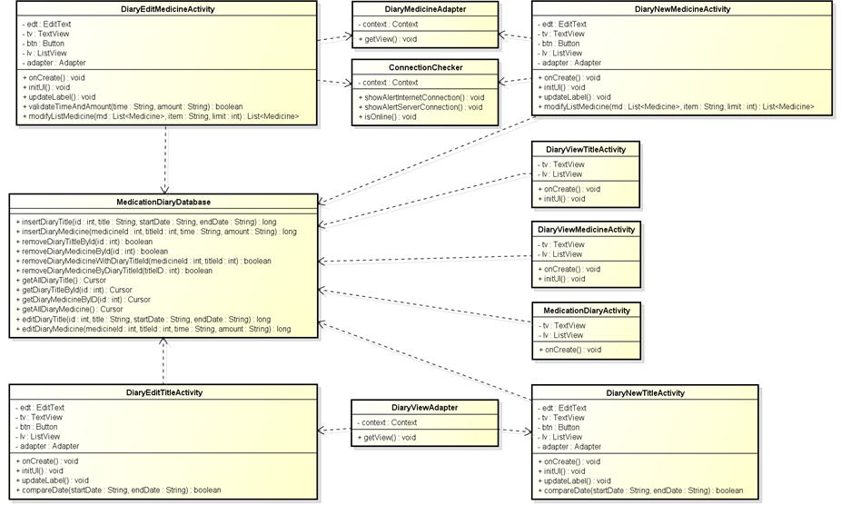

**Figure 4-23:** Class diagram- Medical usage diary

#### Screen design

##### Medication Diary

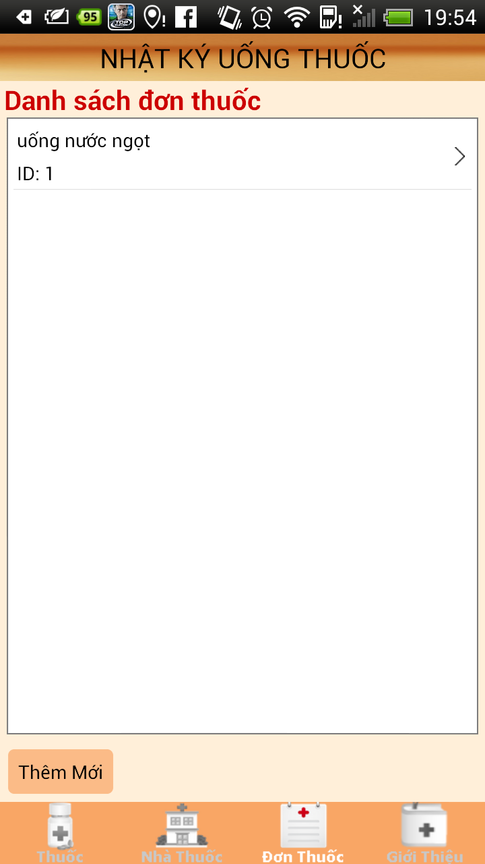

**Figure 4-24:** Medicine diary

**Table4-6:** Medicine diary

|  |  |  |  |  |  |  |
| --- | --- | --- | --- | --- | --- | --- |
| **No** | **Object/ Control Name** | **Object/ Control Name in English** | **Type** | **Required** | **Length** | **Description** |
| 1 | Nhật ký uống thuốc | Medicine usage diary | TextView | Y | N/A | Medicine usage diary title bar |
| 2 | Danh sách đơn thuốc | List prescription | TextView | Y | N/A | List prescription in diary |
| 3 | Thêm mới | Add new | Button | Y | N/A | Add new for diary |

##### Diary Title

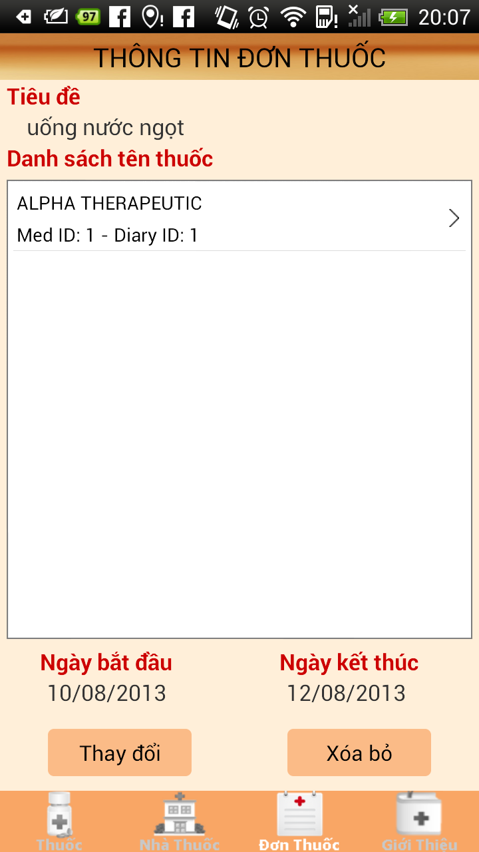

**Figure 4-25:** Diary title

**Table 4-7:** Diary title

|  |  |  |  |  |  |  |
| --- | --- | --- | --- | --- | --- | --- |
| **No** | **Object/ Control Name** | **Object/ Control Name in English** | **Type** | **Required** | **Length** | **Description** |
| 1 | Thông tin đơn thuốc | Prescription information | TextView | Y | N/A | Prescription information title bar |
| 2 | Tiêu đề | Title | TextView | Y | 100 | Title for diary |
| 3 | Danh sách tên thuốc | List medicine’s name | TextView | Y | N/A | List medicine’s name in diary |
| 4 | Ngày bắt đầu | Date start | TextView | Y | N/A | Start date for diary |
| 5 | Ngày kết thúc | Date end | TextView | Y | N/A | End date for diary |
| 6 | Thay đổi | Edit | Button | Y | N/A | Edit diary title |
| 7 | Xóa bỏ | Delete | Button | Y | N/A | Delete diary title |

##### Diary Medicine

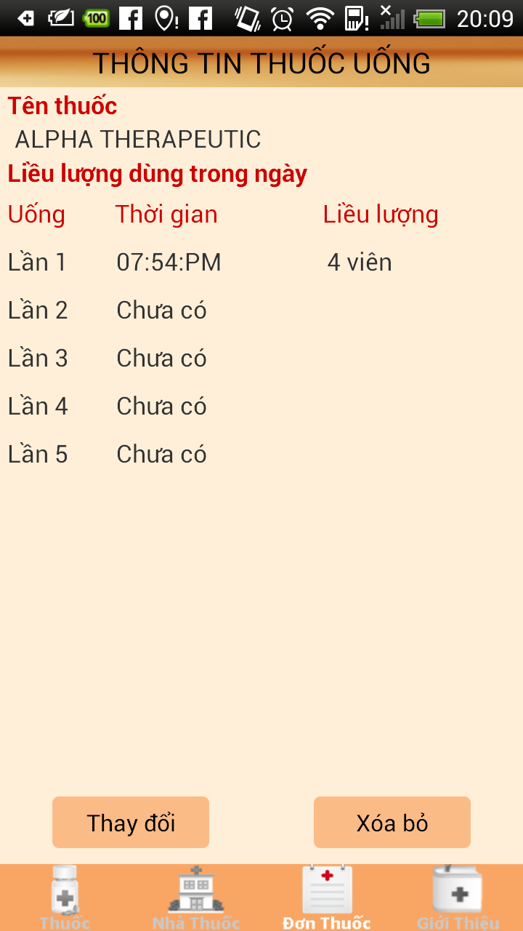

**Figure 4-26:** Diary medicine

**Table 4-8:** Diary medicine

|  |  |  |  |  |  |  |
| --- | --- | --- | --- | --- | --- | --- |
| **No** | **Object/ Control Name** | **Object/ Control Name in English** | **Type** | **Required** | **Length** | **Description** |
| 1 | Thông tin thuốc uống | Medicine usage information | TextView | Y | N/A | Medicine usage information title bar |
| 2 | Tên thuốc | Medicine name | TextView | Y | N/A | Medicine name for diary |
| 3 | Liều lượng dung trong ngày | Dosing on day | TextView | Y | N/A | Dosing for diary on day |
| 4 | Uống | Drink | TextView | Y | N/A | Drink for diary |
| 5 | Thời gian | Time | TextView | Y | N/A | Time for diary |
| 6 | Liều lượng | Dosing | TextView | Y | N/A | Dosing for diary |
| 7 | Thay đổi | Edit | Button | Y | N/A | Edit diary medicine |
| 8 | Xóa bỏ | Delete | Button | Y | N/A | Delete diary medicine |

#### Sequence Diagram

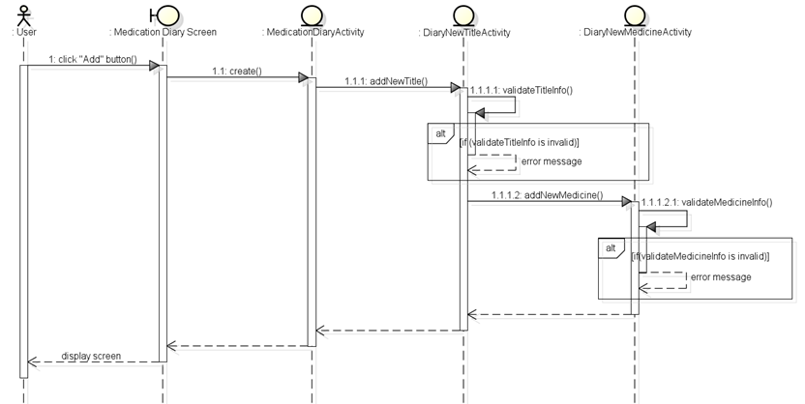

**Figure 4-27:** Sequence diagram- Medical usage diary

### UC 007 – Find Nearest Pharmacy (web version)

#### Class Diagram

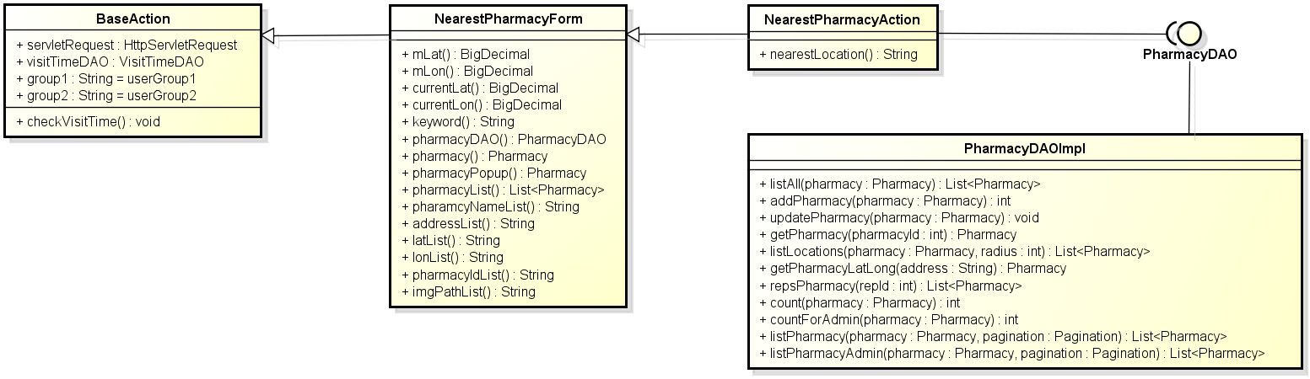

**Figure 4-28:** Class diagram- Find nearest pharmacy (web version)

#### Screen Design

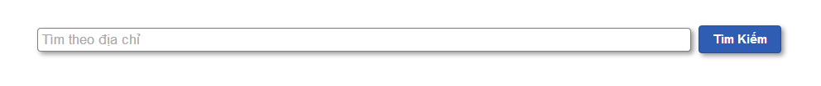

**Figure 4-29:** Find nearest pharmacy (web version)

**Table 4-9:**Find nearest pharmacy (web version)

|  |  |  |  |  |  |  |
| --- | --- | --- | --- | --- | --- | --- |
| No | **Object/Control Name** | **Object/Control Name in English** | **Type** | **Required** | **Length** | **Description** |
| 1 | Địa chỉ nhà thuốc | Pharmacy address | Text width auto complete | N | 300 | Keywords user use to search pharmacy |
| 2 | Tìm kiếm | Search | Button | Y | N/A | Start search pharmacy inside system |

#### Sequence Diagram

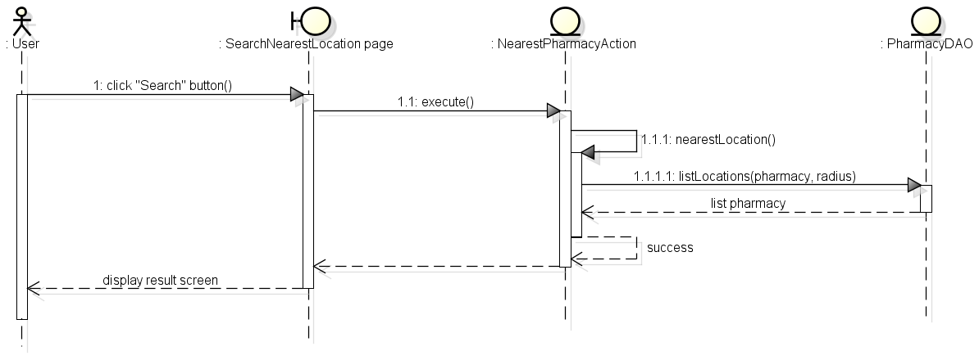

**Figure 4-30:** Sequence diagram- Find nearest pharmacy (web version)

### UC 008 – Register

#### Class Diagram

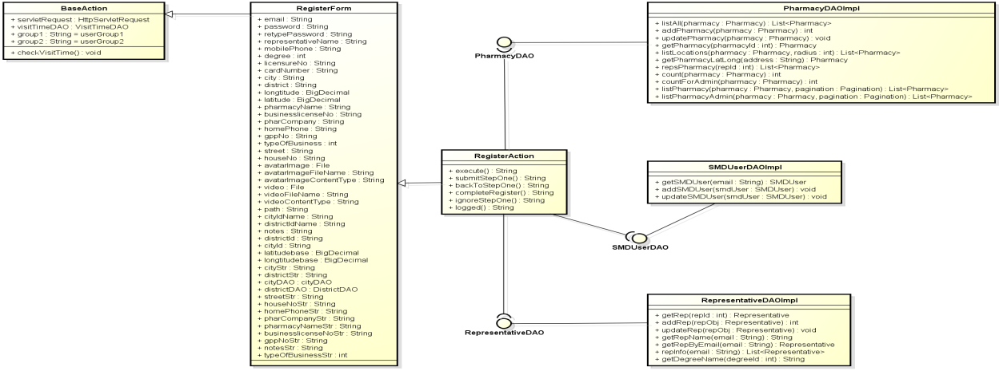

**Figure 4-31:** Class diagram- Register

#### Screen Design

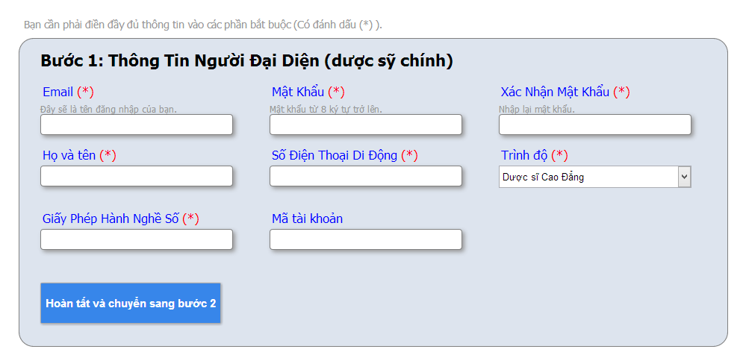

**Figure 4-32:** Register – Step1

**Table 4-10:** Register step1

|  |  |  |  |  |  |  |
| --- | --- | --- | --- | --- | --- | --- |
| No | **Object/Control Name** | **Object/Control Name in English** | **Type** | **Required** | **Length** | **Description** |
| 1 | Email | Email | Text | Y | 150 | Email of representative use to login to system |
| 2 | Mật khẩu | Password | Password | Y | 24 | Password user use to login to system |
| 3 | Nhập lại mật khẩu | Retype password | Password | Y | 24 | Retype password to user check the correctness of password |
| 4 | Họ và tên | Full name | Text | Y | 150 | Name of representative |
| 5 | Số điện thoại di động | Mobile phone | Number | Y | 15 | Mobile phone number of representative |
| 6 | Trình độ | Degree | Combo box | Y | N/A | Degree of representative |
| 7 | Giấy phép hành nghề | Licensure No | Text | Y | 100 | Licensure No of representative |
| 8 | Mã tài khoản | Card number | Text | N | 45 | Card number of representative |

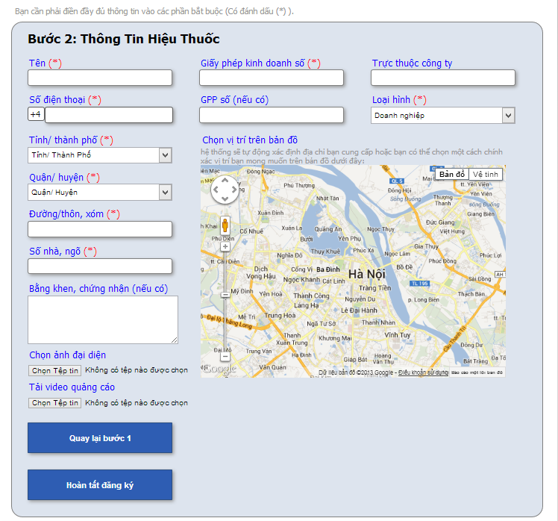

**Figure 4-33:** Register – Step2

**Table 4-11:** Register – step2

|  |  |  |  |  |  |  |
| --- | --- | --- | --- | --- | --- | --- |
| No | **Object/Control Name** | **Object/Control Name in English** | **Type** | **Required** | **Length** | **Description** |
| 1 | Tên | Pharmacy name | Text | Y | 200 | Name of pharmacy |
| 2 | Số giấy phép kinh doanh | Business licensure No | Text | Y | 100 | Business licensure No of pharmacy |
| 3 | Trực thuộc công ty | Pharmaceutical company | Text | N | 200 | Name of Pharmaceutical company |
| 4 | Số điện thoại | Home phone | Number | Y | 15 | Home phone number of pharmacy |
| 5 | Số GPP | GPP number | Number | Y | 45 | GPP number of pharmacy |
| 6 | Loại hình | Type of business | Combo box | Y | N/A | Pharmacy business type |
| 7 | Tỉnh/ Thành phố | Province/ City | Text | Y | 100 | Province name or city name of pharmacy |
| 8 | Quận/ huyện | District | Text | Y | 100 | District name of pharmacy |
| 9 | Đường/Thôn, xóm | Street | Text | Y | 100 | Street of pharmacy |
| 10 | Số nhà, ngõ | House No | Text | Y | 50 | House number of pharmacy |
| 11 | Bằng khen, chứng nhận | Note | Text area | N | 5000 | Pharmacy notes |

#### Sequence Diagram

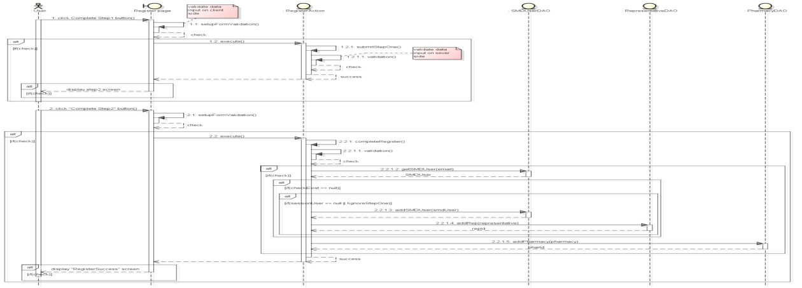

**Figure 4-34:** Sequence diagram- Register

### UC 009 – Login

#### Class Diagram

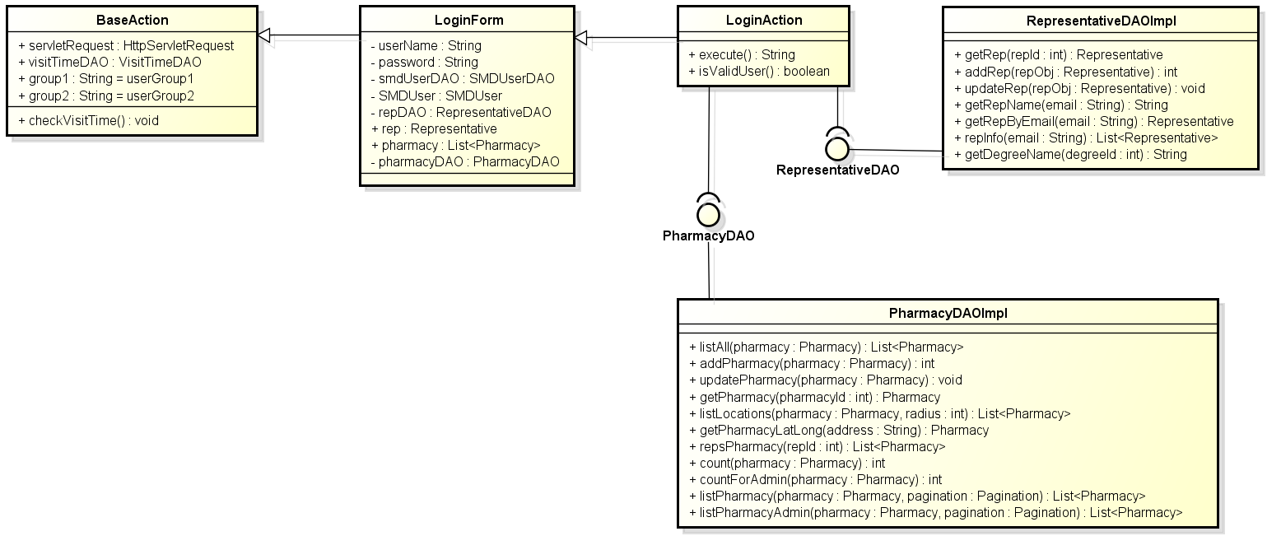

**Figure 4-35:** Class diagram- Login

#### Screen Design



**Figure 4-36:** Login

**Table 4-12:** Login

|  |  |  |  |  |  |  |
| --- | --- | --- | --- | --- | --- | --- |
| **No** | **Object/Control Name** | **Object/Control Name in English** | **Type** | **Required** | **Length** | **Description** |
| 1 | Email | Email | Text | Y | 150 | Email address of representative use to login to system |
| 2 | Mật Khẩu | Password | Text | Y | 150 | Password of user use to login to system, and text view as * |
| 3 | Đăng nhập | Login | Button | Y | N/A | Login user to system |

#### Sequence Diagram

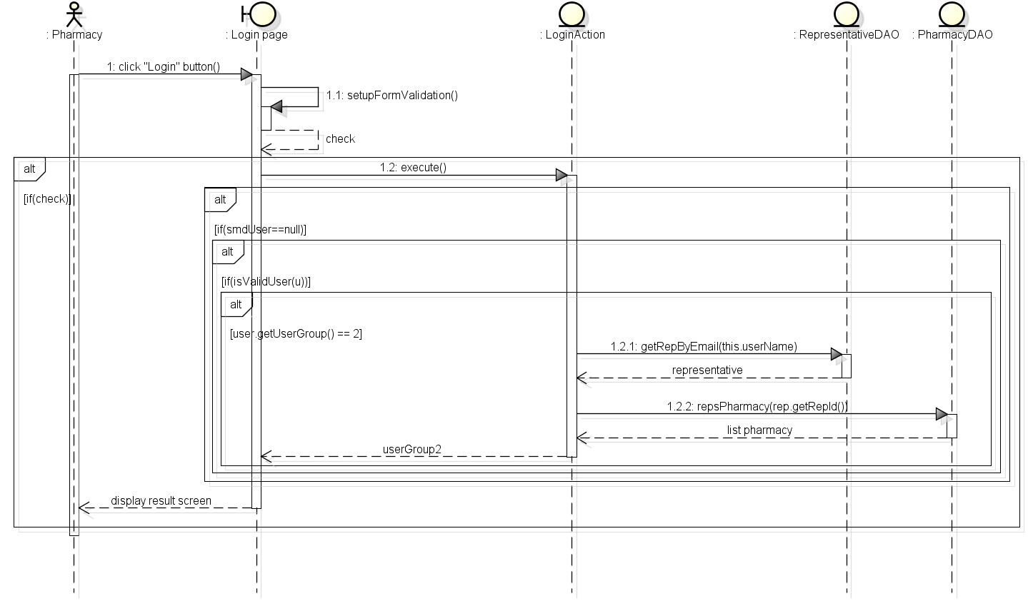

**Figure 4-37:** Sequence diagram- Login

### UC 010 – Logout

#### Class Diagram

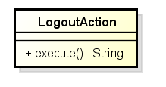

**Figure 4-38:** Class diagram- Logout

#### Screen Design



**Figure 4-39:** Logout

**Table 4-13:** Logout

|  |  |  |  |  |  |  |
| --- | --- | --- | --- | --- | --- | --- |
| **No** | **Object/Control Name** | **Object/Control Name in English** | **Type** | **Required** | **Length** | **Description** |
| 1 | Đăng xuất | Logout | Link | Y | N/A | Logout use from system |

#### Sequence Diagram

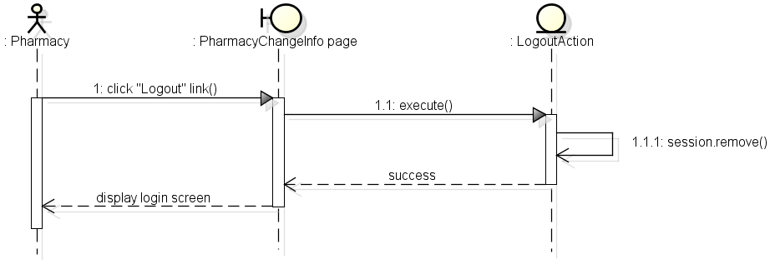

**Figure 4-40:** Sequence diagram- Logout

### UC 011 – Reset Password

#### Class Diagram

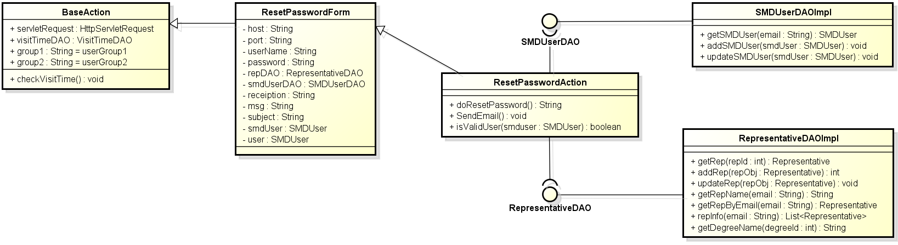

**Figure 4-41:** Class diagram- Reset password

#### Screen Design



**Figure 4-42:** Reset password

**Table 4-14:** Class diagram- Register

|  |  |  |  |  |  |  |
| --- | --- | --- | --- | --- | --- | --- |
| **No** | **Object/Control Name** | **Object/Control Name in English** | **Type** | **Required** | **Length** | **Description** |
| 1 | Email | Email | Text | Y | 150 | Email address of representative use to login to system |
| 2 | Cấp lại | Send | Button | Y | N/A | Reset user password and send email to representative |

#### Sequence Diagram

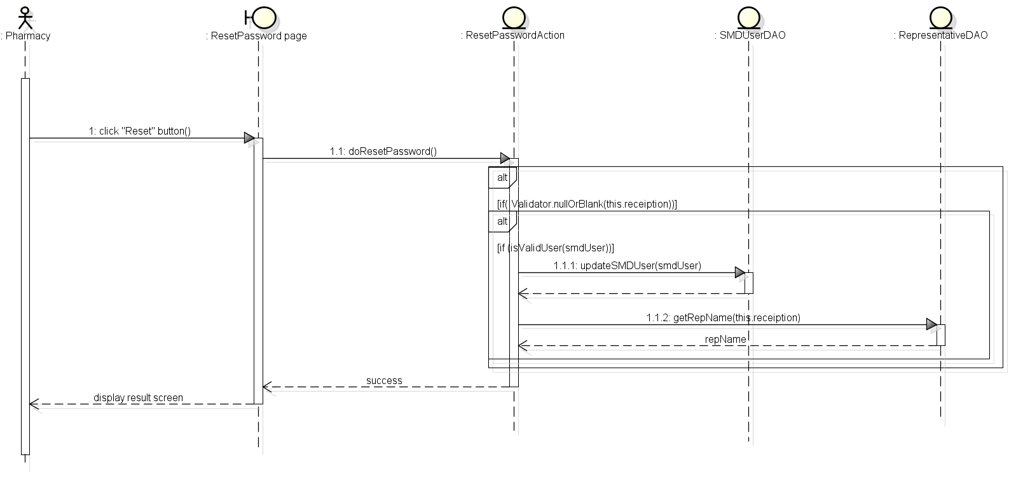

**Figure 4-43:** Sequence diagram- Reset password

### UC 012 – Change Password

#### Class Diagram

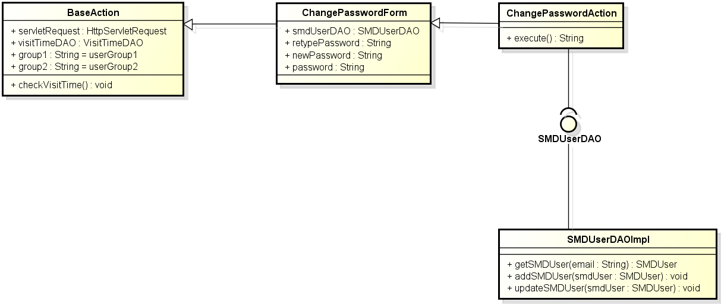

**Figure 4-44:** Class diagram- Change password

#### Screen Design



**Figure 4-45:** Change password

**Table 4-15:**Change password

|  |  |  |  |  |  |  |
| --- | --- | --- | --- | --- | --- | --- |
| **No** | **Object/Control Name** | **Object/Control Name in English** | **Type** | **Required** | **Length** | **Description** |
| 1 | Mật khẩu hiện tại | Current password | Text | Y | 150 | User current password |
| 2 | Mật khẩu mới | New password | Text | Y | 150 | User new password |
| 3 | Nhập lại mật khẩu mới | Retype new password | Text | Y | 150 | User retype password to verify the correctness of password |
| 4 | Lưu thay đổi | Save | Button | Y | N/A | Change user password to system |

#### Sequence Diagram

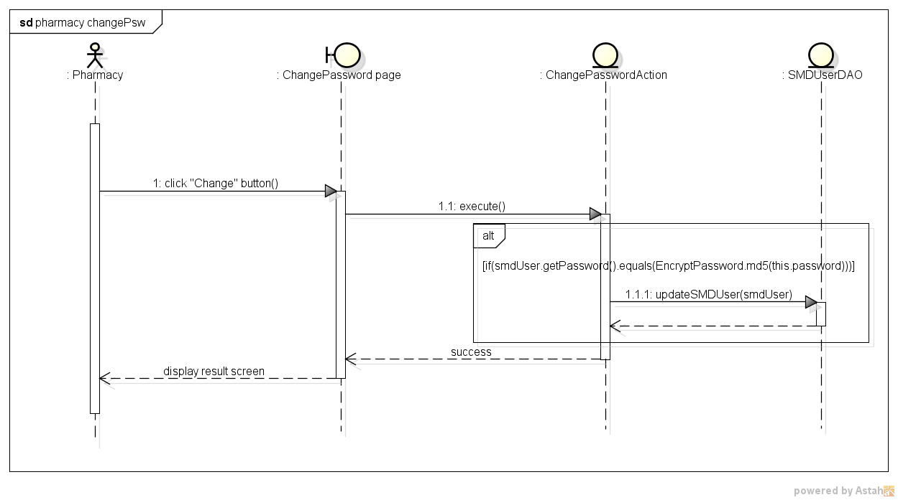

**Figure 4-46:** Sequence diagram- Change password

### Search Medicine

#### Class Diagram

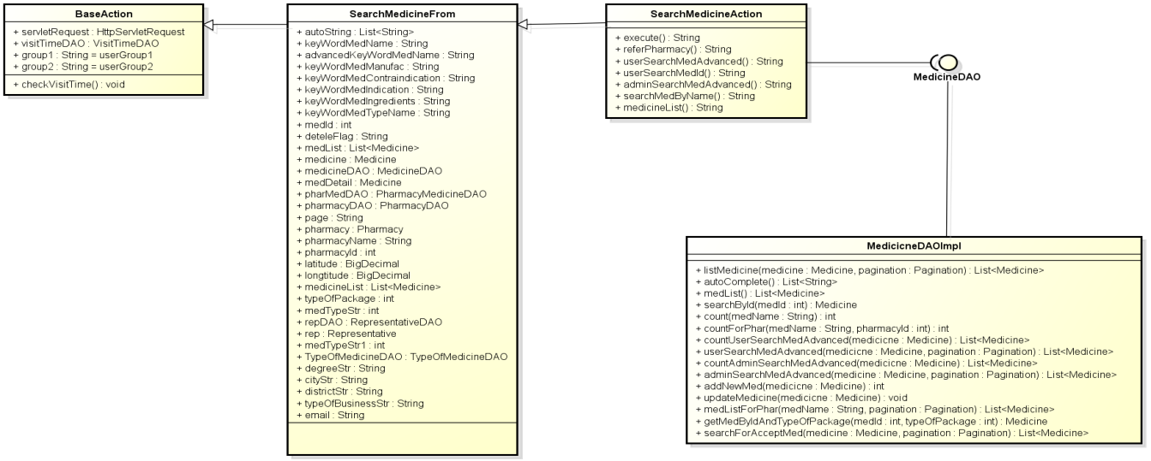

**Figure 4-47:** Class diagram- Search medicine

#### UC 013 - Normal Search

##### Screen Design



**Figure 4-48:** Search medicine- Normal search

**Table 4-16:** Search medicine- Normal search

|  |  |  |  |  |  |  |
| --- | --- | --- | --- | --- | --- | --- |
| **No** | **Object/Control Name** | **Object/Control Name in English** | **Type** | **Required** | **Length** | **Description** |
| 1 | Tìm kiếm theo tên thuốc | Search by medicine name | Text width auto complete | N | 100 | Name of medicine user use to search |
| 2 | Tra cứu | Search | Button | Y | N/A | Start search medicine inside system |
| 3 | Tìm kiếm nâng cao | Advanced search | Link | N | N/A | Switch to advanced search medicine mode |

##### Sequence Diagram

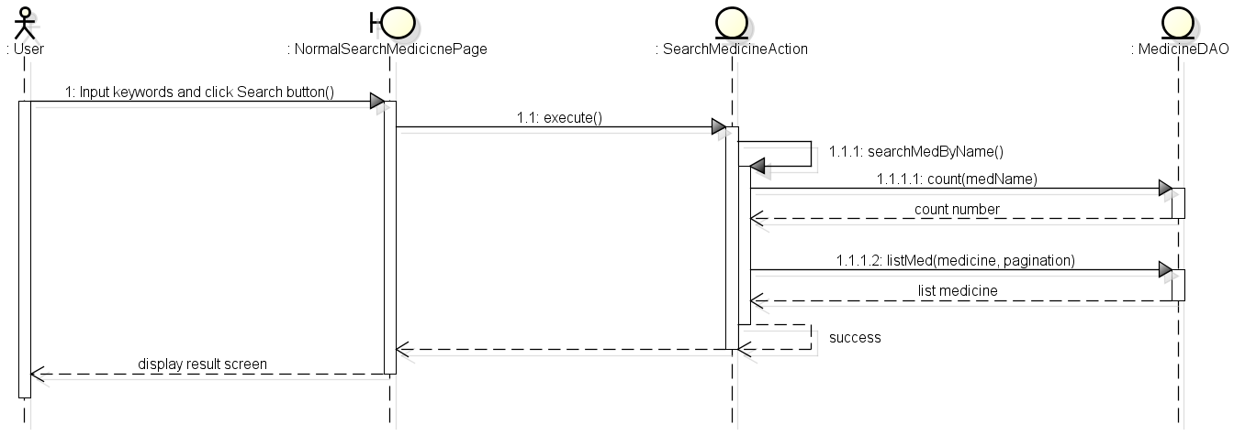

**Figure 4-49:** Sequence diagram- Normal search medicine

### UC 014 - Advanced Search Medicine

#### Screen Diagram

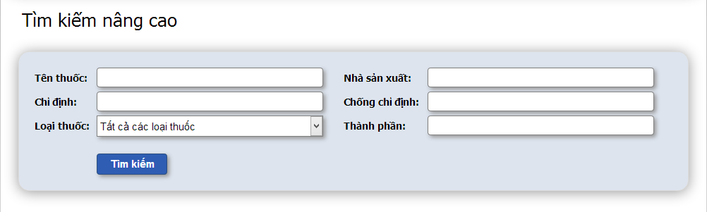**Figure 4-50:** Search medicine- Advanced search

**Table 4-17:** Search medicine- Advanced search

|  |  |  |  |  |  |  |
| --- | --- | --- | --- | --- | --- | --- |
| **No** | **Object/Control Name** | **Object/Control Name in English** | **Type** | **Required** | **Length** | **Description** |
| 1 | Tên thuốc | Medicine name | Text | N | 100 | Name of medicine user use to search medicine |
| 2 | Nhà sản xuất | Manufacturer | Text | N | 100 | Name of manufacturer user use to search medicine |
| 3 | Chỉ định | Indication | Text | N | 3000 | Indications of medicine user use to search medicine |
| 4 | Chống chỉ định | Contraindication | Text | N | 1000 | Contraindications of medicine user use to search medicine |
| 5 | Loại thuốc | Types of medicine | Combo box | N | N/A | Types of medicine user choose to search |
| 6 | Thành phần | Ingredient | Text | N | 1000 | Ingredients of medicine user use to search |

#### Sequence Diagram

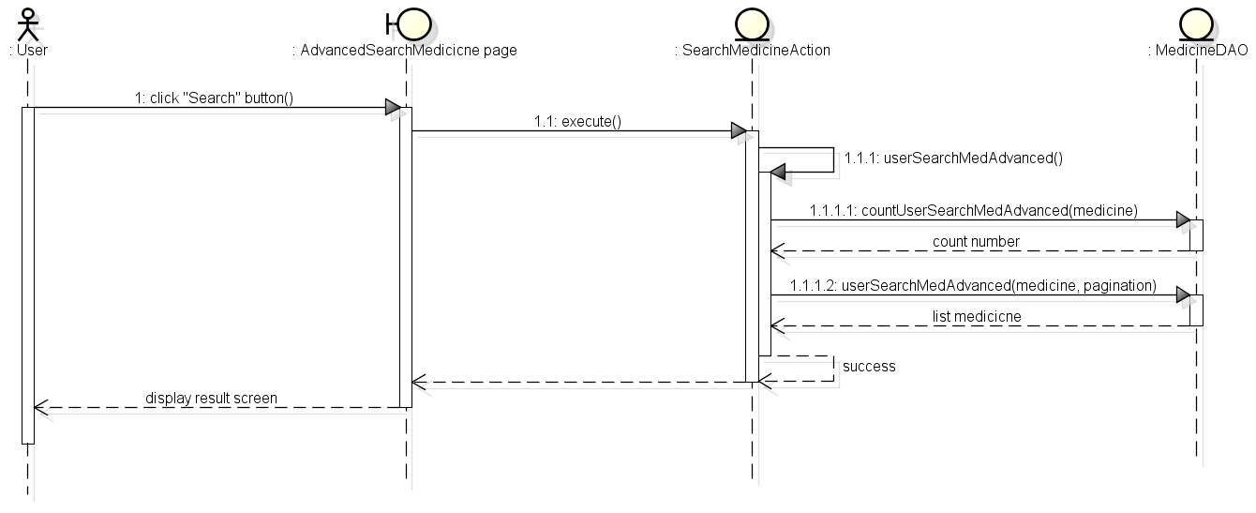

**Figure 4-51:** Sequence diagram- Search medicine

### Manage Medicine Information

#### Class Diagram

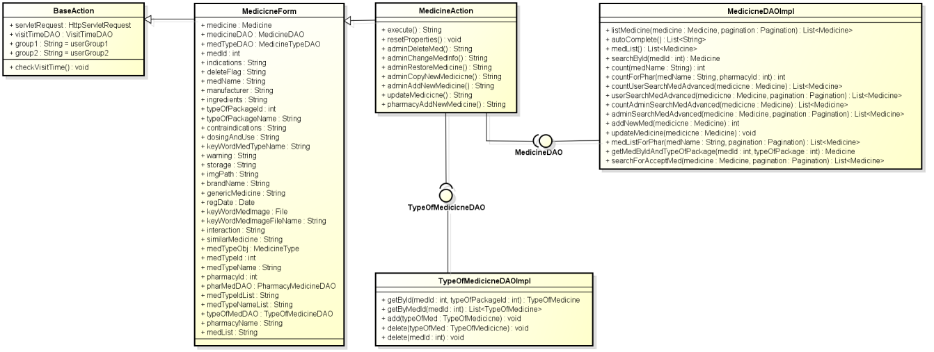

**Figure 4-52:** Class diagram- Manage medicine information

#### UC 015 –Add Medicine

##### Screen Design

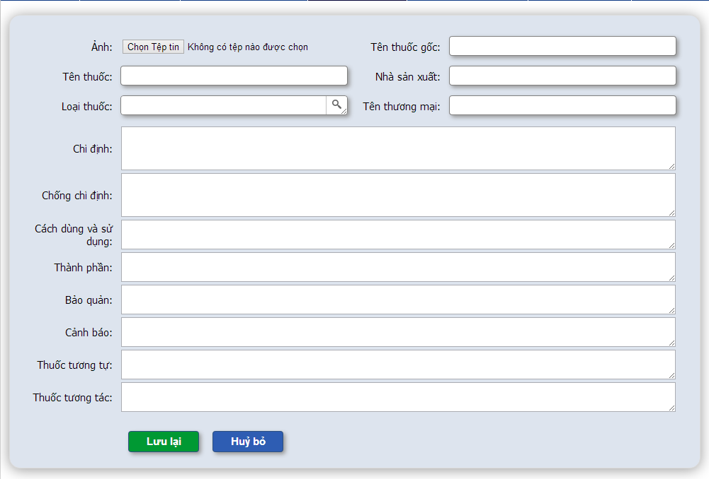

**Figure 4-53:** Manage medicine information- Add medicine

**Table 4-18:** Manage medicine information- Add medicine

|  |  |  |  |  |  |  |
| --- | --- | --- | --- | --- | --- | --- |
| **No** | **Object/Control Name** | **Object/Control Name in English** | **Type** | **Required** | **Length** | **Description** |
| 1 | Ảnh | Image | File | N | N/A | Image of medicine |
| 2 | Tên thuốc gốc | Generic medicine | Text | Y | 100 | Generic medicine name |
| 3 | Tên thuốc | Medicine name | Text | Y | 100 | Name of medicine |
| 4 | Nhà sản xuất | Manufacturer | Text | Y | 100 | Medicine manufacture name |
| 5 | Loại thuốc | Types of package | Text area auto resize + popup | Y | 100 | Type(s) of medicine |
| 6 | Tên thương mại | Brandname | Text | N | 100 | Medicine brand name |
| 7 | Chỉ định | Indications | Text area + auto resize | Y | 3000 | Medicine indication |
| 8 | Chống chỉ định | Contraindication | Text area + auto resize | N | 1000 | Medicine contraindication |
| 9 | Cách dùng và sử dụng | Dosing and use | Text area + auto resize | Y | 1000 | Medicine dosing and use |
| 10 | Thành Phần | Ingredients | Text area + auto resize | Y | 1000 | Medicine ingredient |
| 11 | Bảo quản | Storage | Text area + auto resize | N | 1000 | Medicine storage |
| 12 | Cảnh báo | Warring | Text area + auto resize | N | 1000 | Medicine warring |
| 13 | Tương tự | Similar medicine | Text area + auto resize | N | 1000 | Similar medicines |
| 14 | Tương tác | Interaction medicine | Text area + auto resize | N | 100 | Interaction medicines |
| 15 | Lưu lại | Save | Button | N | N/A | Add new medicine into system |
| 16 | Hủy bỏ | Cancel | Button | N | N/A | Cancel add new medicine |

##### Sequence Diagram

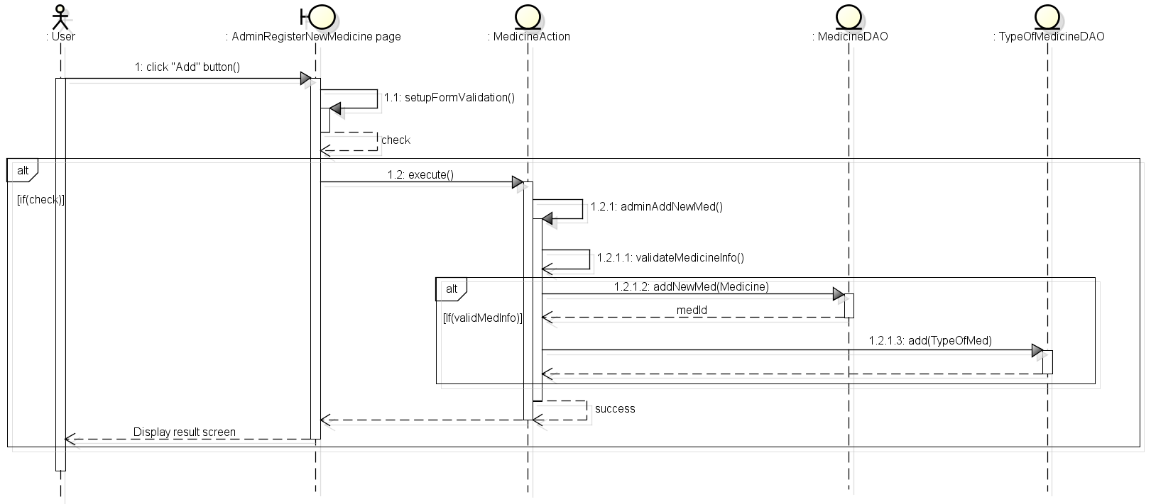

**Figure 4-54:** Sequence diagram- Manage medicine information- Add medicine

### UC 016 - Update Medicine

#### Screen Design

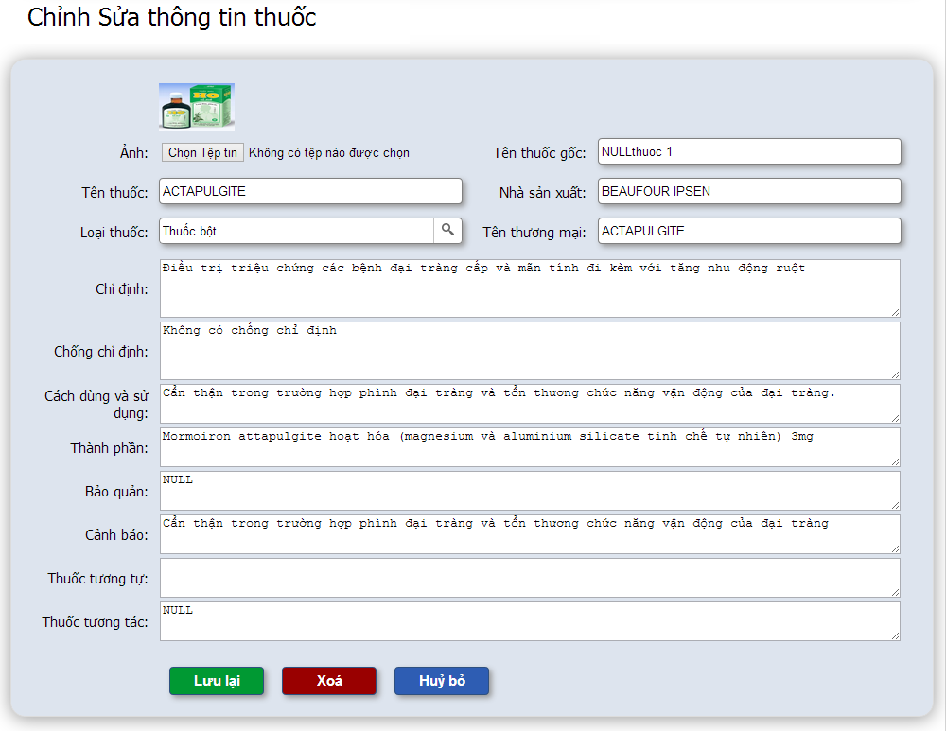

**Figure 4-55:** Manage medicine information- Update medicine

**Table 4-19:** Manage medicine information- Update medicine

|  |  |  |  |  |  |  |
| --- | --- | --- | --- | --- | --- | --- |
| **No** | **Object/Control Name** | **Object/Control Name in English** | **Type** | **Required** | **Length** | **Description** |
| 1 | Ảnh | Image | File | N | N/A | Image of medicine |
| 2 | Tên thuốc gốc | Generic medicine | Text | Y | 100 | Generic medicine name |
| 3 | Tên thuốc | Medicine name | Text | Y | 100 | Name of medicine |
| 4 | Nhà sản xuất | Manufacturer | Text | Y | 100 | Medicine manufacture name |
| 5 | Loại thuốc | Types of package | Text area auto resize + popup | Y | 100 | Type(s) of medicine |
| 6 | Tên thương mại | Brandname | Text | N | 100 | Medicine brand name |
| 7 | Chỉ định | Indications | Text area + auto resize | Y | 3000 | Medicine indication |
| 8 | Chống chỉ định | Contraindication | Text area + auto resize | N | 1000 | Medicine contraindication |
| 9 | Cách dùng và sử dụng | Dosing and use | Text area + auto resize | Y | 1000 | Medicine dosing and use |
| 10 | Thành Phần | Ingredients | Text area + auto resize | Y | 1000 | Medicine ingredient |
| 11 | Bảo quản | Storage | Text area + auto resize | N | 1000 | Medicine storage |
| 12 | Cảnh báo | Warring | Text area + auto resize | N | 1000 | Medicine warring |
| 13 | Tương tự | Similar medicine | Text area + auto resize | N | 1000 | Similar medicines |
| 14 | Tương tác | Interaction medicine | Text area + auto resize | N | 100 | Interaction medicines |
| 15 | Lưu lại | Save | Button | Y | N/A | Update new medicine information into system |
| 16 | Xóa | Delete | Button + confirm popup | N | N/A | Update deleteFlag of medicine to “Y” |
| 17 | Hủy bỏ | Cancel | Button | N | N/A | Cancel edit medicine |

#### Sequence Diagram

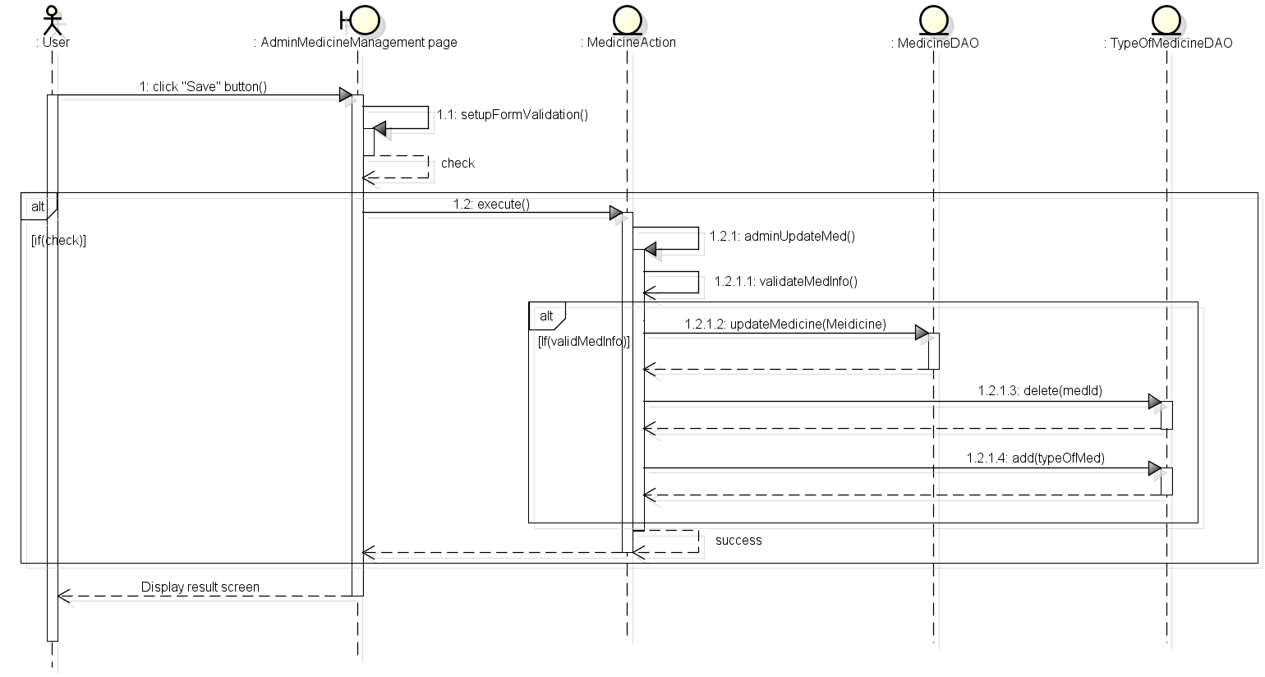

**Figure 4-56:** Sequence diagram- Manage medicine information- Update medicine

### UC 017 - Delete Medicine

#### Screen Design



**Figure 4-57:** Manage medicine information- Delete medicine

**Table 4-20:** Manage medicine information- Delete medicine

|  |  |  |  |  |  |  |
| --- | --- | --- | --- | --- | --- | --- |
| **No** | **Object/Control Name** | **Object/Control Name in English** | **Type** | **Required** | **Length** | **Description** |
| 1 | Ảnh | Image | File | N | N/A | Image of medicine |
| 2 | Tên thuốc gốc | Generic medicine | Text | N | 100 | Generic medicine name |
| 3 | Tên thuốc | Medicine name | Text | N | 100 | Name of medicine |
| 4 | Nhà sản xuất | Manufacturer | Text | N | 100 | Medicine manufacture name |
| 5 | Loại thuốc | Types of package | Text area auto resize + popup | N | 100 | Type(s) of medicine |
| 6 | Tên thương mại | Brandname | Text | N | 100 | Medicine brand name |
| 7 | Chỉ định | Indications | Text area + auto resize | N | 3000 | Medicine indication |
| 8 | Chống chỉ định | Contraindication | Text area + auto resize | N | 1000 | Medicine contraindication |
| 9 | Cách dùng và sử dụng | Dosing and use | Text area + auto resize | N | 1000 | Medicine dosing and use |
| 10 | Thành Phần | Ingredients | Text area + auto resize | N | 1000 | Medicine ingredient |
| 11 | Bảo quản | Storage | Text area + auto resize | N | 1000 | Medicine storage |
| 12 | Cảnh báo | Warring | Text area + auto resize | N | 1000 | Medicine warring |
| 13 | Tương tự | Similar medicine | Text area + auto resize | N | 1000 | Similar medicines |
| 14 | Tương tác | Interaction medicine | Text area + auto resize | N | 100 | Interaction medicines |
| 15 | Lưu lại | Save | Button | N | N/A | Save medicine information into system |
| 16 | Xóa | Delete | Button + confirm popup | Y | N/A | Update deleteFlag of medicine to “Y” |
| 17 | Hủy bỏ | Cancel | Button | N | N/A | Cancel edit medicine |

#### Sequence diagram

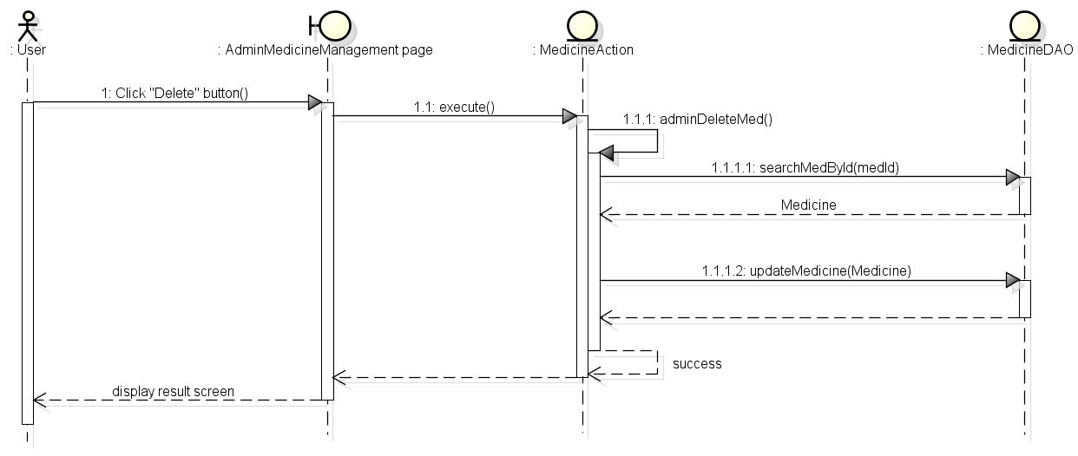

**Figure 4-58:** Sequence diagram- Manage medicine information- Delete medicine

### UC 018 - Restore Medicine

#### Screen Design

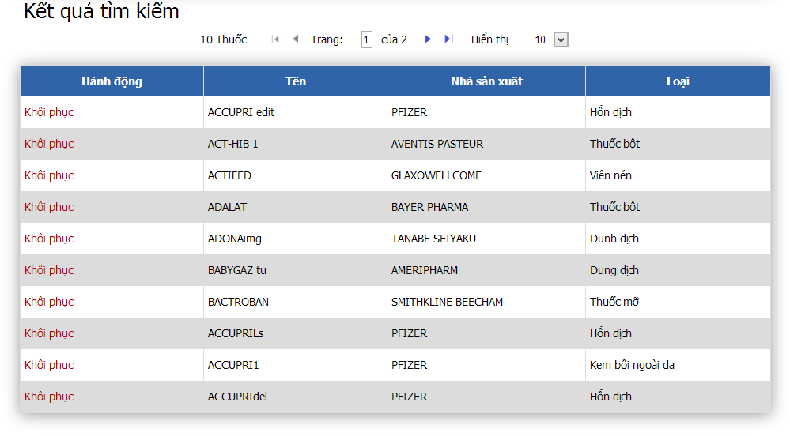

**Figure 4-59:** Manage medicine information- Restore medicine

**Table 4-21:** Manage medicine information- Restore medicine

|  |  |  |  |  |  |  |
| --- | --- | --- | --- | --- | --- | --- |
| **No** | **Object/Control Name** | **Object/Control Name in English** | **Type** | **Required** | **Length** | **Description** |
| 1 | Khôi phục | Restore | Link | Y | N/A | Update deleteFlag of medicine to “N” |
| 2 | Tên | Name | Text | N | N/A | Name of medicine |
| 3 | Nhà sản xuất | Manufacturer | Text | N | N/A | Name of manufacturer |
| 4 | Loại | Types | Text | N | N/A | Types of medicine |

#### Sequence Diagram

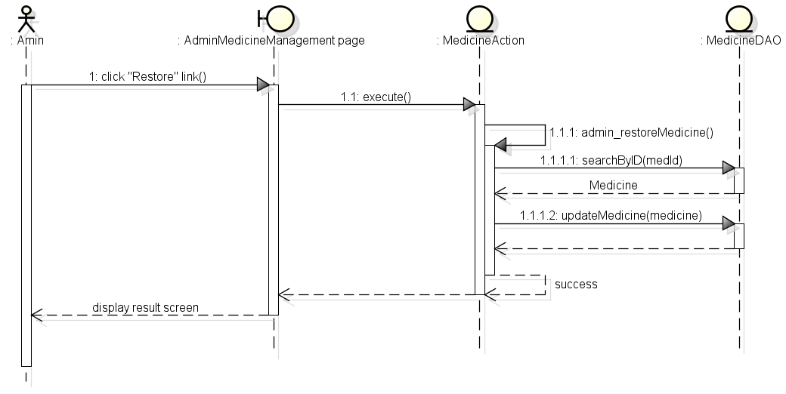

**Figure 4-60:** Sequence diagram- Manage medicine information- Restore medicine

### Search Pharmacy

#### Class Diagram

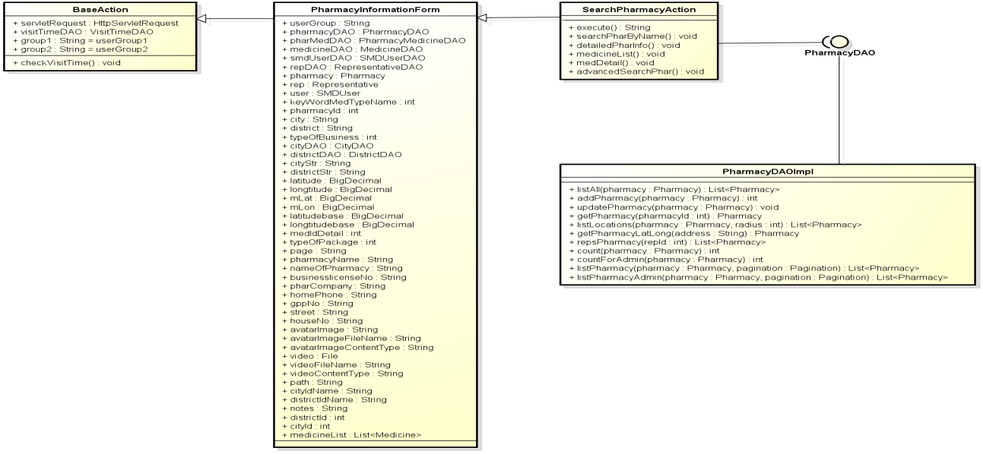

**Figure 4-61:** Class diagram- Search pharmacy

### UC 019 – Normal Search Pharmacy

#### Screen Design

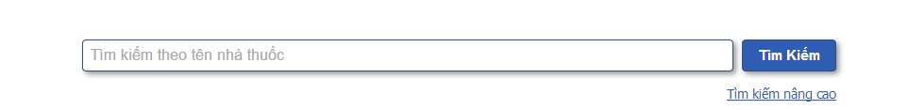

**Figure 4-62:** Search pharmacy- Normal search

**Table 4-22:** Search pharmacy- Normal search

|  |  |  |  |  |  |  |
| --- | --- | --- | --- | --- | --- | --- |
| No | **Object/Control Name** | **Object/Control Name in English** | **Type** | **Required** | **Length** | **Description** |
| 1 | Tìm kiếm theo tên nhà thuốc | Search by pharmacy name | Text width auto complete | N | 200 | Keywords user use to search pharmacy |
| 2 | Tìm kiếm | Search | Button | Y | N/A | Start search pharmacy inside system |
| 3 | Tìm kiếm nâng cao | Advanced search | Link | N | N/A | Switch to advanced search pharmacy |

#### Sequence Diagram

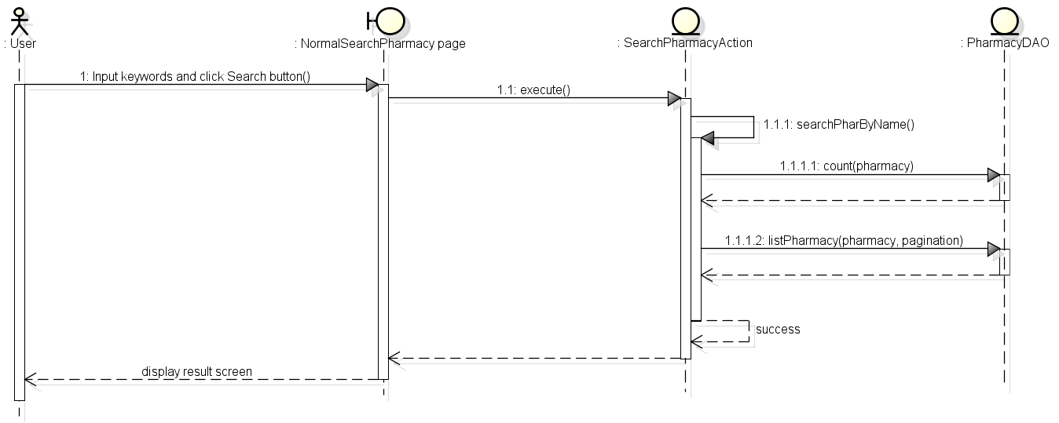

**Figure 4-63:** Sequence diagram- Search pharmacy- Normal search

### UC 020 - Advanced Search Pharmacy

#### Screen Diagram

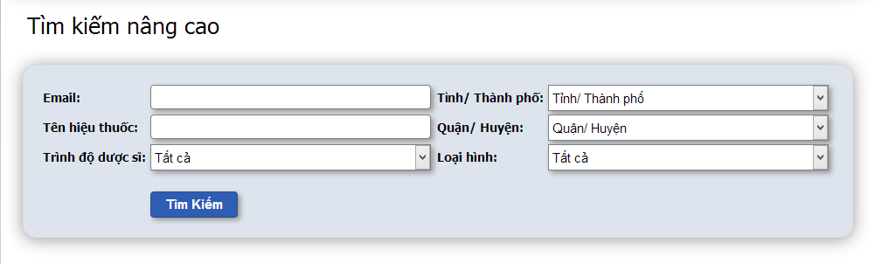

**Figure 4-64:** Search pharmacy- Advanced search

**Table 4-23:** Search pharmacy- Advanced search

|  |  |  |  |  |  |  |
| --- | --- | --- | --- | --- | --- | --- |
| No | **Object/Control Name** | **Object/Control Name in English** | **Type** | **Required** | **Length** | **Description** |
| 1 | Email | Email | Text | N | 150 | Email the representative of pharmacies user used to search |
| 2 | Tỉnh/ Thành phố | Province/ City | Combo box | N | N/A | Name province or city user choose to search |
| 3 | Tên hiệu thuốc | Pharmacy name | Text | N | 200 | Name of pharmacy user use to search |
| 4 | Quận/ Huyện | District | Combo box | N | N/A | Name of district user choose to search |
| 5 | Trình độ dược sĩ | Degree | Combo box | N | N/A | Degree the representative of pharmacy user choose to search |
| 6 | Loại hình | Type of business | Combo box | N | N/A | Type of business user use to search |
| 7 | Tìm kiếm | Search | Button | N | N/A | Search pharmacy into system |

#### Sequence Diagram

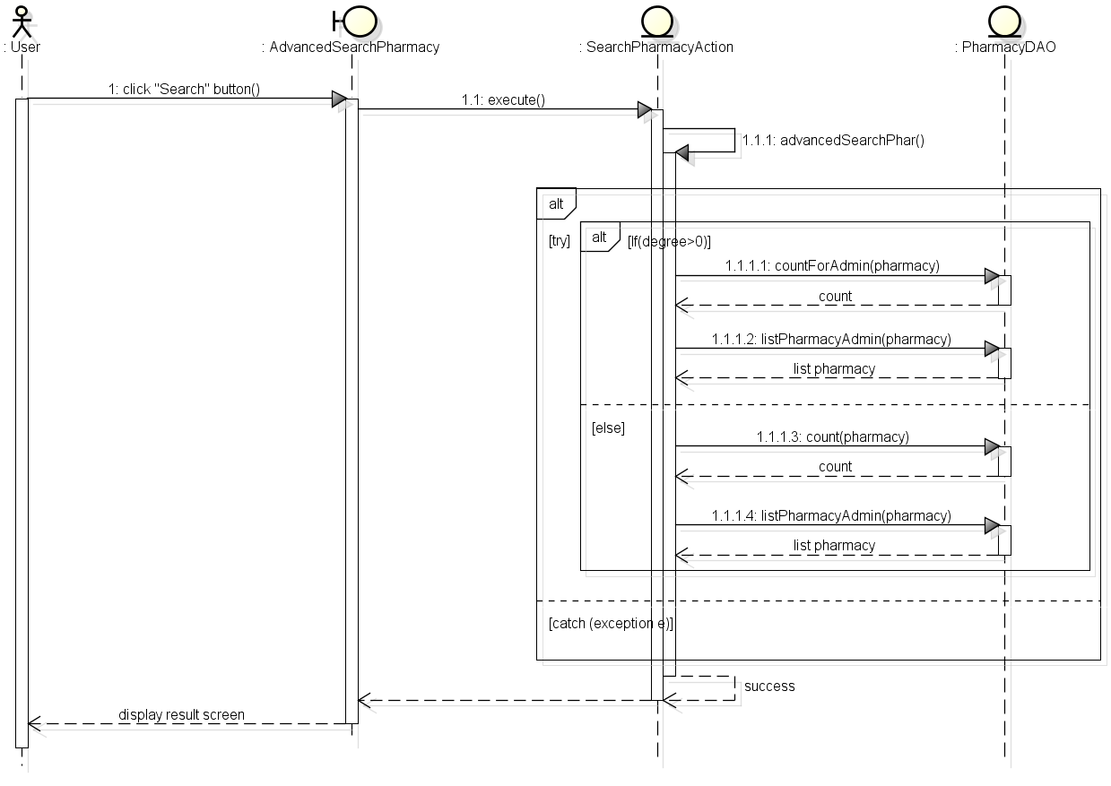

**Figure 4-65:** Sequence diagram- Search pharmacy- Advanced search

### Manage Pharmacy information

#### Class Diagram

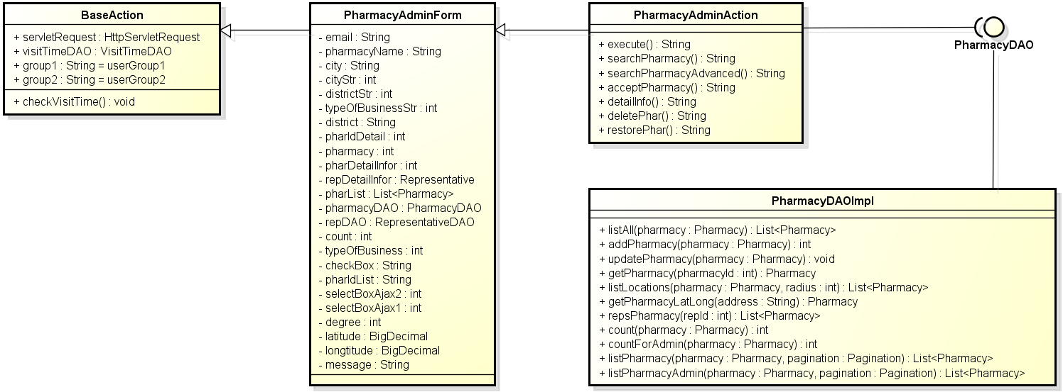

**Figure 4-66:** Class diagram- Manage pharmacy information

### UC 021 – Accept Registered Pharmacy

#### Screen Design

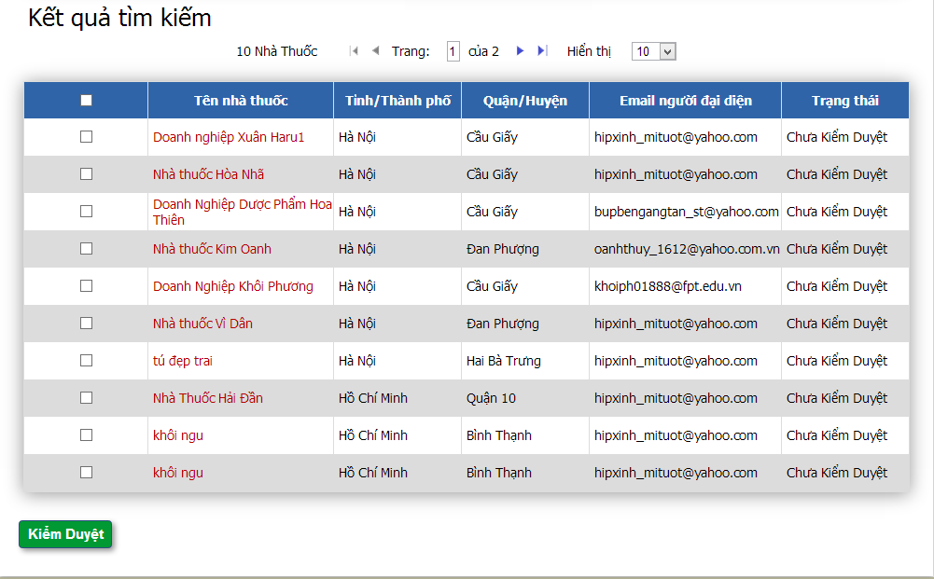

**Figure 4-67:** Manage pharmacy information- Accept pharmacy

**Table 4-24:** Manage pharmacy information- Accept pharmacy

|  |  |  |  |  |  |  |
| --- | --- | --- | --- | --- | --- | --- |
| **No** | **Object/Control Name** | **Object/Control Name in English** | **Type** | **Required** | **Length** | **Description** |
| 1 | Chọn | Tick | Check box | Y | N/A | Tick pharmacy to accept |
| 2 | Tên nhà thuốc | Pharmacy name | Text | N | N/A | Name of pharmacy |
| 3 | Tỉnh/ Thành phố | Province/ City | Text | N | N/A | Name of province or city of pharmacy |
| 4 | Quận/ Huyện | District | Text | N | N/A | District of pharmacy |
| 5 | Email người đại diện | Representative’s email | Text | N | N/A | Representative’s email |
| 6 | Trạng thái | Status | Text | N | N/A | Pharmacy status |
| 7 | Kiểm duyệt | Accept | Button | Y | N/A | Accept the ticked pharmacies |

#### Sequence Diagram

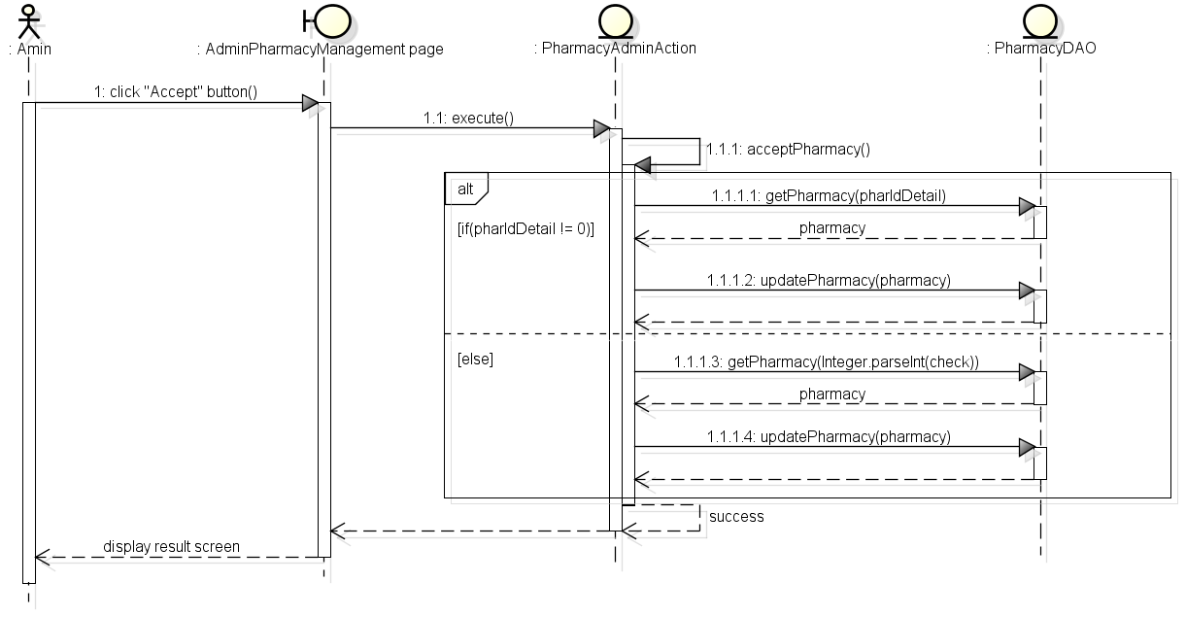

**Figure 4-68:** Sequence diagram- Manage pharmacy information- Accept pharmacy

### UC 022 - Delete Pharmacy

#### Screen Design

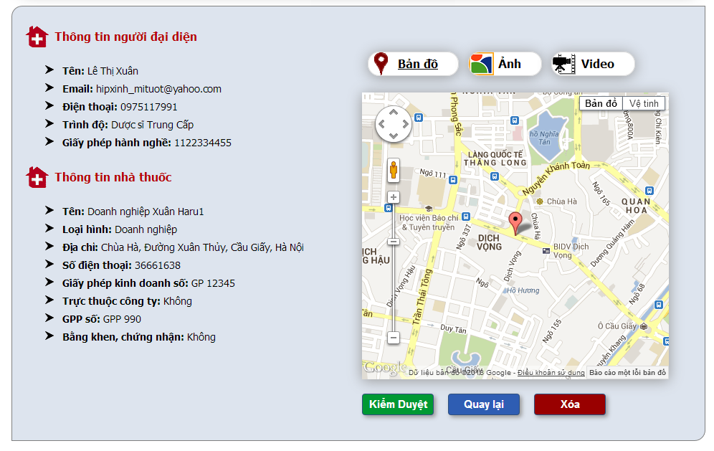

**Figure 4-69:** Manage pharmacy information- Delete pharmacy

**Table 4-25:** Manage pharmacy information- Delete pharmacy

|  |  |  |  |  |  |  |
| --- | --- | --- | --- | --- | --- | --- |
| **No** | **Object/Control Name** | **Object/Control Name in English** | **Type** | **Required** | **Length** | **Description** |
| 1 | Thông tin người đại diện | Representative information | Form | N | N/A | Representative form with 5 detail info ‘Tên’, ‘Email’, ‘Điện thoại’, ‘Trình độ’ and ‘Giấy phép hành nghề’ |
| 2 | Thông tin nhà thuốc | Pharmacy information | Form | N | N/A | Pharmacy information with 8 detail info ‘Tên’, ‘Loại hình’, ‘Địa chỉ’, ‘Số điện thoại’, ‘Giấy phép kinh doanh số’, ‘Trực thuộc công ty’, ‘GPP số’ and ‘Bằng khen, chứng nhận’ |
| 3 | Bản đồ | Map | Tab | N | N/A | Show pharmacy location on google map |
| 4 | Hình ảnh | Image | Tab | N | N/A | Show pharmacy image |
| 5 | Video | Video | Tab | N | N/A | Show pharmacy video |
| 6 | Kiểm duyệt | Accept | Button | N | N/A | Accept pharmacy |
| 7 | Quay lại | Back | Button | N | N/A | Back to previous page |
| 8 | Xóa | Delete | Button + confirm popup | Y | N/A | Update deleteFlag of pharmacy to “Y” |

#### Sequence Diagram

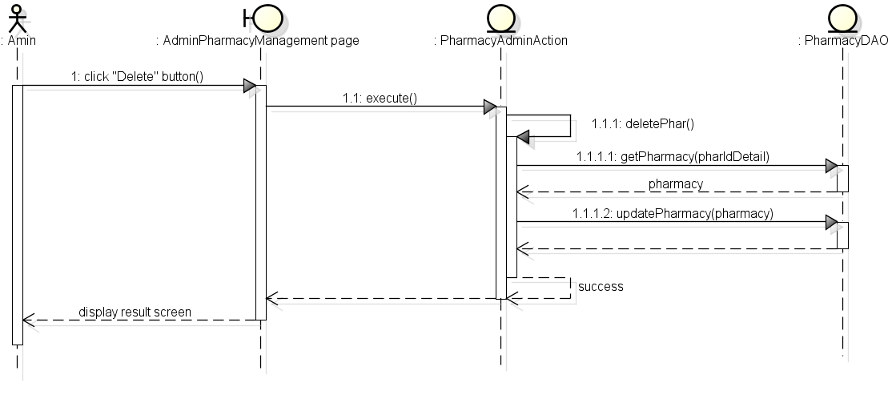

**Figure 4-70:** Sequence diagram- Manage pharmacy information- Delete pharmacy

### UC 023 - Restore Pharmacy

#### Screen Design

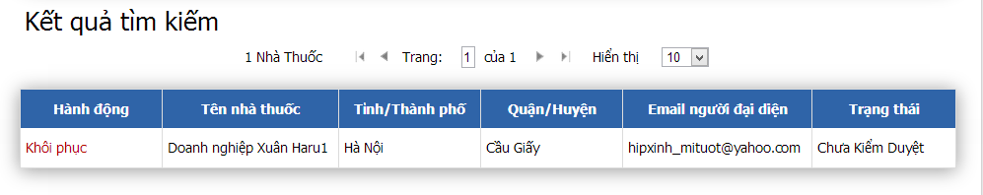

**Figure 4-71:** Manage pharmacy information- Restore pharmacy

**Table 4-26:** Manage pharmacy information- Restore pharmacy

|  |  |  |  |  |  |  |
| --- | --- | --- | --- | --- | --- | --- |
| **No** | **Object/Control Name** | **Object/Control Name in English** | **Type** | **Required** | **Length** | **Description** |
| 1 | Khôi phục | Restore | Link | N | N/A | Update deleteFlag of pharmacy to “N” |
| 2 | Tên nhà thuốc | Pharmacy name | Text | N | N/A | Name of pharmacy |
| 3 | Tỉnh/ Thành phố | Province/ City | Text | N | N/A | Name of province or city of pharmacy |
| 4 | Quận/ Huyện | District | Text | N | N/A | District of pharmacy |
| 5 | Email người đại diện | Representative’s email | Text | N | N/A | Representative’s email |
| 6 | Trạng thái | Status | Text | N | N/A | Pharmacy status |

#### Sequence Diagram

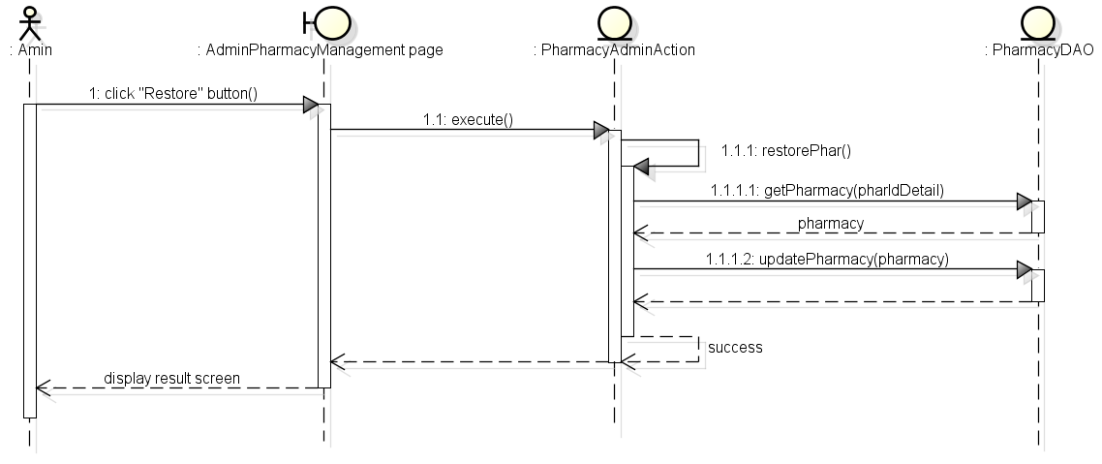

**Figure 4-72:** Sequence diagram- Manage pharmacy information- Restore pharmacy

### UC 024 – Pharmacy Change Info

#### Class Diagram

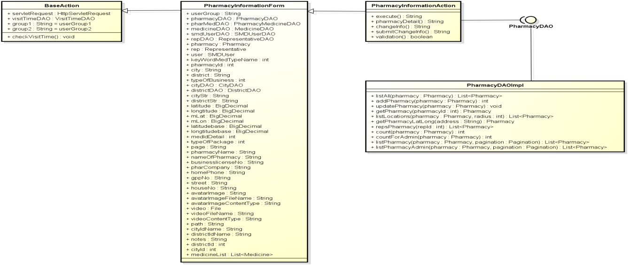

**Figure 4-73:** Class diagram- Pharmacy change info

#### Screen Design

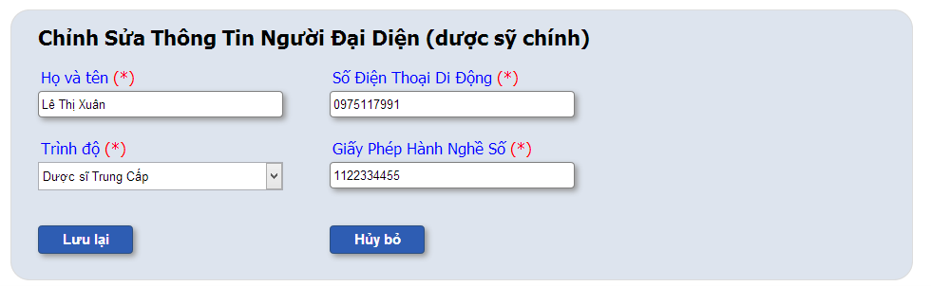

**Figure 4-74:** Pharmacy change info

**Table 4-27:** Pharmacy change info

|  |  |  |  |  |  |  |
| --- | --- | --- | --- | --- | --- | --- |
| **No** | **Object/Control Name** | **Object/Control Name in English** | **Type** | **Required** | **Length** | **Description** |
| 1 | Họ và tên | Name | Text | Y | 150 | New representative name |
| 2 | Số điện thoại di động | Mobile phone | Number | Y | 15 | New representative mobile phone number |
| 3 | Trình độ | Degree | Combo box | Y | N/A | New representative degree |
| 4 | Giấy phép hành nghề số | Licensure No | Text | Y | 100 | New representative licensure number |
| 5 | Lưu lại | Save | Button | N | N/A | Update representative changes infomation |
| 6 | Hủy bỏ | Cancel | Button | N | N/A | Cancel update |

#### Sequence Diagram



**Figure 4-75:** Sequence diagram- Pharmacy change info

### Manage News

#### Class Diagram

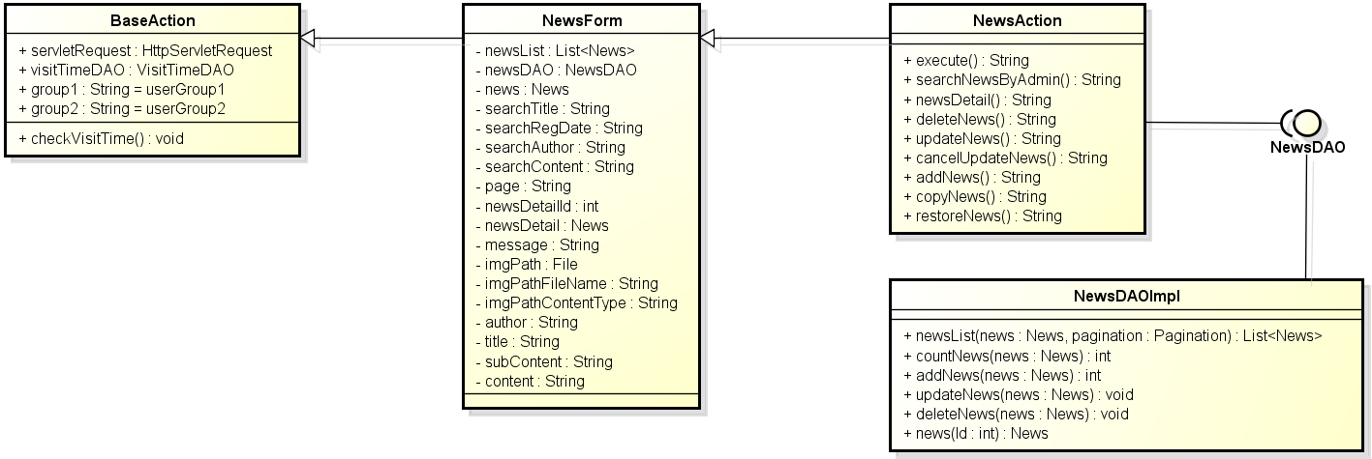

**Figure 4-76:** Class diagram- Manage news

#### UC025 – Add News

##### Screen Design

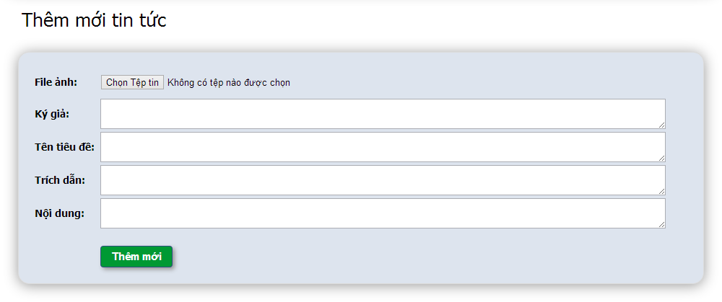**Figure 4-77:** Manage news- Add news

**Table 4-28:** Manage news- Add news

|  |  |  |  |  |  |  |
| --- | --- | --- | --- | --- | --- | --- |
| **No** | **Object/Control Name** | **Object/Control Name in English** | **Type** | **Required** | **Length** | **Description** |
| 1 | File ảnh | Image file | File | Y | N/A | Image of news |
| 2 | Ký giả | Author | Text area | Y | 150 | Name of news’s author |
| 3 | Tên tiêu đề | Title | Text area | Y | 150 | Title of news |
| 4 | Trích dẫn | Sub content | Text area | Y | 500 | Sub content of news |
| 5 | Nội dung | Content | Text area | Y | 5000 | Content of news |
| 6 | Thêm mới | Add | Button | Y | N/A | Add news into system |

##### Sequence Diagram

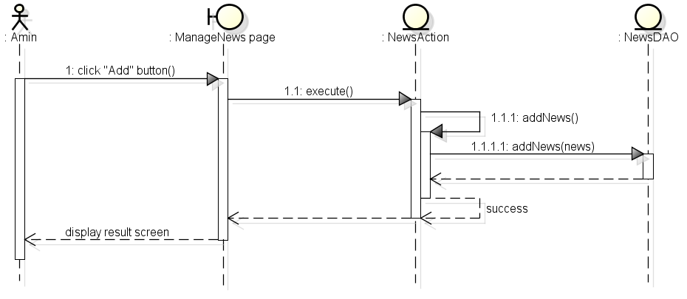

**Figure 4-78:** Sequence diagram- Manage news- Add news

### UC 026 – Update News

#### Screen Design

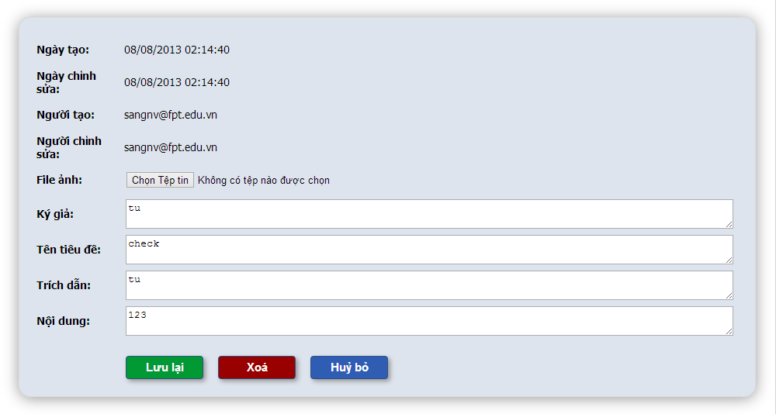

**Figure 4-79:** Manage news- update news

**Table 4-29:** Manage news- update news

|  |  |  |  |  |  |  |
| --- | --- | --- | --- | --- | --- | --- |
| **No** | **Object/Control Name** | **Object/Control Name in English** | **Type** | **Required** | **Length** | **Description** |
| 1 | Ngày tạo | Created date | Text | Y | N/A | News created date |
| 2 | Ngày chỉnh | Modified date | Text | Y | N/A | News modified date |
| 3 | Người tạo | Register user | Text | Y | N/A | News register user name |
| 4 | Người chỉnh sửa | Modify user | Text | Y | N/A | News modify user name |
| 5 | File ảnh | Image file | File | Y | N/A | Image of news |
| 6 | Ký giả | Author | Text area | Y | 150 | Name of news’s author |
| 7 | Tên tiêu đề | Title | Text area | Y | 150 | Title of news |
| 8 | Trích dẫn | Sub content | Text area | Y | 500 | Sub content of news |
| 9 | Nội dung | Content | Text area | Y | 5000 | Content of news |
| 10 | Lưu lại | Save | Button | Y | N/A | Update new news information into system |
| 11 | Xóa | Delete | Button + confirm popup | N | N/A | Update deleteFlag of news to “Y” |
| 12 | Hủy bỏ | Cancel | Button | N | N/A | Cancel edit news |

#### Sequence Diagram

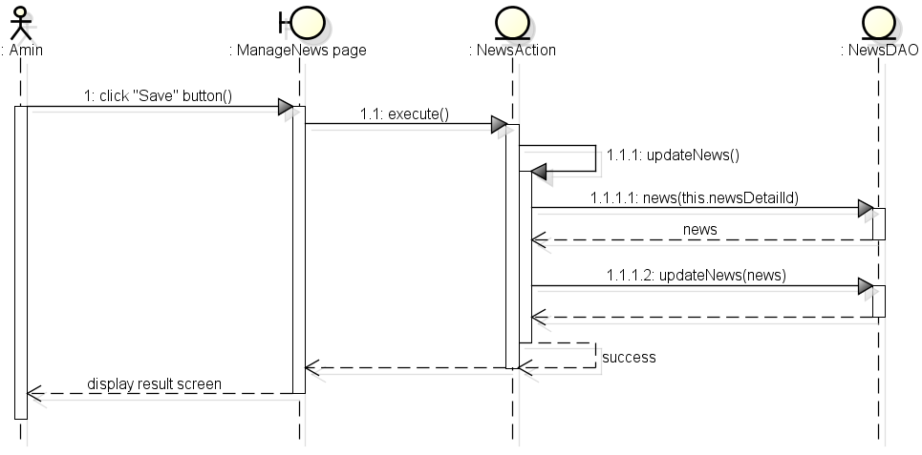

**Figure 4-80:** Sequence diagram- Manage news- Update news

### UC 027 - Delete News

#### Screen Design



**Figure 4-81:** Manage news- Delete news

**Table 4-30:** Manage news- Delete news

|  |  |  |  |  |  |  |
| --- | --- | --- | --- | --- | --- | --- |
| **No** | **Object/Control Name** | **Object/Control Name in English** | **Type** | **Required** | **Length** | **Description** |
| 1 | Ngày tạo | Created date | Text | N | N/A | News created date |
| 2 | Ngày chỉnh | Modified date | Text | N | N/A | News modified date |
| 3 | Người tạo | Register user | Text | N | N/A | News register user name |
| 4 | Người chỉnh sửa | Modify user | Text | N | N/A | News modify user name |
| 5 | File ảnh | Image file | File | N | N/A | Image of news |
| 6 | Ký giả | Author | Text area | N | 150 | Name of news’s author |
| 7 | Tên tiêu đề | Title | Text area | N | 150 | Title of news |
| 8 | Trích dẫn | Sub content | Text area | N | 500 | Sub content of news |
| 9 | Nội dung | Content | Text area | N | 5000 | Content of news |
| 10 | Lưu lại | Save | Button | N | N/A | Update new news information into system |
| 11 | Xóa | Delete | Button + confirm popup | Y | N/A | Update deleteFlag of news to “Y” |
| 12 | Hủy bỏ | Cancel | Button | N | N/A | Cancel edit news |

#### Sequence Diagram

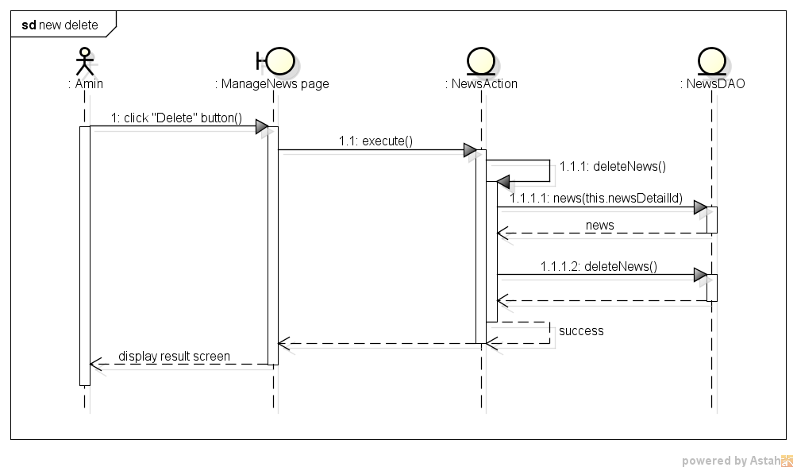

**Figure 4-82:** Sequence diagram- Manage news- Delete news

### UC 028 – Restore News

#### Screen Design

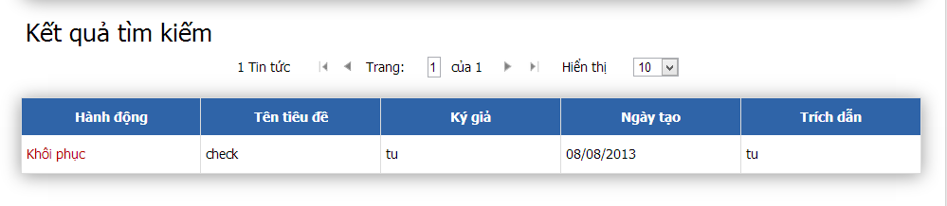

**Figure 4-83:** Manage news- Restore news

**Table 4-31:** Manage news- Restore news

|  |  |  |  |  |  |  |
| --- | --- | --- | --- | --- | --- | --- |
| **No** | **Object/Control Name** | **Object/Control Name in English** | **Type** | **Required** | **Length** | **Description** |
| 1 | Khôi phục | Restore | Link | Y | N/A | Update deleteFlag of news to “N” |
| 2 | Tên tiêu đề | Title | Text | N | N/A | Title of news |
| 3 | Ký giả | Author | Text | N | N/A | Author of news |
| 4 | Ngày tạo | Created date | Text | N | N/A | Created date of news |
| 5 | Trích dẫn | Sub content | Text | N | N/A | Sub content of news |

#### Sequence Diagram

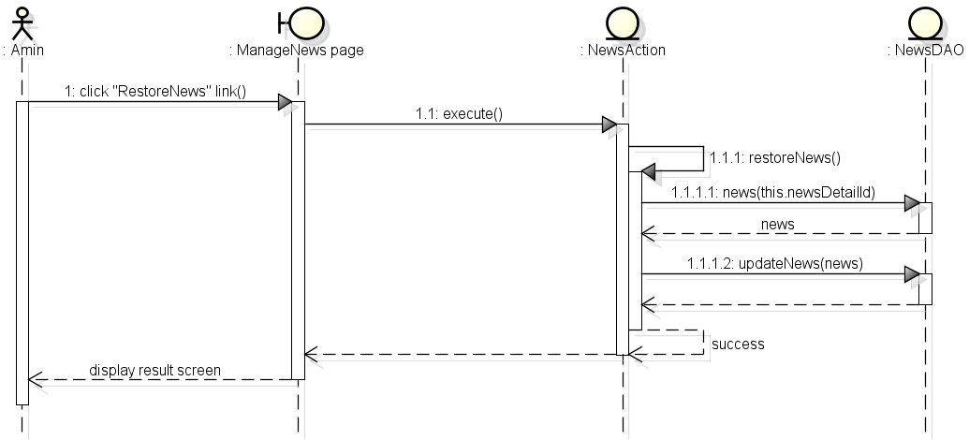

**Figure 4-84:** Sequence diagram- Manage news- Restore news

### UC 029 - Search News

#### Screen Design

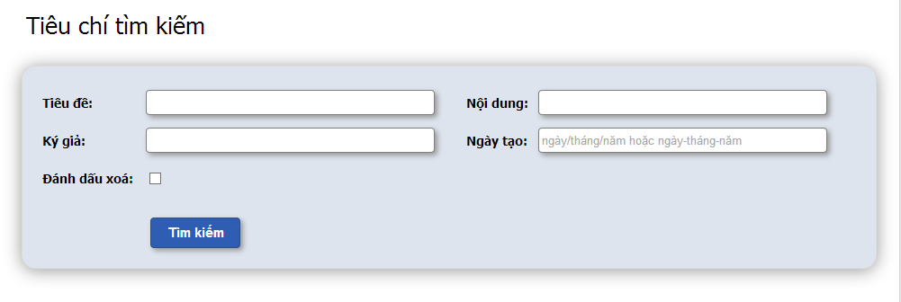

**Figure 4-85:** Manage news- Search news

**Table 4-32:** Manage news- Search news

|  |  |  |  |  |  |  |
| --- | --- | --- | --- | --- | --- | --- |
| **No** | **Object/Control Name** | **Object/Control Name in English** | **Type** | **Required** | **Length** | **Description** |
| 1 | Tên tiêu đề | Title | Text | Y | 150 | Title of news |
| 2 | Nội dung | Content | Text | Y | 5000 | Content of news |
| 3 | Ký giả | Author | Text | Y | 150 | Name of news’s author |
| 4 | Ngày tạo | Create date | Text + date format | Y | N/A | Create date of news |
| 5 | Tìm kiếm | Search | Button | Y | N/A | Search news into system |

#### Sequence Diagram

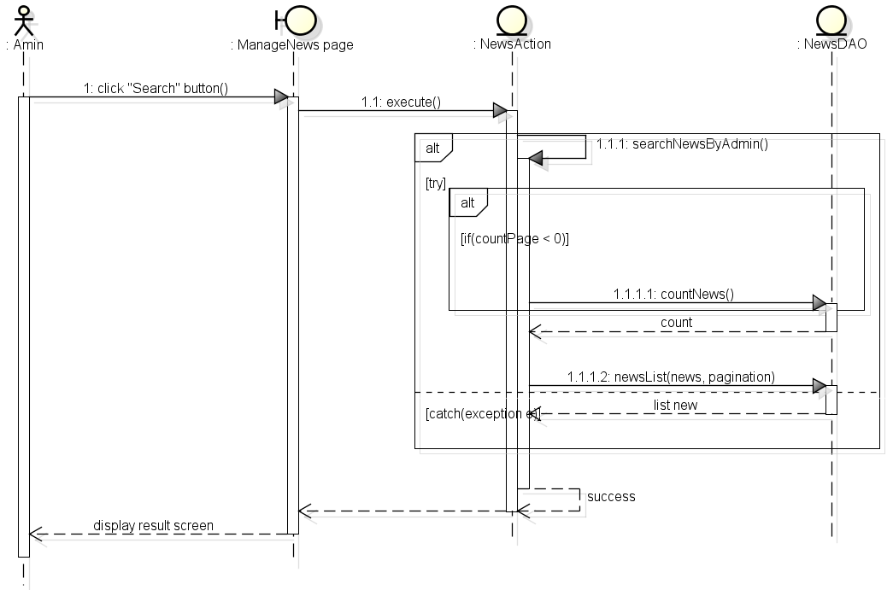

**Figure 4-86:** Manage news- Search news

### UC 030 – View News

#### Screen Design

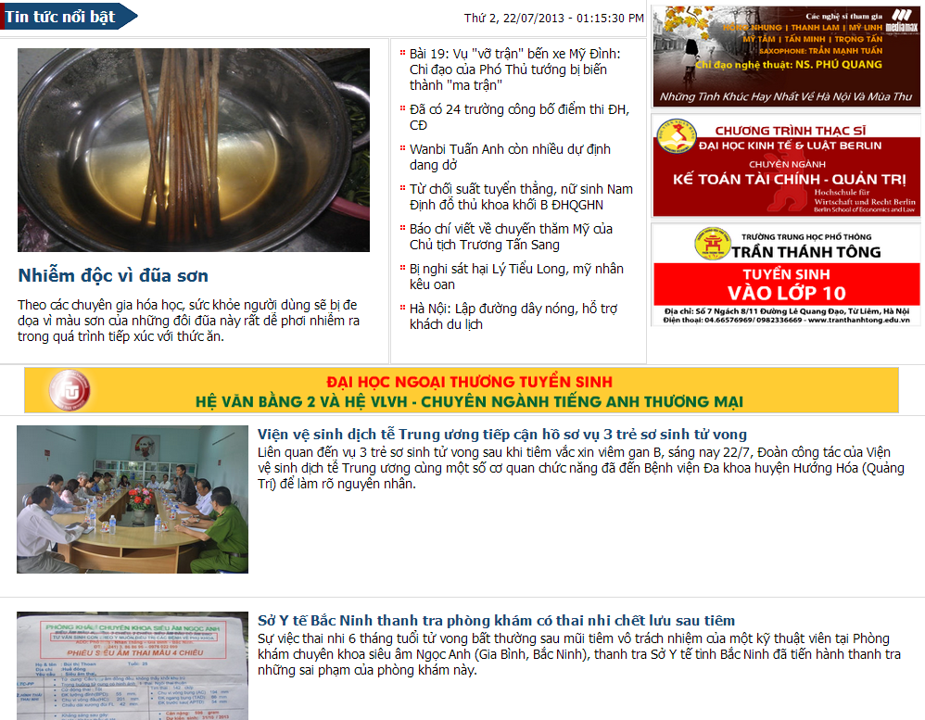

**Figure 4-87:** Manage news- View news

**Table 4-33:** Manage news- View news

|  |  |  |  |  |  |  |
| --- | --- | --- | --- | --- | --- | --- |
| **No** | **Object/Control Name** | **Object/Control Name in English** | **Type** | **Required** | **Length** | **Description** |
| 1 | Tin tức nổi bật | Hight light news | Form | N | N/A | The biggest and hottest news |
| 2 | Những tin tức đáng chú ý | Noteworthy news | Form | N | N/A | Top 7 Noteworthy news |
| 3 | Tin tức thường | Normal news | Form | N | N/A | Normal news |

#### Sequence Diagram

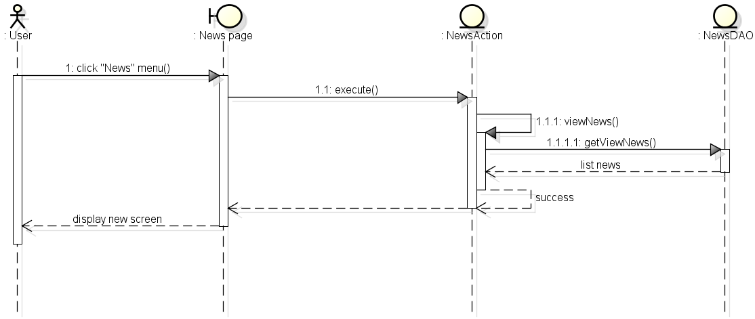

**Figure 4-88:** *Manage news- View news*

### UC 031 – View Detail Medicine Info

#### Class Diagram

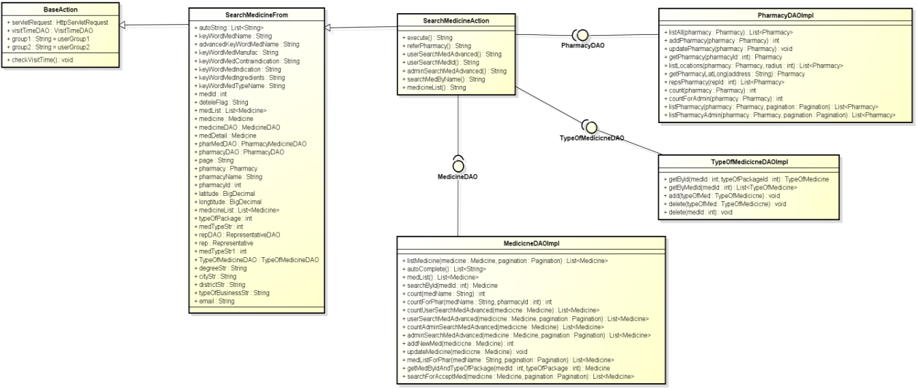

**Figure 4-89:** Class diagram- View detail medicine info

#### Screen Design

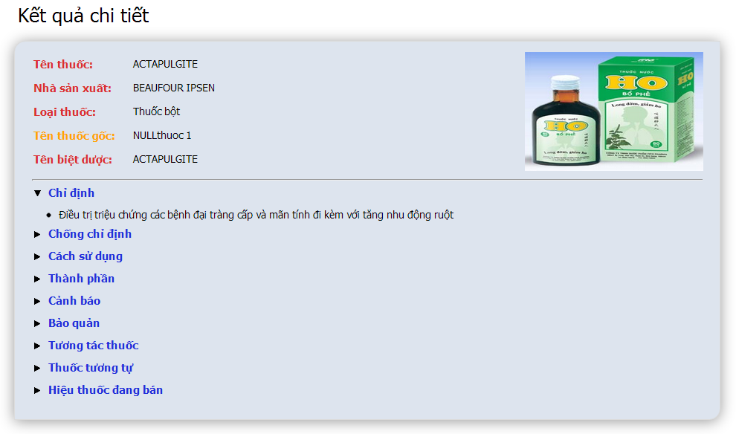

**Figure 4-90:** View detail medicine info

**Table 4-34:** View detail medicine info

|  |  |  |  |  |  |  |
| --- | --- | --- | --- | --- | --- | --- |
| **No** | **Object/Control Name** | **Object/Control Name in English** | **Type** | **Required** | **Length** | **Description** |
| 1 | Tên thuốc | Name | Text | N | N/A | Medicine name |
| 2 | Nhà sản xuất | Manufacturer | Text | N | N/A | Medicine name |
| 3 | Loại thuốc | Types of medicine | Text | N | N/A | Medicine types |
| 4 | Tên thuốc gốc | Generic medicine | Text | N | N/A | Generic name of medicine |
| 5 | Tên biệt dược | Brand name | Text | N | N/A | Brand name of medicine |
| 6 | Chỉ định | Indication | Text + dynamic drop down | N | N/A | Medicine indication |
| 7 | Chống chỉ định | Contraindication | Text + dynamic drop down | N | N/A | Medicine contraindication |
| 8 | Cách sử dụng | Dosing and use | Text + dynamic drop down | N | N/A | Dosing and use of medicine |
| 9 | Thành phần | Ingredient | Text + dynamic drop down | N | N/A | Medicine ingredients |
| 10 | Cảnh bảo | Warring | Text + dynamic drop down | N | N/A | Medicine warring |
| 11 | Bảo quản | Storage | Text + dynamic drop down | N | N/A | Medicine storage |
| 12 | Tương tác thuốc | Interaction medicine | Text + dynamic drop down | N | N/A | Medicines interaction with the medicine |
| 13 | Thuốc tương tự | Similar medicine | Text + dynamic drop down | N | N/A | Medicines similar with the medicine |
| 14 | Hiệu thuốc đang bán | Selling pharmacy | Link + dynamic drop down | N | N/A | Pharmacies selling this medicine |

#### Sequence Diagram

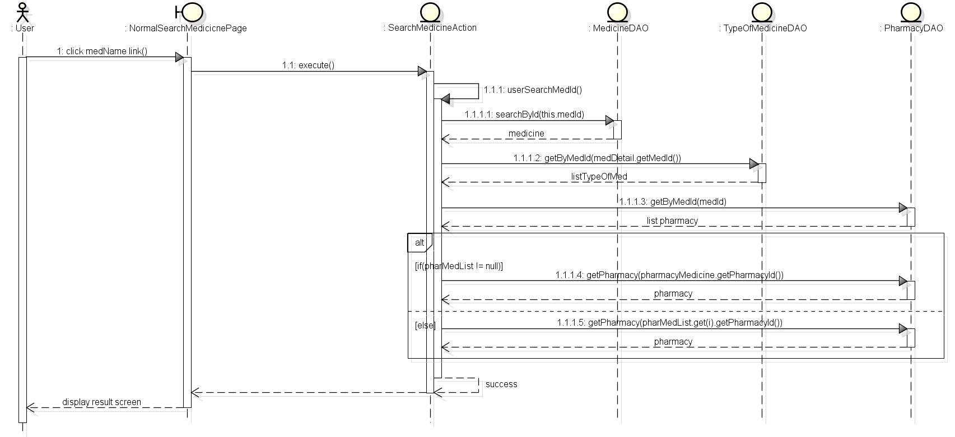

**Figure 4-91:** Sequence diagram- View detail medicine info

### UC 032 – View Detail Pharmacy Info

#### Class Diagram

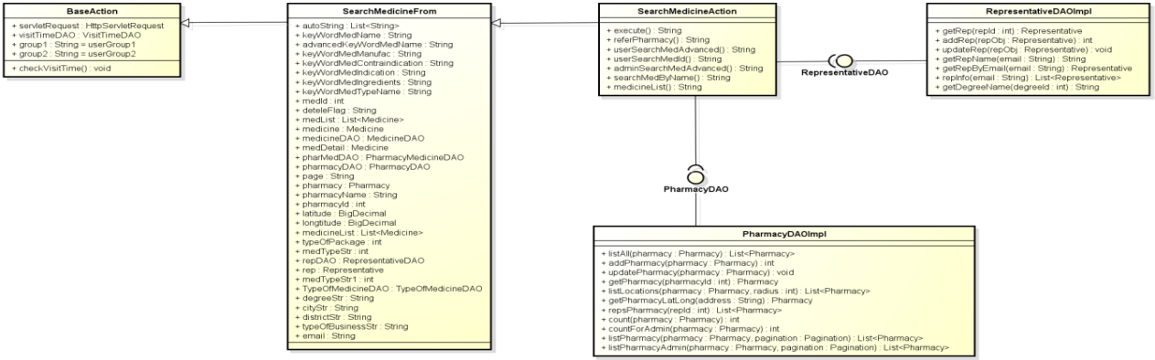

**Figure 4-92:** Class diagram- View detail pharmacy info

#### Screen Design

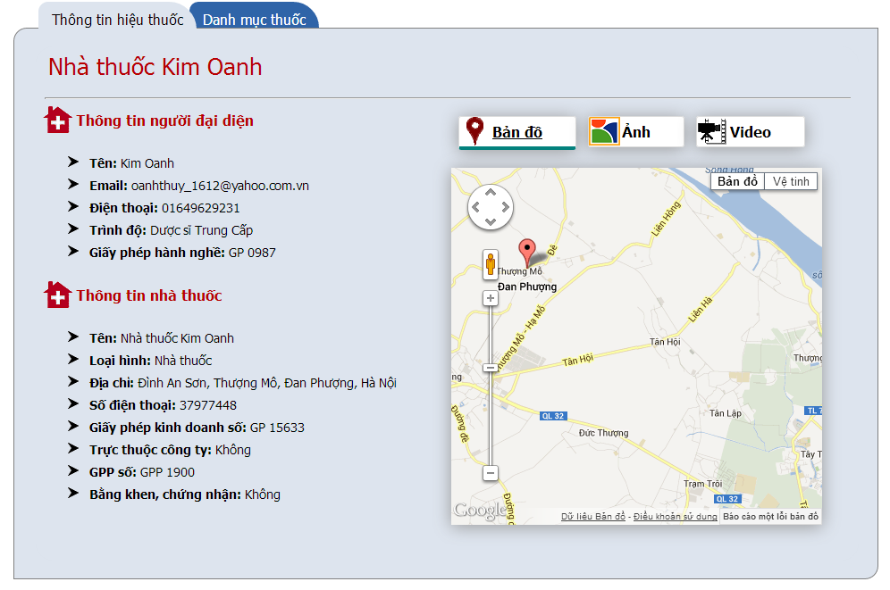

**Figure 4-93:** View detail pharmacy info

**Table 4-35:** View detail pharmacy info

|  |  |  |  |  |  |  |
| --- | --- | --- | --- | --- | --- | --- |
| **No** | **Object/Control Name** | **Object/Control Name in English** | **Type** | **Required** | **Length** | **Description** |
| 1 | Thông tin người đại diện | Representative information | Form | N | N/A | Representative form with 5 detail info ‘Tên’, ‘Email’, ‘Điện thoại’, ‘Trình độ’ and ‘Giấy phép hành nghề’ |
| 2 | Thông tin nhà thuốc | Pharmacy information | Form | N | N/A | Pharmacy information with 8 detail info ‘Tên’, ‘Loại hình’, ‘Địa chỉ’, ‘Số điện thoại’, ‘Giấy phép kinh doanh số’, ‘Trực thuộc công ty’, ‘GPP số’ and ‘Bằng khen, chứng nhận’ |
| 3 | Bản đồ | Map | Tab | N | N/A | Show pharmacy location on google map |
| 4 | Hình ảnh | Image | Tab | N | N/A | Show pharmacy image |
| 5 | Video | Video | Tab | N | N/A | Show pharmacy video |

#### Sequence Diagram

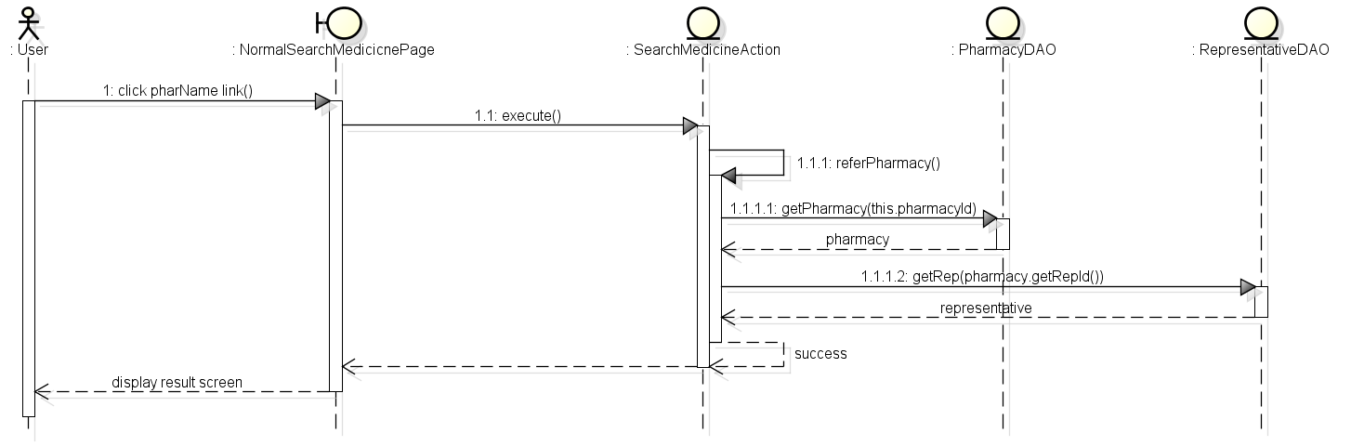

**Figure 4-94:** Sequence diagram- View detail pharmacy info

## Database Design

### Entity Relationship Diagram

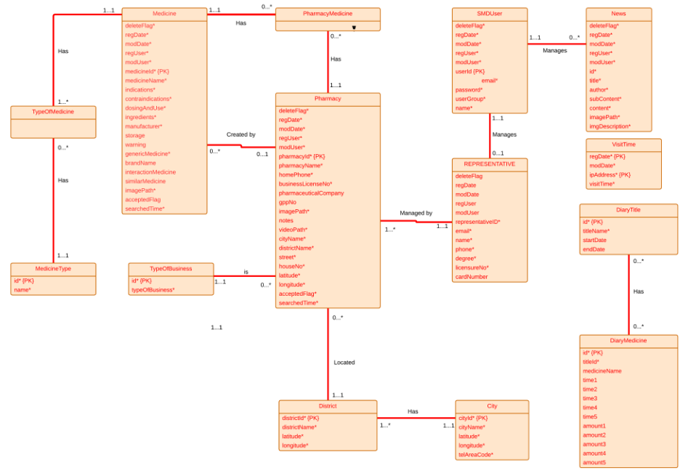

**Figure 4-95:** Entity relationship diagram

### Database Diagram

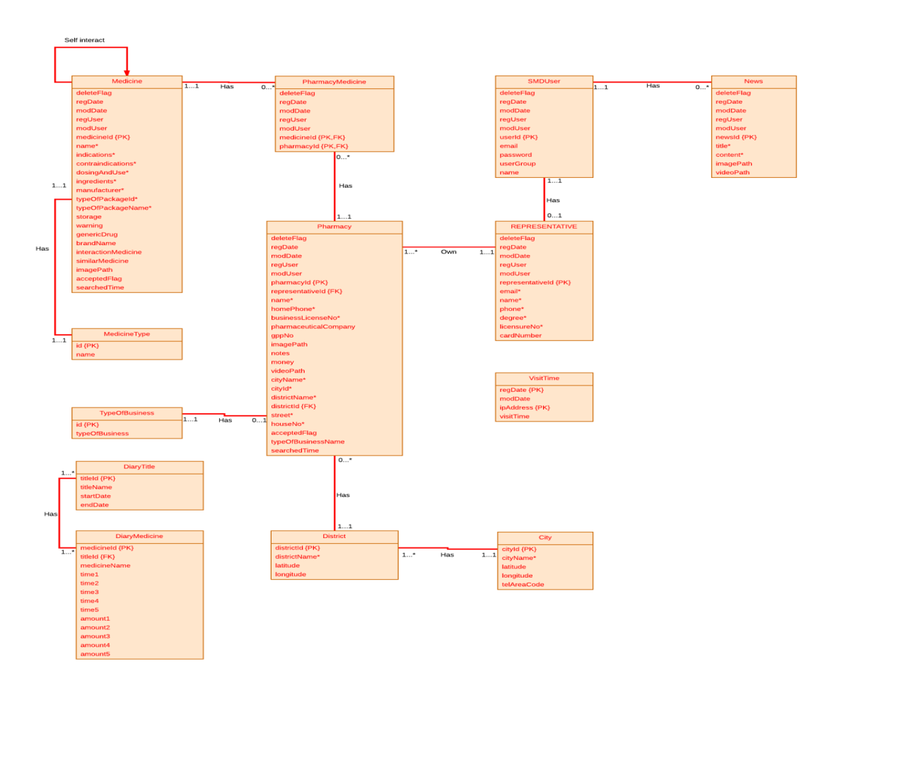**Figure 4-96:** Database diagram

### Table Descriptions

#### Table Medicine

|  |  |  |  |  |
| --- | --- | --- | --- | --- |
| No | Attribute | Type | Constraints | Description |
| 1 | MEDICINE_ID | INT(11) | Not null,  primary key | The primary key auto generated by the system |
| 2 | DELETE_FLAG | VARCHAR(1) | Not null | Marked deleted |
| 3 | REG_DATE | DATE | Not null | Date register medicine |
| 4 | MOD_DATE | DATE | Not null | Date modify medicine |
| 5 | REG_USER | VARCHAR  (150) | Not null | User register medicine |
| 6 | MOD_USER | VARCHAR  (150) | Not null | User modify medicine |
| 7 | PHARMACY_ID | INT(11) | Not null | Pharmacy register the medicine |
| 8 | MEDICINE_NAME | VARCHAR  (150) | Not null | Name of medicine |
| 9 | INDICATIONS | VARCHAR  (3000) | Not null | Indication of medicine |
| 10 | CONTRAINDICATIONS | VARCHAR  (3000) | Not null | Contraindications of medicine |
| 11 | DOSING_AND_USE | VARCHAR  (3000) | Not null | Dosing and use of  medicine |
| 12 | INGREDIENTS | VARCHAR  (3000) | Not null | Ingredients of medicine |
| 13 | MANUFACTURER | VARCHAR  (150) | Not null | Manufacturer of medicine |
| 14 | TYPE_OF_PACKAGE  _ID | INT(11) | Not null,  foreign key | Type of package id of medicine |
| 15 | TYPE_OF_PACKAGE  _NAME | VARCHAR  (150) | Not null | Type of package name of medicine |
| 16 | STORAGE | VARCHAR  (3000) |  | Storage medicine |
| 17 | WARNING | VARCHAR  (3000) |  | Warning of medicine |
| 18 | GENERIC_MEDICINE | VARCHAR  (150) | Not null | Name generic of medicine |
| 19 | BRANDNAME | VARCHAR  (150) |  | Brand name of medicine |
| 20 | INTERACTION_  MEDICINE | VARCHAR  (1500) |  | Interaction of medicine |
| 21 | SIMILAR_MEDICINE | VARCHAR  (1000) |  | Name of similar medicine |
| 22 | IMAGE_PATH | VARCHAR  (150) | Not null | Path to image of medicine |
| 23 | ACCEPTED_FLAG | VARCHAR(1) | Not null | Marked accepted |
| 24 | SEARCH_TIME | INT(11) | Not null | Time to search |

#### Table Pharmacy

|  |  |  |  |  |
| --- | --- | --- | --- | --- |
| No | Attribute | Type | Constraints | Description |
| 1 | PHARMACY_ID | INT(11) | Not null, primary key | The primary key auto generated by the system |
| 2 | DELETE_FLAG | VARCHAR(1) | Not null | Marked deleted |
| 3 | REG_DATE | DATE | Not null | Date register pharmacy |
| 4 | MOD_DATE | DATE | Not null | Date modify pharmacy |
| 5 | REG_USER | VARCHAR(150) | Not null | User register pharmacy |
| 6 | MOD_USER | VARCHAR(150) | Not null | User modify pharmacy |
| 7 | PHARMACY_NAME | VARCHAR(200) | Not null | Name of pharmacy |
| 8 | HOME_PHONE | VARCHAR(10) | Not null | Home phone number of pharmacy |
| 9 | BUSINESS_LICENSE_NO | VARCHAR(100) | Not null | Number business license of pharmacy |
| 10 | PHARMACEUTICAL_COMPANY | VARCHAR(200) |  | Name of pharmaceutical company |
| 11 | GPP_NO | VARCHAR(45) |  | Number of GPP |
| 12 | NOTES | VARCHAR(1000) |  | Notes about pharmacy |
| 13 | IMAGE_PATH | VARCHAR(150) |  | Path to image of pharmacy |
| 14 | VIDEO_PATH | VARCHAR(150) |  | Path to video of pharmacy |
| 15 | REPRESENTATIVE_ID | INT(11) | Not null, foreign key | ID of representative |
| 16 | CITY_NAME | VARCHAR(100) | Not null | City of pharmacy |
| 17 | DISTRICT_NAME | VARCHAR(100) | Not null | District of pharmacy |
| 18 | CITY_ID | INT(11) | Not null | ID of city |
| 19 | DISTRICT_ID | INT(11) | Not null | ID of district |
| 20 | STREET | VARCHAR(100) | Not null | Street of pharmacy |
| 21 | HOUSE_NO | VARCHAR(50) | Not null | Number house of pharmacy |
| 22 | LATITUDE | DOUBLE | Not null | Latitude of pharmacy |
| 23 | LONGTITUDE | DOUBLE | Not null | Longitude of pharmacy |
| 24 | ACCEPTED_FLAG | VARCHAR(1) | Not null | Marked accepted |
| 25 | SEARCHED_TIME | INT(11) | Not null | Time to search |
| 26 | TYPE_OF_BUSINESS | VARCHAR(45) | Not null | Name of type business |

#### Table Pharmacy_Medicine

|  |  |  |  |  |
| --- | --- | --- | --- | --- |
| No | Attribute | Type | Constraints | Description |
| 1 | PHARMACY_ID | INT(11) | Not null, primary key, foreign key | ID of pharmacy |
| 2 | MEDICINE_ID | INT(11) | Not null, primary key, foreign key | ID of medicine |
| 3 | DELETE_FLAG | VARCHAR(1) | Not null | Marked deleted |
| 4 | REG_DATE | DATE | Not null | Date register medicine |
| 5 | MOD_DATE | DATE | Not null | Date modify medicine |
| 6 | REG_USER | VARCHAR(150) | Not null | User register medicine |
| 7 | MOD_USER | VARCHAR(150) | Not null | User modify medicine |

#### Table SMD_User

|  |  |  |  |  |
| --- | --- | --- | --- | --- |
| No | Attribute | Type | Constraints | Description |
| 1 | USER_ID | INT(11) | Not null, primary key | The primary key auto generated by the system |
| 2 | DELETE_FLAG | VARCHAR(1) | Not null | Marked deleted |
| 3 | REG_DATE | DATE | Not null | Date register medicine |
| 4 | MOD_DATE | DATE | Not null | Date modify medicine |
| 5 | REG_USER | VARCHAR(150) | Not null | User register medicine |
| 6 | MOD_USER | VARCHAR(150) | Not null | User modify medicine |
| 7 | EMAIL | VARCHAR(100) | Not null | Email of User |
| 8 | PASSWORD | VARCHAR(100) | Not null | Password of User |
| 9 | NAME | VARCHAR(150) | Not null | Name of User |
| 10 | USER_GROUP | INT(11) | Not null | Group of User |

#### Table Representative

|  |  |  |  |  |
| --- | --- | --- | --- | --- |
| No | Attribute | Type | Constraints | Description |
| 1 | REPRESENTATIVE_ID | INT(11) | Not null, primary key | The primary key auto generated by the system |
| 2 | DELETE_FLAG | VARCHAR(1) | Not null | Marked deleted |
| 3 | REG_DATE | DATE | Not null | Date register medicine |
| 4 | MOD_DATE | DATE | Not null | Date modify medicine |
| 5 | REG_USER | VARCHAR(150) | Not null | User register medicine |
| 6 | MOD_USER | VARCHAR(150) | Not null | User modify medicine |
| 7 | EMAIL | VARCHAR(150) | Not null | Email of representative |
| 8 | NAME | VARCHAR(150) | Not null | Name of representative |
| 9 | PHONE | VARCHAR(11) | Not null | Phone of representative |
| 10 | DEGREE | VARCHAR(11) | Not null | Degree of representative |
| 11 | LICENSURE_NO | VARCHAR(100) | Not null | Licensure number of representative |
| 12 | CARD_NUMBER | VARCHAR(45) |  | Number card of representative |

#### Table Medicine_Type

|  |  |  |  |  |
| --- | --- | --- | --- | --- |
| No | Attribute | Type | Constraints | Description |
| 1 | PACKAGE_ID | INT(11) | Not null, primary key | Id of medicine type |
| 2 | PACKAGE_NAME | VARCHAR(150) | Not null | Name of medicine type |

#### Table City

|  |  |  |  |  |
| --- | --- | --- | --- | --- |
| No | Attribute | Type | Constraints | Description |
| 1 | CITY_ID | INT(11) | Not null, primary key | Id of City |
| 2 | DELETE_FLAG | VARCHAR(1) | Not null | Marked deleted |
| 3 | REG_DATE | DATE | Not null | Date register medicine |
| 4 | MOD_DATE | DATE | Not null | Date modify medicine |
| 5 | REG_USER | VARCHAR(150) | Not null | User register medicine |
| 6 | MOD_USER | VARCHAR(150) | Not null | User modify medicine |
| 7 | CITY_NAME | VARCHAR(50) | Not null | Name of city |
| 8 | LATITUDE | DOUBLE | Not null | Latitude of city |
| 9 | LONGITUDE | DOUBLE | Not null | Longitude of city |
| 10 | TEL_AREA_CODE | INT(11) | Not null | Tel area code of city |

#### Table District

|  |  |  |  |  |
| --- | --- | --- | --- | --- |
| No | Attribute | Type | Constraints | Description |
| 1 | DISTRICT_ID | INT(11) | Not null, primary key | Id of District |
| 2 | DELETE_FLAG | VARCHAR(1) | Not null | Marked deleted |
| 3 | REG_DATE | DATE | Not null | Date register medicine |
| 4 | MOD_DATE | DATE | Not null | Date modify medicine |
| 5 | REG_USER | VARCHAR(150) | Not null | User register medicine |
| 6 | MOD_USER | VARCHAR(150) | Not null | User modify medicine |
| 7 | DISTRICT_NAME | VARCHAR(100) | Not null | Name of District |
| 8 | CITY_ID | INT(11) | Not null, foreign key | Latitude of district |
| 9 | LATITUDE | DOUBLE | Not null | Longitude of district |
| 10 | LONGITUDE | DOUBLE | Not null | ID of City |

#### Table News

|  |  |  |  |  |
| --- | --- | --- | --- | --- |
| No | Attribute | Type | Constraints | Description |
| 1 | NEWS_ID | INT(11) | Not null, primary key | The primary key auto generated by the system |
| 2 | DELETE_FLAG | VARCHAR(1) | Not null | Marked deleted |
| 3 | REG_DATE | DATE | Not null | Date register medicine |
| 4 | MOD_DATE | DATE | Not null | Date modify medicine |
| 5 | REG_USER | VARCHAR(150) | Not null | User register medicine |
| 6 | MOD_USER | VARCHAR(150) | Not null | User modify medicine |
| 7 | TITLE | VARCHAR(200) | Not null | Title of News |
| 8 | CONTENT | VARCHAR(3000) | Not null | Content of News |
| 9 | IMAGE_PATH | VARCHAR(150) | Not null | Path to image of News |
| 10 | VIDEO_PATH | VARCHAR(150) | Not null | Path to video of News |

#### Table Type_Of_Business

|  |  |  |  |  |
| --- | --- | --- | --- | --- |
| No | Attribute | Type | Constraints | Description |
|  | NEWS_ID | INT(11) | Not null, primary key | ID of type |
|  | TYPE_OF_BUSINESS | VARCHAR(100) | Not null | Type of business |

#### Table Visit_Time

|  |  |  |  |  |
| --- | --- | --- | --- | --- |
| No | Attribute | Type | Constraints | Description |
|  | REG_DATE | DATETIME | Not null, primary key | Date register |
|  | MOD_DATE | DATETIME | Not null | Date modify |
|  | IP_ADDRESS | VARCHAR(15) | Not null, primary key | IP of address |
|  | VISIT_TIME | INT(11) | Not null | Time to visit |

#### Table Diary_Title

|  |  |  |  |  |
| --- | --- | --- | --- | --- |
| No | Attribute | Type | Constraints | Description |
|  | TITLE_ID | TEXT | Not null, primary key | Title’sid of Diary |
|  | TITLE_NAME | TEXT | Not null | Title’s name of Diary |
|  | START_DATE | TEXT | Not null | Date’s start of Diary |
|  | END_DATE | TEXT | Not null | Date’s end of Diary |

#### Table Diary_Medicine

|  |  |  |  |  |
| --- | --- | --- | --- | --- |
| No | Attribute | Type | Constraints | Description |
|  | MEDICINE_ID | TEXT | Not null, primary key | Medicine’s id of Diary |
|  | TITLE_ID | TEXT | Not null, foreign key | Title’s id of Diary |
|  | MEDICINE_NAME | TEXT | Not null | Medicine’s name of Diary |
|  | TIME1 | TEXT | Not null | Using time of medicine no.1 |
|  | TIME2 | TEXT | Not null | Using time of medicine no.2 |
|  | TIME3 | TEXT | Not null | Using time of medicine no.3 |
|  | TIME4 | TEXT | Not null | Using time of medicine no.4 |
|  | TIME5 | TEXT | Not null | Using time of medicine no.5 |
|  | AMOUNT1 | TEXT | Not null | Amount medicine for time no.1 |
|  | AMOUNT2 | TEXT | Not null | Amount medicine for time no.2 |
|  | AMOUNT3 | TEXT | Not null | Amount medicine for time no.3 |
|  | AMOUNT4 | TEXT | Not null | Amount medicine for time no.4 |
|  | AMOUNT5 | TEXT | Not null | Amount medicine for time no.5 |

**Report #5:**

**SOFTWARE TEST DOCUMENTATION**

# SOFTWARE TESTING

## Introduction

### Purpose

The purpose of this document is to plan all the activities needed to perform testing for the system including test strategy and test control. This document also defines scope, requirements, and constraints, risks of testing stages.

### System Overview

SMD is an online system that can run in both web application and Android devices so it is flexible and convenient to use every time and everywhere that can connect to the internet. The system is divided into multiple modules for each specific kind of user. The combination of these modules makes the workflow of the whole system become unified, so that it can work fluently

* **On web module**, that system provides these main functions:
  + **Manage medicine information**

System just allows user who logins as Administrator have permission to manage medicine information. So that they can search/ add new/ edit/ delete/ restore medicine information as they want.

With normal user, they only have permission in add new medicine into the selling list of their pharmacy

* + **Manage pharmacy information**

Administrator user will also have permission to manage pharmacy information. They can accept or reject or delete every pharmacies information which has problem

Normal user can only apply their own pharmacy into system after being accepted by admin

* + **Search medicine**

Everyone who uses that system can make search with medicine information.

* + **Search pharmacy**

Everyone who uses that system can make search with pharmacy information.

* + **Find the nearest pharmacy**

Everyone who uses that system can easily find out the pharmacy that is near by their location by input their position

* + **View news**

Everyone who uses that system can up to date with medical information through that software

* **Mobile module** has these main functions:
  + **Search medicine**

Everyone who uses that system can make search with medicine or pharmacy information.

* + **Find the nearest pharmacy**

Everyone who uses that system can easily find out the pharmacy that is near by their location by accessing their mobile GPS satellite

* + **Diary**

This feature just runs on mobile version. User can save their medicine taking schedule to be alarmed on time

## Test plan

### Scope of testing

The scope of testing in the project include:

* **Stages of testing**: the team has responsibility to conduct Unite testing, Integration testing and System testing
* **Types of testing**: The test team have to test functional and user interface testing
* **Range of testing**: Team performs testing all functions defined in the SRS based on the approved version. Test cases of each function are defined in the Test cases document that will be tested to determine if they meet the requirements and intermediate result will also be checked according to the SRS

### Requirement for testing

#### Test items

|  |  |  |
| --- | --- | --- |
| **No** | **Group of functions** | **Functions** |
| Mobile module | | |
|  | Mobile module | Search medicine |
|  | View Medicine Details |
|  | Find the nearest pharmacy |
|  | Pharmacy detail information |
|  | Medical Diary |
| Web module | | |
|  | Search medicine | Search medicine |
|  | Medicine advance search |
|  | Search pharmacy | Pharmacy advance search |
|  | Find the nearest pharmacy |
|  | News | View News |
|  | Add News |
|  | Edit News |
|  | Delete News |
|  | Account control | Register |
|  | Login |
|  | Logout |
|  | <Pharmacy user> Change information |
|  | <Pharmacy user> Change password |
|  | <Pharmacy user> Add new selling medicine |
|  | <Pharmacy user> Remove selling medicine |
|  | Manage pharmacy information | Search registered pharmacy |
|  | Accept registered pharmacy |
|  | Deny registered pharmacy |
|  | Delete pharmacy |
|  | Manage medicine information | Search medicine |
|  | Add new medicine |
|  | Copy new medicine |
|  | Edit medicine |
|  | Delete medicine |
|  | Restore medicine |

#### Acceptance Test Criteria

* Test coverage: >= 97%
* Test successful coverage: >= 97%

Number of test cases failed: less than 3% of total test cases

#### Constraints

* Duration of testing is from 30-Jul to 10-Aug
* Testing team only has 2 members
* The program has many functions so the number of line code is also, lead to have more number of test cases.

#### Risk list

The project could face with some risks:

* Tester has not familiar with Android OS so that the progress testing is slower than plan, team may not keep the deadline as plan
* Test devices may go off
* Lack of time and resources for testing

### Test strategy

#### Test policy

* “Test without good faith”
* “Find bugs as soon as possible and always make sure they have been fixed”
* “No outstanding high severity faults”
* “Ensuring the product covers key features and attributes requirements”

#### Test model

Using V-Model to implement testing process

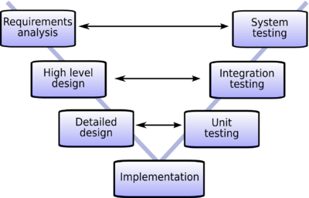

**Figure 5-1:** V-Model to implement testing process

Due to scope of SMD project and project must always fulfill user requirements. With V-Model, software development is separated into two appropriate phases’ groups: development and testing. Testing phase is carried out simultaneously from the early of project, the requirement specification phase. Therefore, tester could study and understand the entire requirement as well as business of project

Moreover, there are many variations among planning, design and implementation during the whole project. To catch up with all changes and ensure logic as well as business, V-model is chose as a solution to help testers control and follow the actual workflows.

This testing is executed to ensure that all requirements mentioned in SRS, included both functional requirements and non-functional requirements which are implemented correctly.

* **Technique:**
* **Integration test**: Base on requirement in SRS and validation in database, test team will test as black box testing method to check if the input and output display as expected and does that flow work fluently
* **System** **testing**: Based on requirements in SRS, test team will create scenarios for system testing (ST) to ensure project’s business. In ST, tester will create test cases based on these scenarios and run to verify functional and non-functional requirements.
* **Completion criteria:**
* All planned test cases have been executed compared with expected result in test cases.
* System test cases must be green (passed) at least 97%
* All defects must be logged into test documents and re-tested after it is fixed.
* All defects, which are accepted by customer or project technical leader and project manager, will be marked as accepted and not be retested.
* All defects must be resolved or accepted.
* These criteria will be applied for all test types.
* **Special considerations:**
* Test databases will be required
* Testing may be stopped when
* Time runs out
* A certain number of defects found
* Test coverage > 97%
* Stop when testing becomes unproductive.

#### Type of testing

##### Functional Testing

Function testing of the target-of-test should focus on any requirements for test that can be traced directly to use cases or business functions and business rules.  The goals of these tests are to verify proper data acceptance, processing, and retrieval, and the appropriate implementation of the business rules.  This type of testing is based upon black box a 1application via the Graphical User Interface (GUI) and analyzing the output or results.  Identified below is an outline of the testing recommended for each application

|  |  |
| --- | --- |
| Test Objective: | The type of this test is to ensure proper target-of-test functionality, including user interaction, all function defined in specification document implemented correctly. |
| Technique: | The test team will execute each use case, use-case flow, or function, using valid and invalid data, to verify the following:  The expected results occur when valid data is used.  The appropriate error or warning messages are displayed when invalid data is used.  Each business rule is properly applied. |
| Completion Criteria: | All planned tests have been executed.  All identified defects have been addressed and closed |
| Special Considerations: | Testing may be stopped when  Time runs out  A certain number of defects found  Test coverage > 97%  Stop when testing becomes unproductive |

Table 5-1: Functional testing

##### User Interface Testing

User Interface (UI) testing verifies a user’s interaction with the software. The goal of UI testing is to ensure that the User Interface provides the user with the appropriate access and navigation through the functions of the target-of-test.  In addition, UI testing ensures that the objects within the UI function as expected and conform to corporate or industry standards.

|  |  |
| --- | --- |
| Test Objective: | Verify the following: Navigation through the target-of-test properly reflects business functions and requirements, including window-to-window, field-to-field, and use of access methods (tab keys, mouse movements, accelerator keys |
| Technique: | Create or modify tests for each page to verify proper navigation and object states for each page |
| Completion Criteria: | Each window successfully verified to remain consistent with benchmark version or within acceptable standard |

Table 5-2: User Interface testing

#### Test stage

Clearly state the stage in which the test will be executed. Identified below are the stages in which common test are executed

|  |  |  |  |
| --- | --- | --- | --- |
| Type of Tests | Stage of Test | | |
| Unit | Integration | System |
| Function Test | x | x | x |
| User Interface test | x |  | x |

Table 5-3: Test stages

#### Tools

|  |  |  |  |
| --- | --- | --- | --- |
| Purpose | Tool | Vendor/In-house | Version |
| Access to website | Internet explorer |  |  |
| Chrome |  |  |
| Firefox |  |  |
| Opera |  |  |
| Run the software | Android OS device |  | Android OS 2.3.3 or upper |
| Keep tracking defects | MS Word |  | Office 2010 & 2013 |
| Test Plan | MS Word |  | Office 2010 & 2013 |
| Test Case, Test Report | MS Excel |  | Office 2010 & 2013 |

Table 5-4: Tools

#### Resources

This table shows the staffing assumptions for the project.

|  |  |
| --- | --- |
| Worker/Doer | Specific Responsibilities/Comments |
| Ngô Hà Thu  Phạm Hà Hải | Manage Test resource and assign test tasks  Create Test Plan  Review Test Cases  Create Test Report  Execute Test |

Table 5-5: Human resource

## Test case

Refer to TestCases_FunctionTest_SMD.xls

## Checklist

### Check list about Home page

|  |  |  |  |
| --- | --- | --- | --- |
| **Question** | **Yes** | **No** | **N/A** |
| Navigation space is the same on all page |  |  |  |
| Do feature buttons on submenu display with the right role of users? |  |  |  |
| Do Quick search part display right below submenu? |  |  |  |
| Display advertisement below Quick search part on Homepage |  |  |  |
| Do feature button link to the right page? |  |  |  |
| Does contact information part display at the bottom of the page? |  |  |  |

### Check list about validation

|  |  |  |  |
| --- | --- | --- | --- |
| **Question** | **Yes** | **No** | **N/A** |
| If the user enters an invalid value and clicks on the OK button is the invalid field identified and highlighted correctly with an error message? |  |  |  |
| Do all mandatory fields require user input? |  |  |  |
| For all numeric fields check whether negative numbers cannot and should not be able to be entered. |  |  |  |
| Does username require the right form of an email? |  |  |  |
| Can input password less than 9 characters? |  |  |  |
| Can edit mandatory fields? |  |  |  |

### Submission check list

|  |  |  |  |
| --- | --- | --- | --- |
| **Question** | **Yes** | **No** | **N/A** |
| **TABLES AND FIGURES** | | | |
| Does every table column, including the stub column, have a heading? |  |  |  |
| Are all tables referred to in text? |  |  |  |
| Is lettering in a figure no smaller than 12 points and no larger than 14 points? |  |  |  |
| Are all figures and tables mentioned in the text and numbered in the order in which they are mentioned? |  |  |  |
| **REFERENCES** | | | |
| Are references cited both in text and in the reference list? |  |  |  |
| Do the text citations and reference list entries agree both in spelling and in date? |  |  |  |
| Are website links in the reference list typed fully? |  |  |  |
| Have all referenced information noted with their sources? |  |  |  |
| **FORMAT** | | | |
| Do all pages have header and footer? |  |  |  |
| Does margin display as: Top: 2.5cm, Bottom: 2.5cm, Left: 3.5cm, Right: 2cm for the whole report? |  |  |  |
| Is “Time New Roman” font used for the whole report? |  |  |  |
| Are all pages numbered in sequence, starting with the title page? |  |  |  |
| **PARAGRAPHS AND HEADINGS** | | | |
| Is each paragraph longer than a single sentence but not longer than one manuscript page? |  |  |  |
| Are all paragraph distributed as justify format? |  |  |  |
| Does all normal text have font size as 12point? |  |  |  |
| Is the line spacing multiple at 1.15 for the whole report? |  |  |  |
| Do the levels of headings accurately reflect the organization of the report? |  |  |  |
| Do all headings of the same level appear in the same format? |  |  |  |
| **USABILITY** | | | |
| Are the entire field prompts spelt correctly? |  |  |  |
| Are fonts too large or too small to read? |  |  |  |
| Are names in command button & option box names are not abbreviations. |  |  |  |
| Assure that option boxes, option buttons, and command buttons are logically grouped together in clearly demarcated areas "Group Box" |  |  |  |
| Can the typical user run the system without frustration? |  |  |  |
| Does the site have a consistent, clearly recognizable "look-&-feel"? |  |  |  |
| Is all terminology understandable for all of the site’s intended users? |  |  |  |
| **USER INTERFACE TESTING-COLOR** |  |  |  |
| Are hyperlink colors standard? |  |  |  |
| Are the field prompts the correct color? |  |  |  |
| Are the field backgrounds the correct color? |  |  |  |
| Are the screen and field colors adjusted correctly for non-editable mode? |  |  |  |
| Does the site use (approximately) standard link colors? |  |  |  |
| Are all the buttons are in standard format and size? |  |  |  |
| Is the general screen background the correct color? |  |  |  |
| Is the page background (color) distraction free? |  |  |  |
| **USER INTERFACE TESTING-CONTENT** |  |  |  |
| All fonts to be the same |  |  |  |
| Are all the screen prompts specified in the correct screen font? |  |  |  |
| Is all text properly aligned? |  |  |  |
| Is the text in all fields specified in the correct screen font? |  |  |  |
| Is all the headings left aligned? |  |  |  |
| Does the first letter of the second word appear in lowercase? |  |  |  |

## TEST LOGS

### Defect logs

|  |  |  |  |  |  |  |  |
| --- | --- | --- | --- | --- | --- | --- | --- |
| **No** | **Module name** | **Defect** | **Priority** | **Status** | **Assign to** | **Fix on** | **Retest on** |
|  |  |  |  |  |  |  |  |
|  |  |  |  |  |  |  |  |

### Test report

|  |  |  |  |
| --- | --- | --- | --- |
| **Project Name** | Smart Medicine Dictionary | **Creator** | ThuNH |
| **Project Code** | SMD | **Reviewer/Approver** | SangNV |
| **Document Code** |  | **Issue Date** | August 1­­0th 2013 |

|  |  |  |  |  |  |  |
| --- | --- | --- | --- | --- | --- | --- |
| **No** | **Module code** | **Pass** | **Fail** | **Untested** | **N/A** | **Number of test cases** |
| **Mobile module** | | | | | | |
| 1 | Search medicine |  |  |  |  |  |
| 2 | View Medicine Details |  |  |  |  |  |
| 3 | Find the nearest pharmacy |  |  |  |  |  |
| 4 | Pharmacy detail information |  |  |  |  |  |
| 5 | Medical Diary |  |  |  |  |  |
| **Web module** | | | | | | |
| 6 | Search medicine |  |  |  |  |  |
| 7 | Medicine advance search |  |  |  |  |  |
| 8 | Pharmacy advance search |  |  |  |  |  |
| 9 | Find the nearest pharmacy |  |  |  |  |  |
| 10 | View News |  |  |  |  |  |
| 11 | Add News |  |  |  |  |  |
| 12 | Edit News |  |  |  |  |  |
| 13 | Delete News |  |  |  |  |  |
| 14 | Register |  |  |  |  |  |
| 15 | Login |  |  |  |  |  |
| 16 | Logout |  |  |  |  |  |
| 17 | <Pharmacy user> Change information |  |  |  |  |  |
| 18 | <Pharmacy user> Change password |  |  |  |  |  |
| 19 | <Pharmacy user> Add new selling medicine |  |  |  |  |  |
| 20 | <Pharmacy user> Remove selling medicine |  |  |  |  |  |
| 21 | Search registered pharmacy |  |  |  |  |  |
| 22 | Accept registered pharmacy |  |  |  |  |  |
| 23 | Deny registered pharmacy |  |  |  |  |  |
| 24 | Delete pharmacy |  |  |  |  |  |
| 25 | Search medicine |  |  |  |  |  |
| 26 | Add new medicine |  |  |  |  |  |
| 27 | Copy new medicine |  |  |  |  |  |
| 28 | Edit medicine |  |  |  |  |  |
| 29 | Delete medicine |  |  |  |  |  |
| 30 | Restore medicine |  |  |  |  |  |
|  | **Sub total** |  |  |  |  |  |

**Test coverage**

**Test successful coverage**

**Report #6:**

**SOFTWARE USER’S MANUALS**

# Software User’s Manuals

## Installation Guide

### Introduction

This document contains guide-lines step by step to use SMD application, and set up its own database.

### Environment

Following are the software required to start the SMD System:

- Operating System: Windows 7

- Application server: SMD application system requires an application server running on Windows 7

- Browsers : Firefox 20, Chrome 25, IE 9 or higher.

- Smartphone: Android OS version 2.3 or higher

- .NET 4.0 Framework

- Database: MySQL 5.6.9 or higher

- Apache Tomcat 6

- Tool: Eclipse Indigo SR1

### Application Installation

#### Set up Environments:

- For web: If users want to use SMD system on personal computer, users need to install Chrome25 /Firefox 20/ IE9 or higher version and MySQL to create and store database.

- For mobile: Users can use SMD system on Smartphone support Android Os version 2.3 or higher.

- Tool development: Eclipse Indigo SR1

- Deployment environment for research: JDK 1.6 or JRE 1.6

- Application server for research: Tomcat 6

- Application server for real application: JBoss AS 7.1

#### Database creation

Please follow these steps to create a new database for system:

**Step 1**: Preparing database.

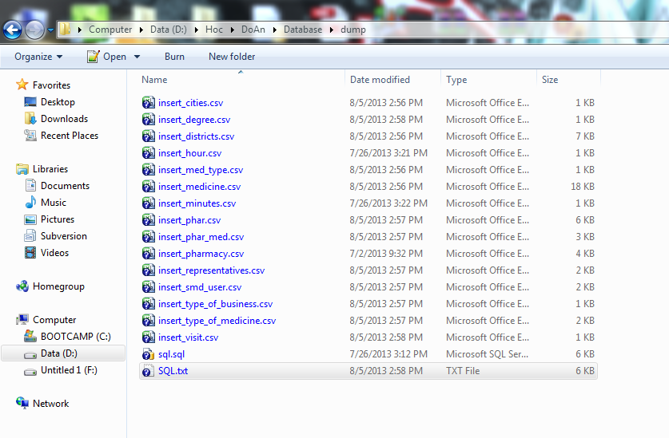

**Figure 6-1**: Create database folder

They include a .sql file and .csv file. The .sql file is database SQL scrip file and .csv file is file store data.

**Step 2**: Import database to MySQL

After we have a database server ( that installs MySQL ) as I said sooner, we open it

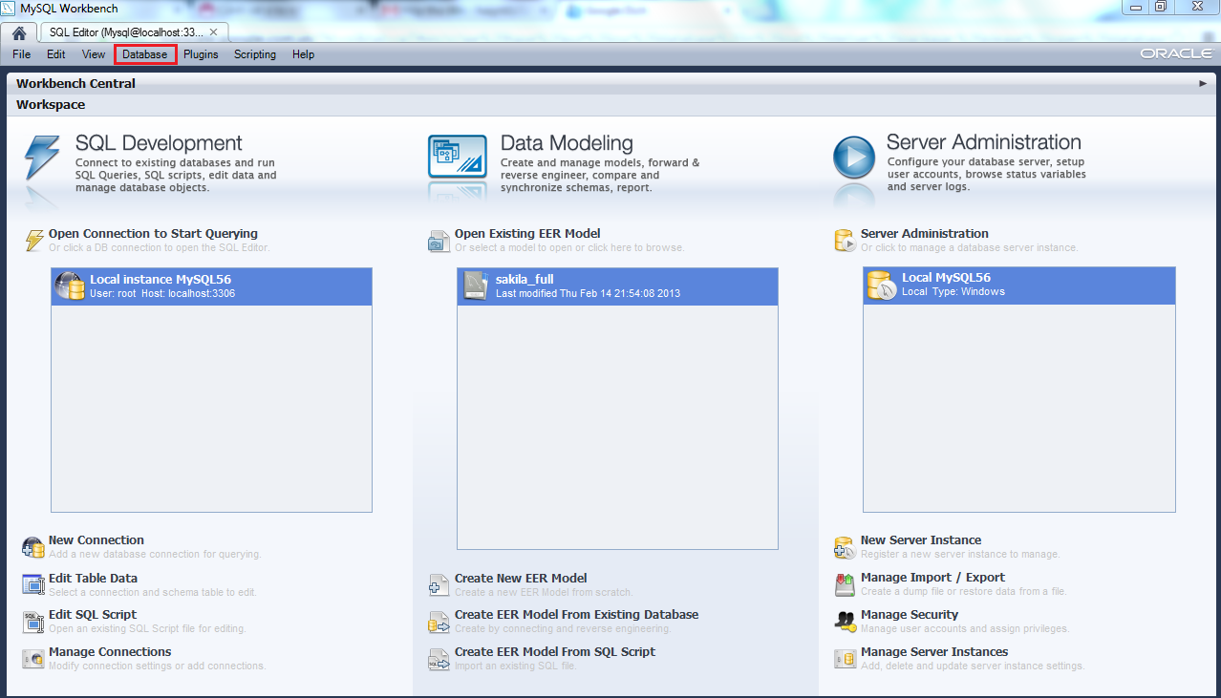

**Figure 6-2:** Open MySQL

After open MySQL, select Database menu 🡪 Query Database or press Ctrl + U 🡪 Display table to login and connect to database.

Please login to Database by the account that you have defined in the installation progress and click “OK” button.

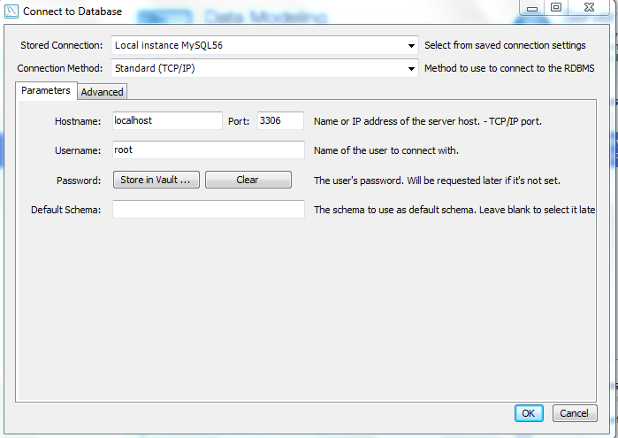

**Figure 6-3:** Login to Database

After login to MySQL server, create new schema, import file .sql and select excute

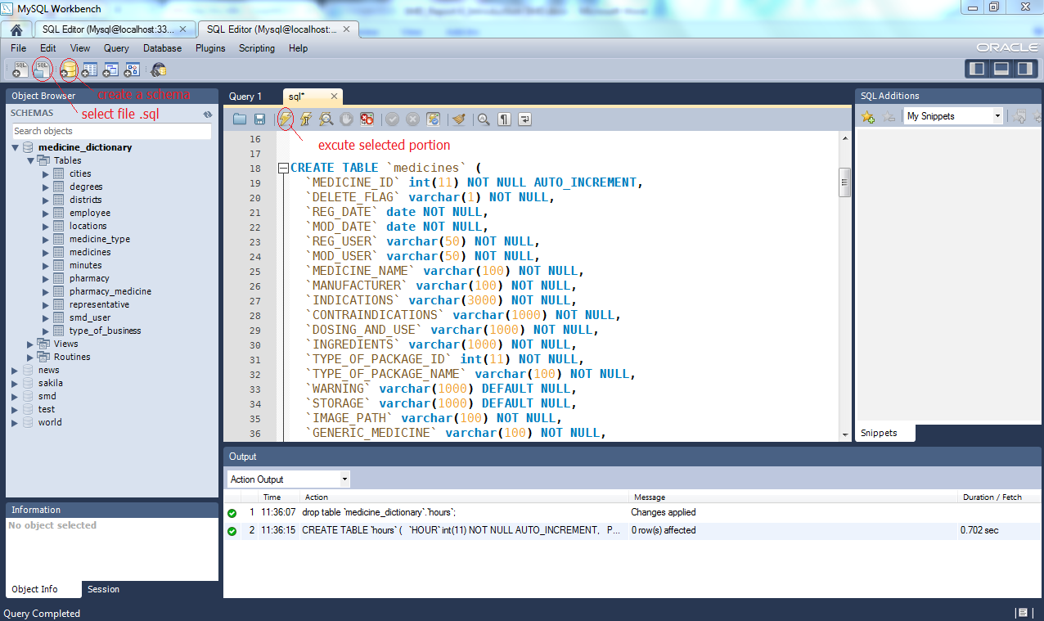

**Figure 6-4**: Execute database success

After excute .sql file, import file csv to Tables of Schema.

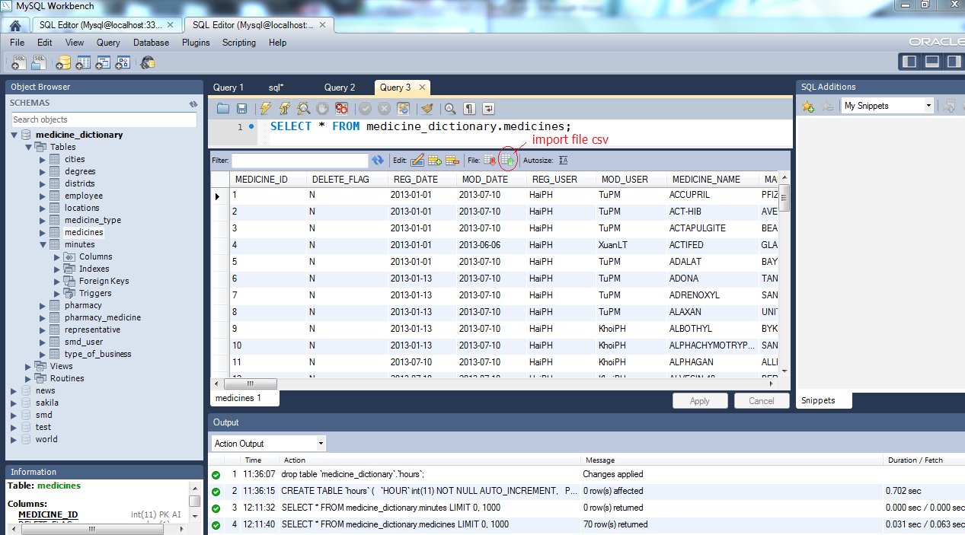

**Figure 6-5**: Import file .csv success

Through these step, you have database SMD in MySQL server.

#### Deploy web application

After you have browser ( that install Firefox 20, Chrome 25, IE 9 or higher ).

Open browser and enter format link:

[http://servername:port no/MedicineDictionaryWebApp/*](http://servername:port%20no/MedicineDictionaryWebApp/*)

🡪 Browser will access automatically to the home page of SMD.

##### Deploy application in Tomcat:

**Step 1**: Start Apache Tomcat

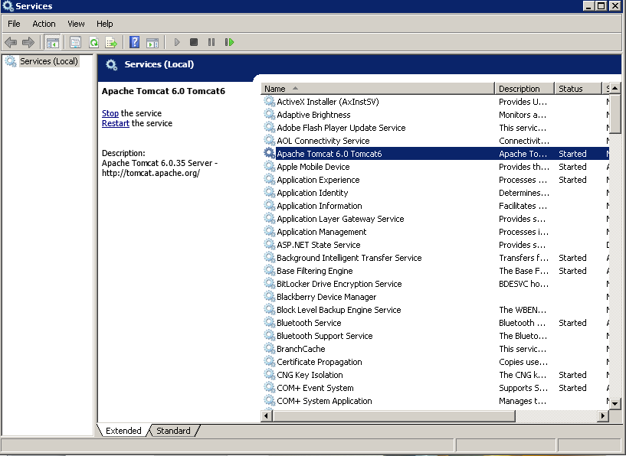

**Step 2**: Copy **MedicineDictionaryWebApp.war** to **<Apache_Home>\Tomcat 6.0\webapps** and it will deploy automatically.

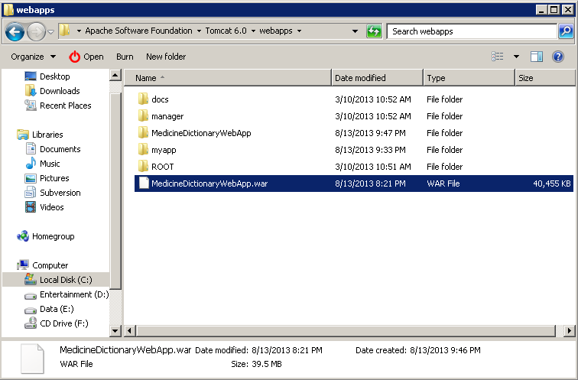

**Step 3**: Open a browser and go to link: <http://localhost:8080/MedicineDictionaryWebApp/home> and see the result

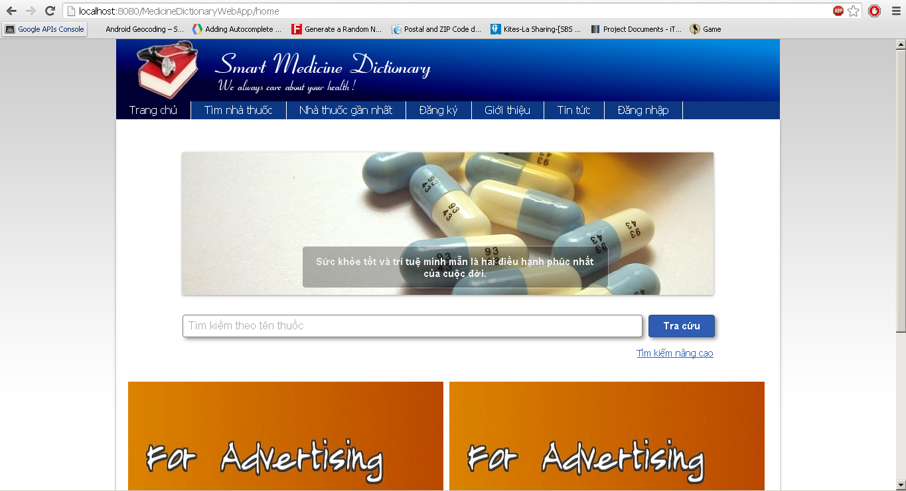

##### Deploy application in JBoss AS:

**Step 1:** Start JBoss. You can do this by starting a Standalone Server<JBOSS_HOME>\bin\standalone.bat(Windows)

You'll need to make sure you've set a JAVA_HOME system variable that points to a JDK1.6 version or later of the JDK before starting JBoss.

**Step 2**: Copy file **MedicineDictionaryWebApp.war** to **<JBOSS_HOME>\standalone\deployments**. This will "hot deploy" the Web application, which means it will automatically deploy without having to restart JBoss. If **MedicineDictionaryWebApp.war.deployed** it means that you deployed successful.

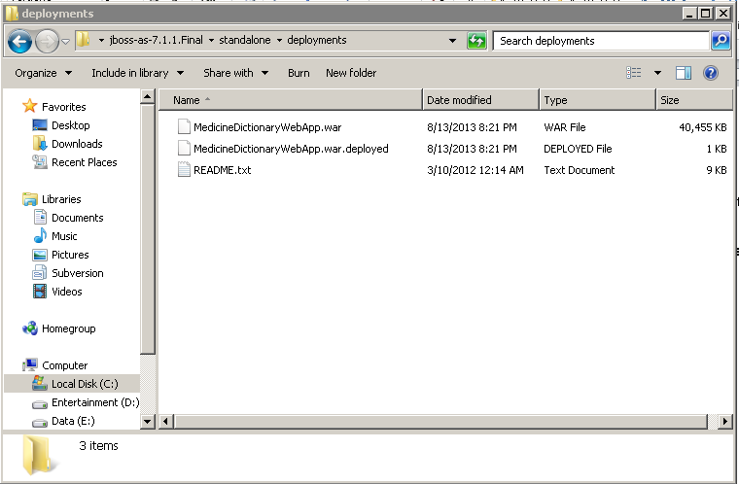

**Step 3:** Open a browser and go to link: <http://localhost:8080/MedicineDictionaryWebApp/home> and see the result

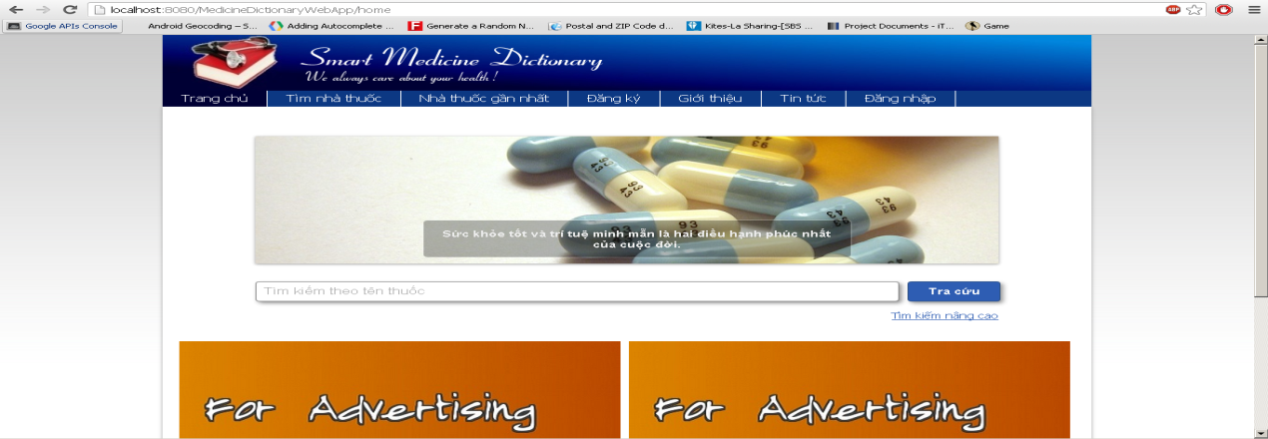

**Step 4:** Stopping the Server

The JBoss AS7 server can be stopped by pressing **Ctrl-C** on the command line.

If the server is running in a background process, the server can be stopped using the JBoss CLI:

**<JBOSS_HOME>/bin/jboss-cli.sh --connect --command=:shutdown**

#### Deploy mobile application

To run this application, your mobile must be running Android OS version 2.3 or higher. First, you must download SMD .apk file to install.

There is way to download and install this file :

- In your mobile device, you access to Play Store then search SMD application and download directly to your mobile. After download, system will automatic install application on you mobile. After install successful, open application and run it.

- You also can access directly from link: ( not available )

On Local:

**Step 1**: Download AppInstaller from android market

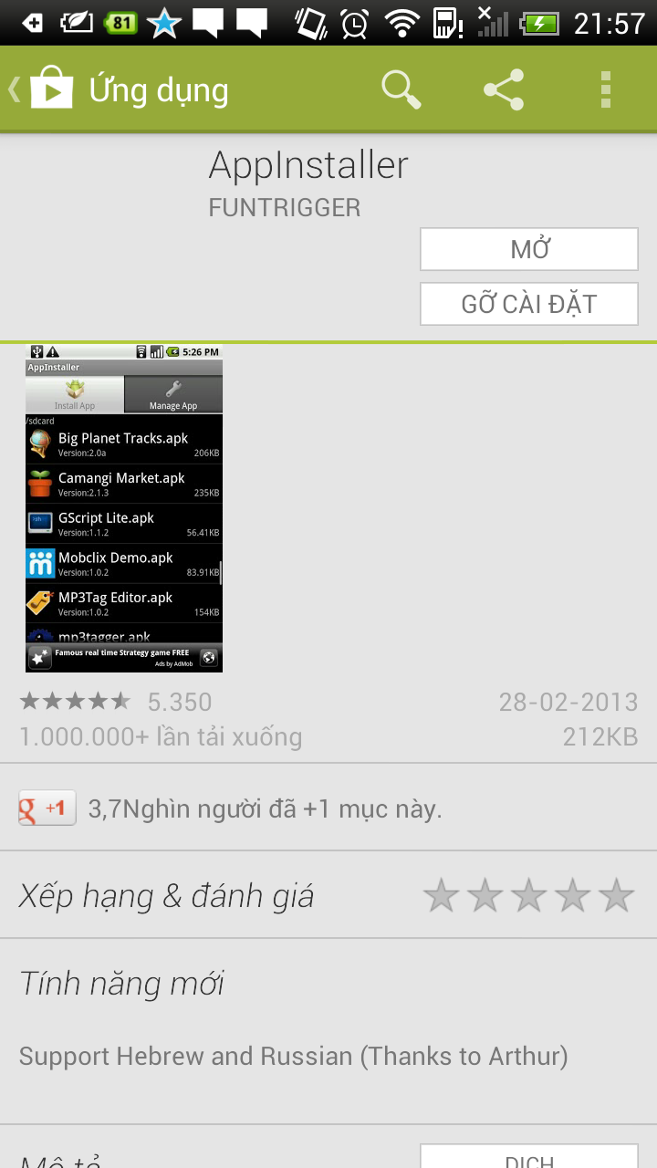

**Step 2**: Copy files SMDProject.apk to smart phone (memory card or memory in mobile)

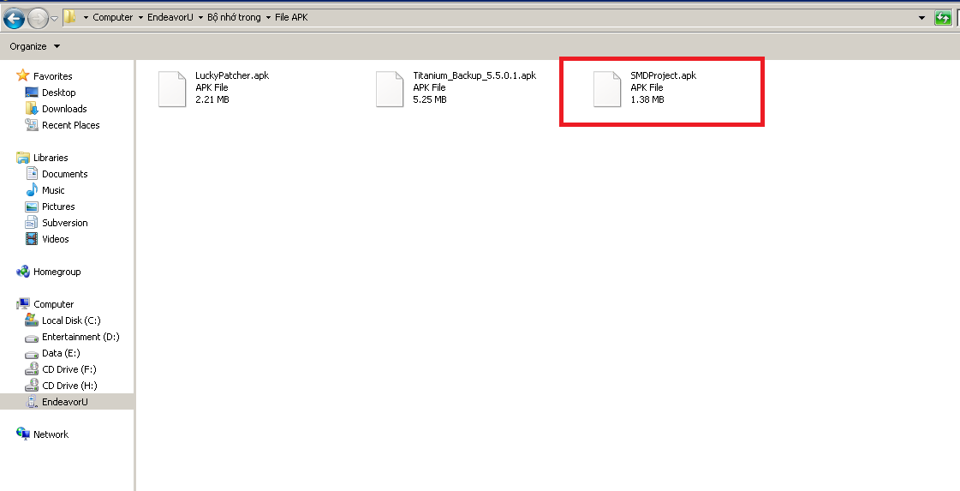

**Step 3**: Run AppInstaller to search file .APK and install to use

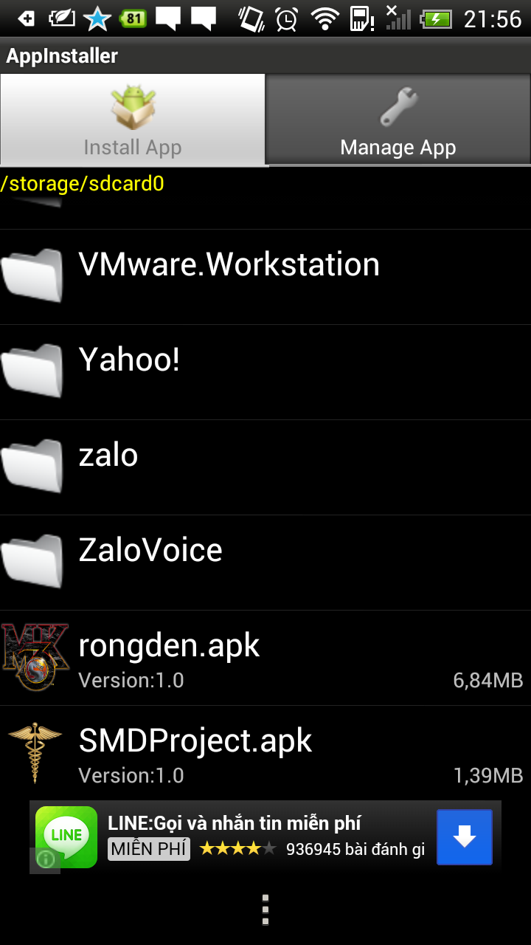

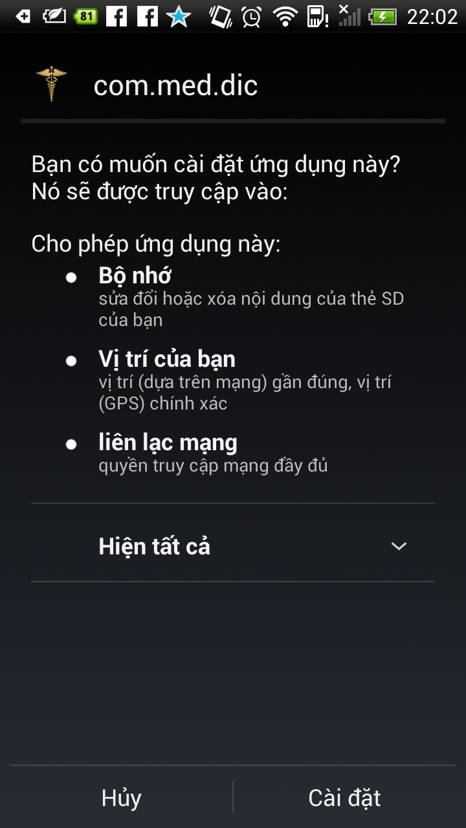

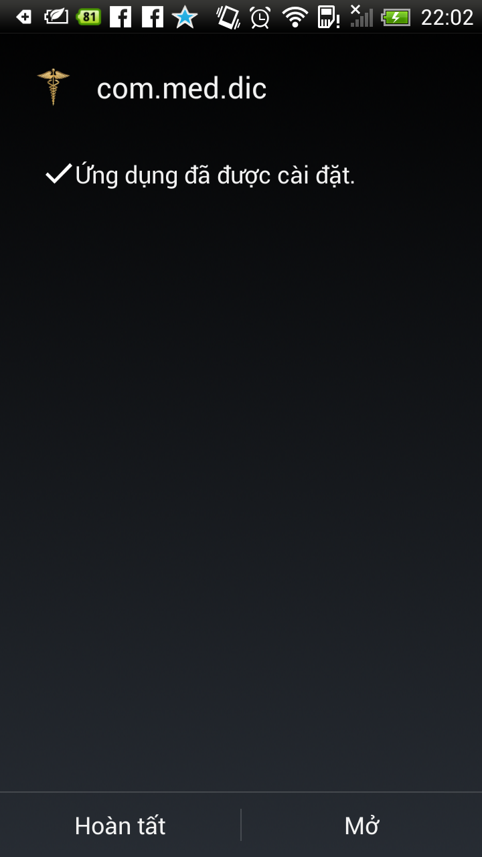

## User’s Guide

### Purpose

This user's manual has been developed to help users better understand the requirements that may apply to use this application by providing them simple step by step tutorials. This manual is intended to help make application's functions more accessible and their associated requirements more understandable to users.

### Functional Description

Before using the SMD System, you need to have an account that provides from administrator. After your browser loading website, the homepage will be show. For using the features of SMD application that you can access (depend on your user group), the first step that you need to do is log-in to the system.

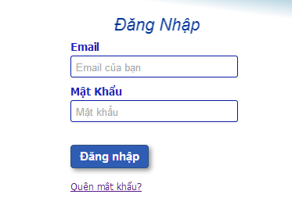

**Figure 6-6:** Login screen

### Detail guidelines

#### Homepage

The first page which user will see is the homepage. From this page the user can go to every page they want.

**Step 1**: Open browser and enter to the address bar: localhost, IP address or name of the distant server:

Example: <http://localhost:8080/MedicineDictionaryWebApp/home>

**Step 2**: Oberver homepage.

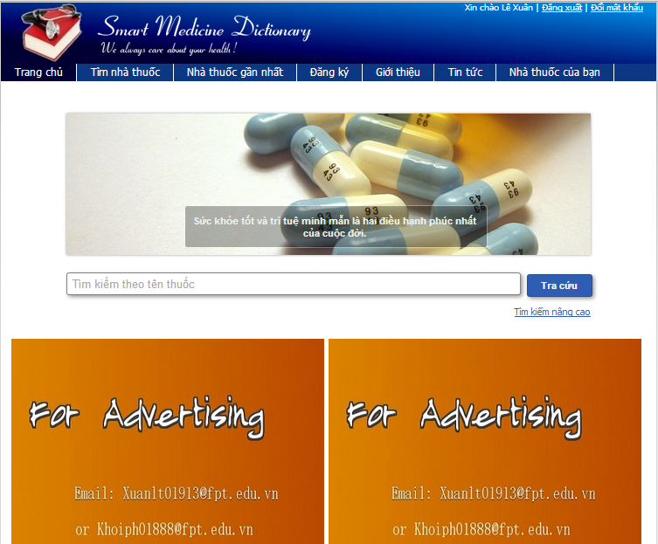

**Figure 6-7:** Homepage screen

#### Quick Search Medicine

To use quick search function on website, the users do the steps below:

**Step 1**: Type medicine name into search box on Home page

**Step 2**: Click “Search” button 🡪 Display result list of found medicine

**Step 3**: Click on a medicine name 🡪 Displays medicine detail information

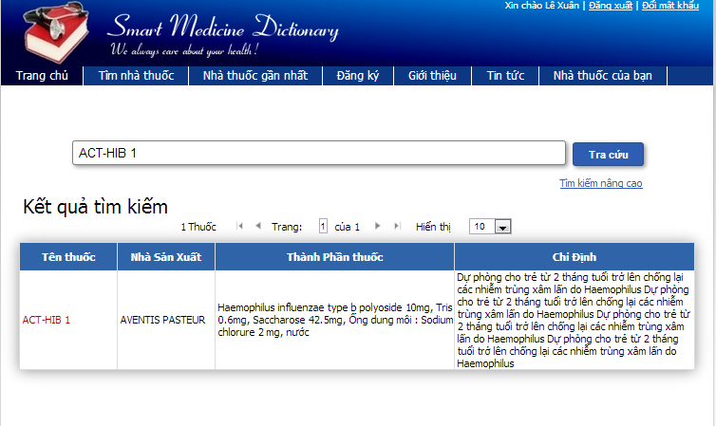

**Figure 6-8:** Quick search screen

#### Medicine Advance Search

To use medicine advance search function on website, the users do the steps below:

**Step 1**: Click on “Medicine/ Medicine Advanced Search” hyperlink on Search Medicine screen

**Step 2**: Type the element that they want to filter result by into the right text box

**Step 3**: Click “Search” button 🡪 Display result list of found medicine

**Step 4**: Click on medicine name on the search result 🡪 Displays medicine detail information

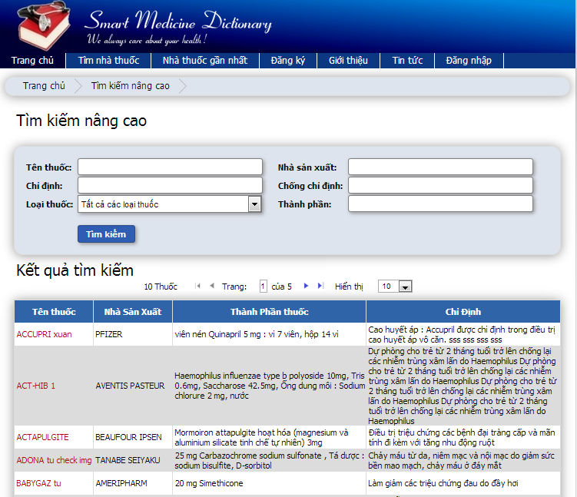

**Figure 6-9:** Medicine advanced search screen

#### Pharmacy Advanced Search

To use pharmacy advanced search function on website, the users do the steps below:

**Step 1**: Click on “Pharmacy Advance Search” hyperlink on Search Pharmacy screen

**Step 2**: Type pharmacy name into text box then press Search button

**Step 3**: Click on pharmacy name 🡪 Show that pharmacy information

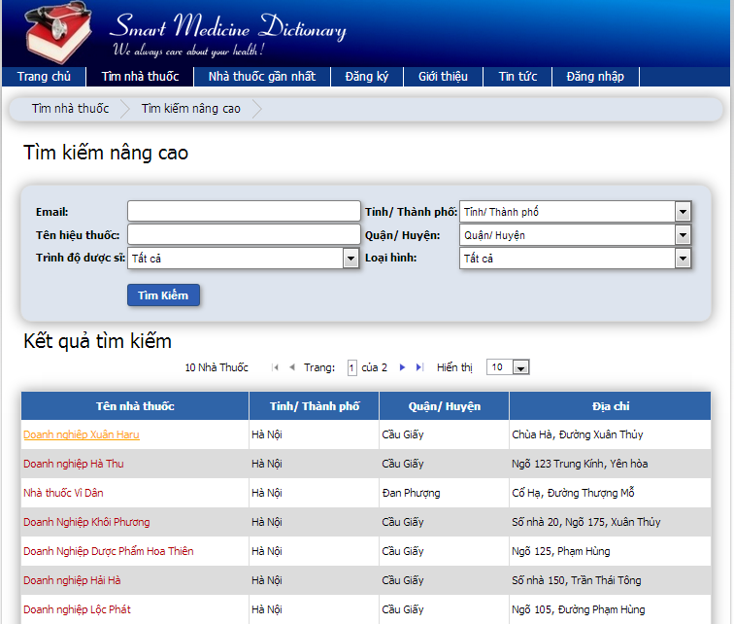

**Figure 6-10:** Pharmacy advanced search screen

#### Find Nearest Pharmacy (web)

To use find nearest pharmacy function on website, the users do the steps below:

**Step 1**: Click on “Find Nearest Pharmacy” tab

**Step 2**: Insert their location address into text box then press Search button

**Step 3**: Click on the nearest pharmacy icon on map 🡪 Show that pharmacy information and the direction to get there

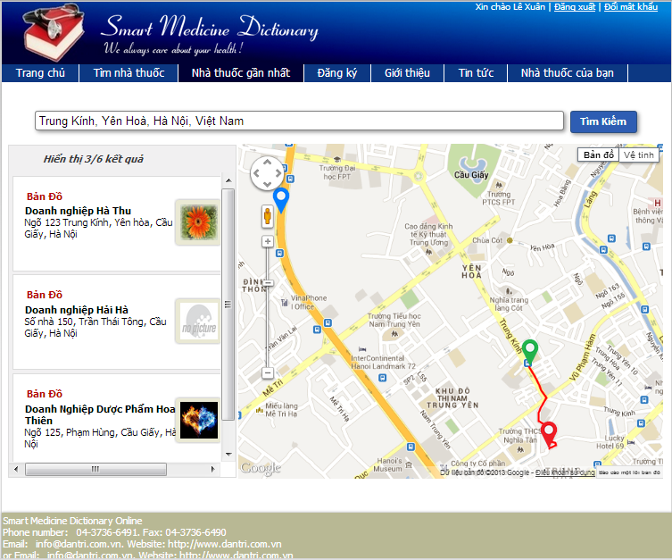

**Figure 6-9:** Find nearest pharmacy screen

#### Register

To use register function on website, the users do the steps below:

**Step 1**: Click on “Register” tab on submenu

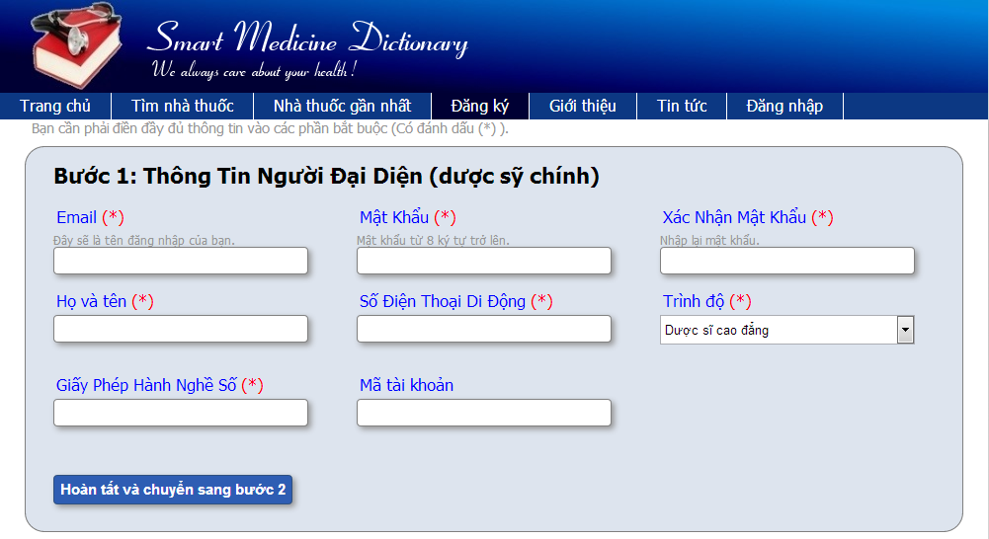

**Figure 6-9.1:** Register screen

**Step 2**: Fill all necessary and mandatory information

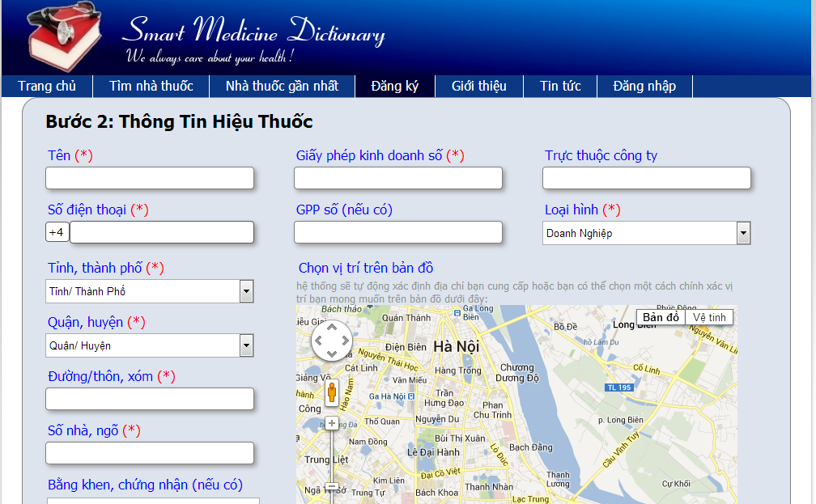

**Figure 6-9.2:** Register screen

**Step 3**: Click “Save” button

#### View News on web

To use view News function on website, the users do the steps below:

**Step 1**: Click on News tab

**Step 2**: Clicks on one headline 🡪 Shows that article in detail

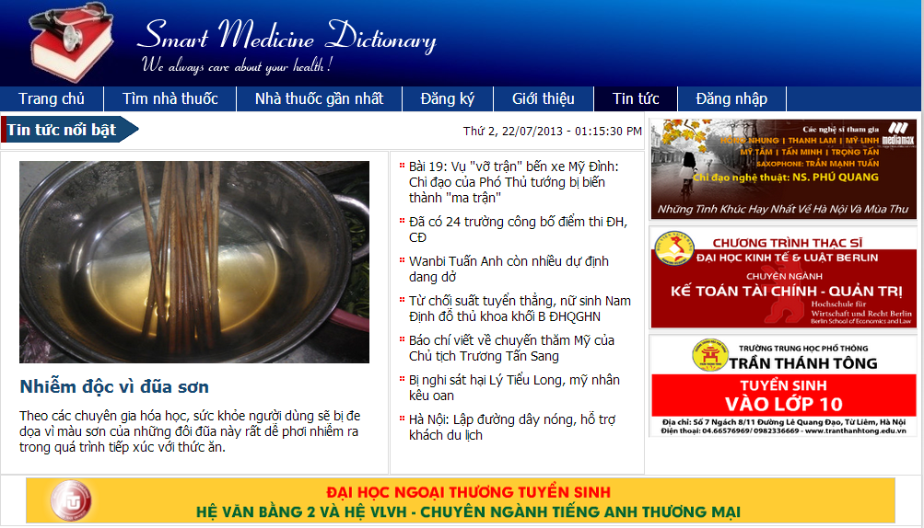

**Figure 6-10:** News screen

#### Login

To use Login function on website, the users do the steps below:

**Step 1**: Click on “Login” hyperlink on the right top corner



**Figure 6-11.1:** Login screen

**Step 2**: Fill right User Name and Password

**Step 3**: Click “Login” button

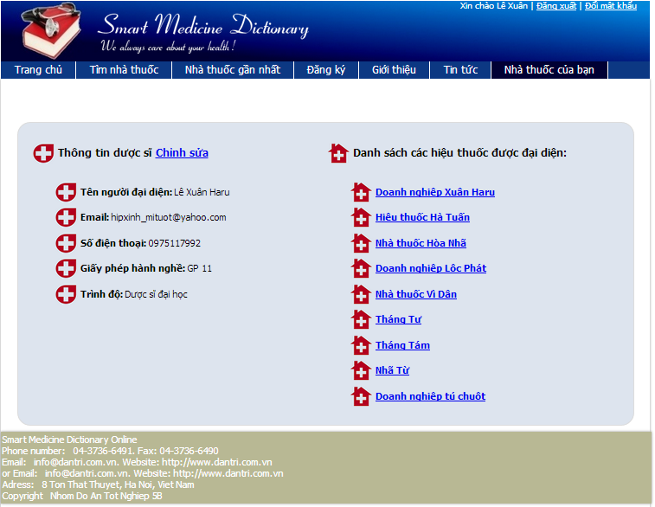

**Figure 6-11.2:** Login screen

#### Logout

To use Logout function on website, the users do the steps below:

**Step 1**: Have logged into system

**Step 2**: Click on “Log out” link on right top corner of the page 🡪 Back to login screen



**Figure 6-12:** Logout screen

#### Manage Pharmacy Information

##### Search Registered Pharmacy (Admin)

To use search registered pharmacy function on website, the users do the steps below:

**Step 1**: Have logged into system as an admin

**Step 2**: Click on “Pharmacy/ Pharmacy manage” tab

**Step 3**: Fill the name of the pharmacy that they want to find into these fields then click “Search” button

**Step 4**: Click on that pharmacy name 🡪 Display Pharmacy information

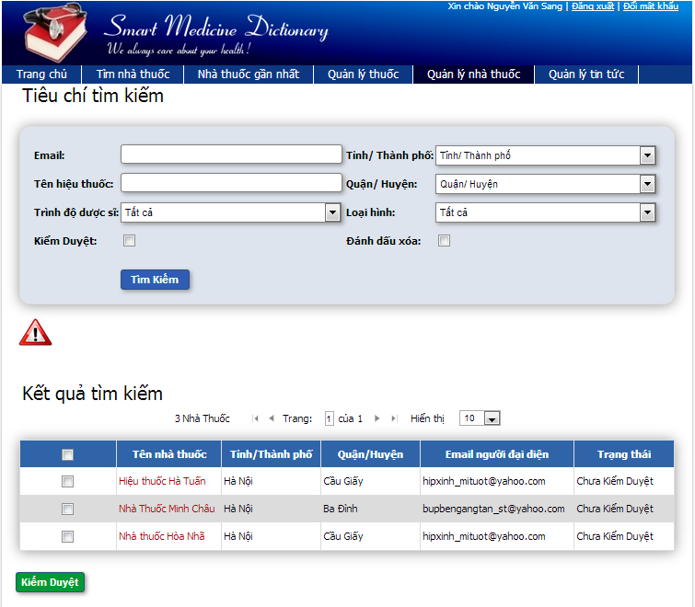

**Figure 6-13:** Search register pharmacy screen

##### Accept Registered Pharmacy ( Admin )

To use accept registered pharmacy function on website, the users do the steps below:

**Step 1**: Have logged into system as an admin

**Step 2**: Click on “Pharmacy/ Pharmacy management” tab

**Step 3**: Fill the name of the pharmacy that they want to find into these fields then click “Search” button

**Step 4**: Tick on check box beside the pharmacies that they want to accept

**Step 5**: Click Accept button 🡪 Accept these registered pharmacies to have permission to promote their information on that software

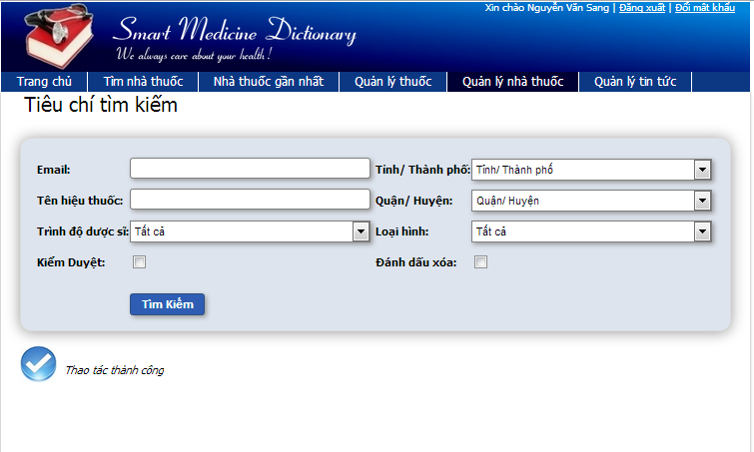

**Figure 6-14:** Accept register pharmacy screen

##### Deny Registered Pharmacy (Admin )

To use deny registered pharmacy function on website, the users do the steps below:

**Step 1**: Have logged into system as an admin

**Step 2**: Click on “Pharmacy/ Pharmacy Management” tab

**Step 3**: Fill the name of the pharmacy that they want to find into these fields then click “Search” button

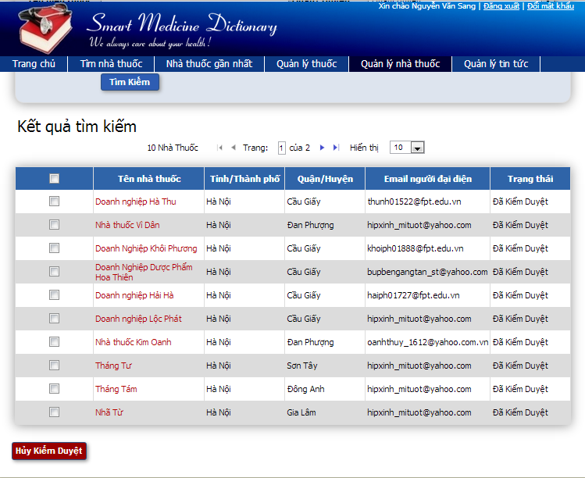

**Figure 6-15.1:** Deny register pharmacy screen

**Step 4**: Tick on check box beside the pharmacies that they want to deny or click on pharmacy you want to deny

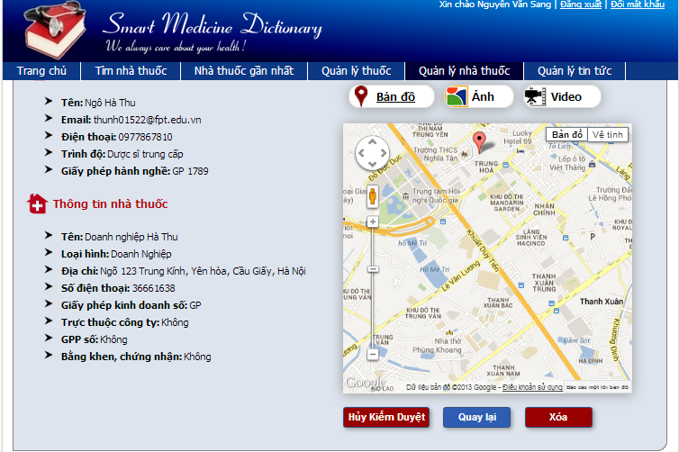

**Figure 6-15.2:** Deny register pharmacy screen

**Step 5**: Click Deny button 🡪 Do not approve these registered pharmacies to have permission to promote their information on that software

##### Delete Registered Pharmacy ( Admin )

To use delete registered pharmacy function on website, the users do the steps below:

**Step 1**: Have logged into system as an admin

**Step 2**: Click on “Pharmacy/ Pharmacy management” tab

**Step 3**: Fill the name of the pharmacy that they want to find into these fields then click “Search” button

**Step 4**: Click on pharmacy you want to delete

**Step 5**: Click Delete button 🡪 Delete these pharmacy from system then they do not have permission to promote their information on that software anymore

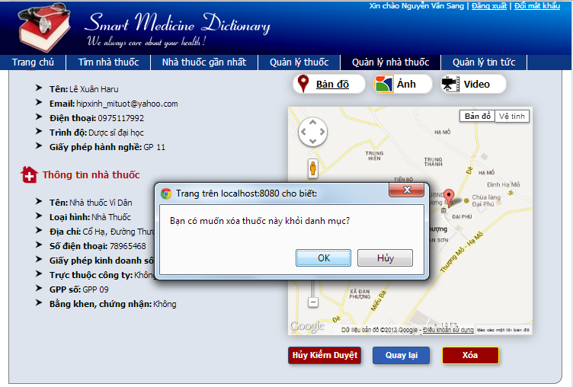

**Figure 6-16:** Delete register pharmacy screen

##### Add New medicine ( Admin )

To use add new medicine function on website, the users do the steps below:

**Step 1**: Have logged into system as an admin

**Step 2**: Click on “Medicine/ Add new” tab

**Step 3**: Fill medicine information into all necessary or mandatory fields

**Step 4**: Click “Save” button 🡪 The system validates the input data and then save new medicine data into database

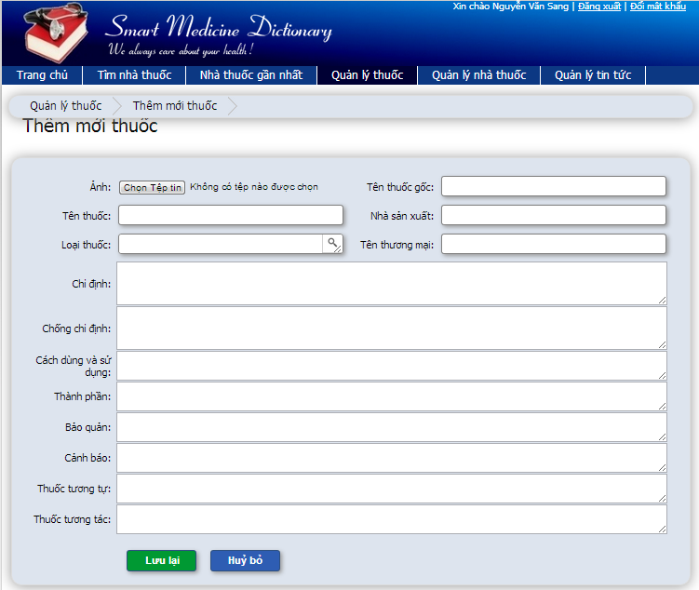

**Figure 6-17:** Add new medicine screen

##### Copy New medicine ( Admin )

To use copy new medicine function on website, the users do the steps below:

**Step 1**: Have logged into system as an admin

**Step 2**: Click on “Medicine/ Medicine Advanced Search ” then search for the medicine that they want to copy

**Step 3**: Click on “Copy New” button beside that medicine row

**Step 4**: Edit medicine information

**Step 5**: Click “Save” button 🡪 The system validates the input data and then save data into database

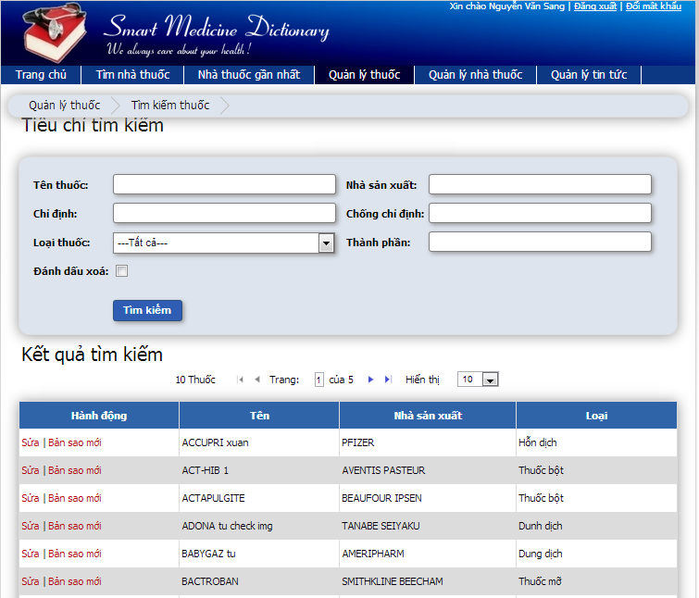

**Figure 6-18:** Copy new medicine screen

##### Edit medicine ( Admin )

To use edit medicine function on website, the users do the steps below:

**Step 1**: Have logged into system as an admin

**Step 2**: Click on “Medicine/ Medicine Advanced Search ” then search for the medicine that they want to edit

**Step 3**: Click on Edit button beside that medicine row

**Step 4**: Edit medicine information

**Step 5**: Click “Save” button 🡪 The system validates the input data and then save edited data into database

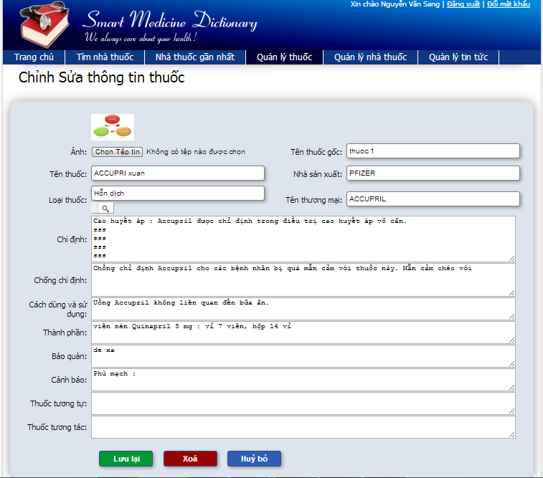

**Figure 6-19:** Edit medicine screen

##### Delete medicine ( Admin )

To use delete medicine function on website, the users do the steps below:

**Step 1**: Have logged into system as an admin

**Step 2**: Click on “Medicine/ Medicine Advanced Search ” then search for the medicine that they want to edit

**Step 3**: Click on “Delete” button beside that medicine row

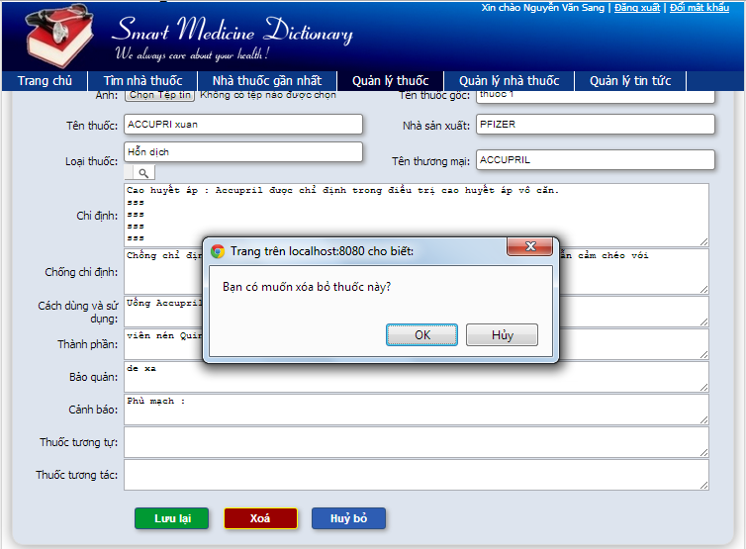

**Figure 6-20.1:** Delete medicine screen

**Step 4**: Click “Yes” button on popup 🡪 Closes the popup then remove that medicine name from medicine list

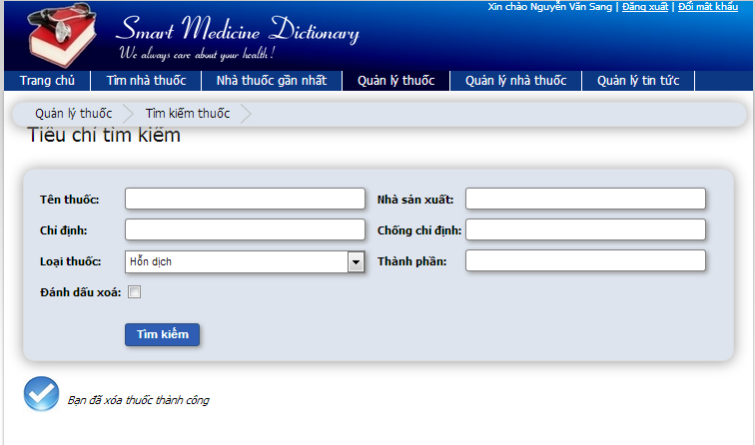

**Figure 6-20.2:** Delete medicine screen

##### Restore medicine ( Admin )

To use restore medicine function on website, the users do the steps below:

**Step 1**: Have logged into system as an admin

**Step 2**: Click on “Medicine/ Medicine Advanced Search ” tab

**Step 3**: Tick on Delete flag then search for the medicine that they want to edit

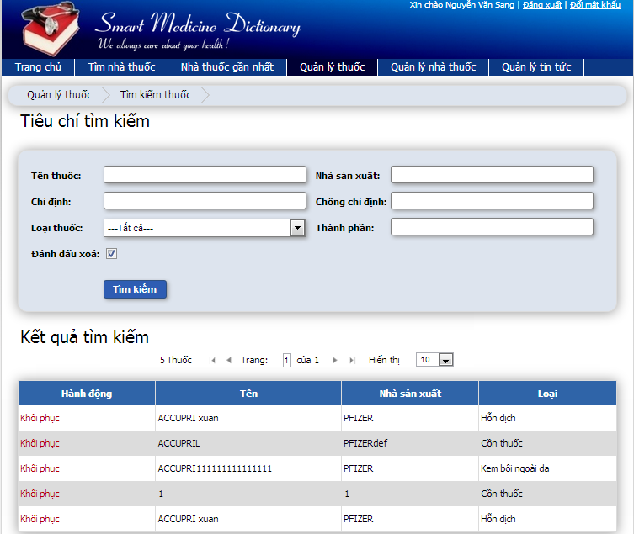

**Figure 6-21.1:** Restore medicine screen

**Step 4**: Click on “Restore” button beside that medicine row

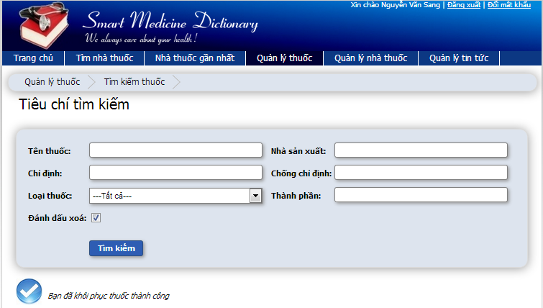

**Figure 6-21.2:** Restore medicine screen

#### Manage Medicine Information (User)

##### Change Information (User)

To use change information function on website, the users do the steps below:

**Step 1**: Have logged into system as an user

**Step 2**: Click on pharmacy user representative

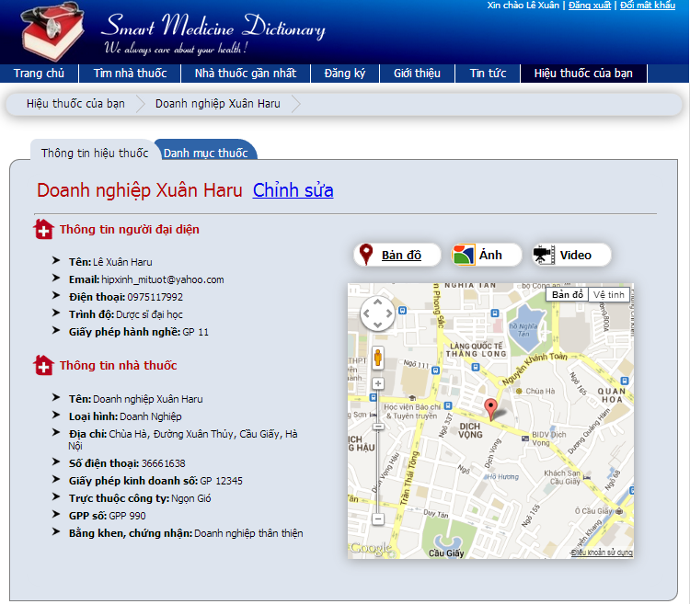

**Figure 6-22.1:** Change information screen

**Step 3**: Click on “Change information” button

**Step 4**: Type new information into text fields (validate)

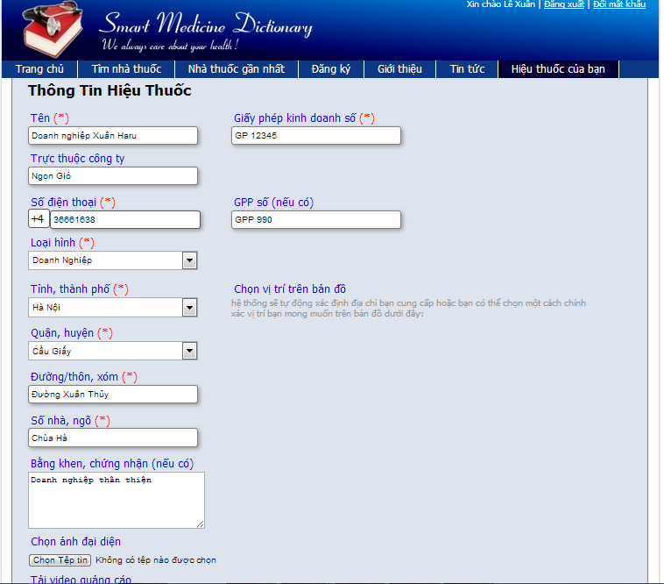

**Figure 6-22.2:** Change information screen

**Step 5**: Click on “Save” button 🡪 The system validates the input data and then save new information into database

##### Change password ( User )

To use change password function on website, the users do the steps below:

**Step 1**: Have logged into system as an user

**Step 2**: Click on “Change password” link on the right top corner of the page



**Figure 6-23.1:** Change password screen

**Step 3**: Insert current password then insert new password that is validate

**Step 4**: Click “Change password” button 🡪 Display successful page with message to inform user that new password can be used after being confirm by admin



**Figure 6-23.2:** Change password screen

##### Add new medicine into pharmacy’s sell list (User)

To use add new medicine into pharmacy’s sell list function on website, the users do the steps below:

**Step 1**: Have logged into system as an user

**Step 2**: Click on Manage tab on submenu

**Step 3**: Click on one pharmacy name

**Step 4**: Click on “Selling list” tab

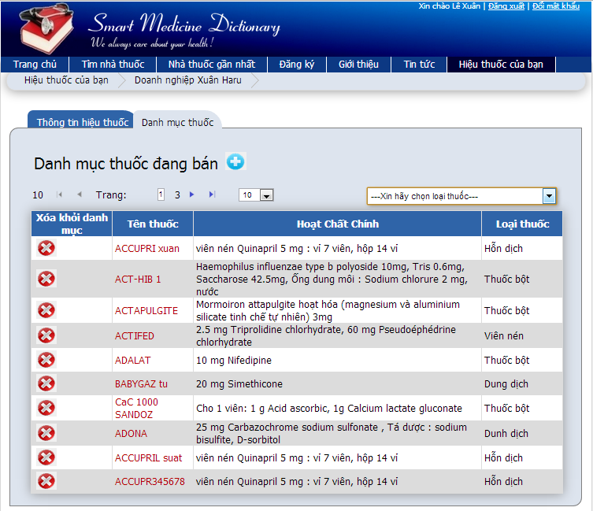

**Figure 6-24.1:** Add new medicine to sell list screen

**Step 5**: Click on “Add new” button

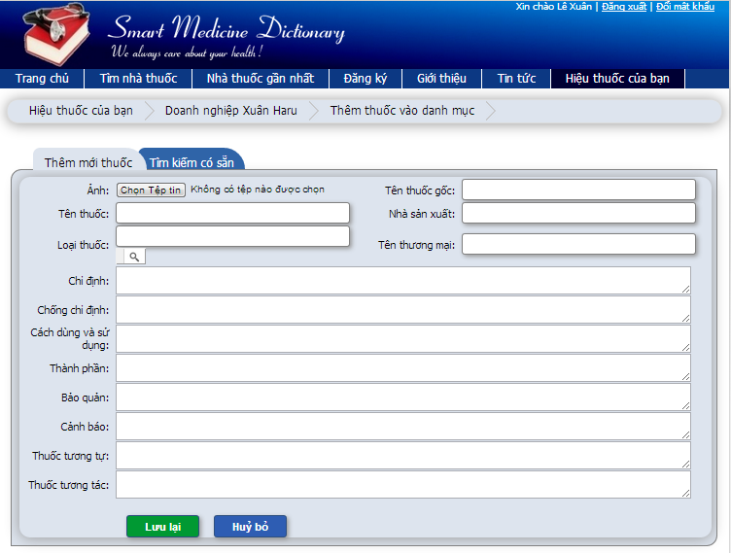

**Figure 6-24.2:** Add new medicine to sell list screen

**Step 6**: Fill medicine information into all necessary or mandatory fields

**Step 7**: Click on “Save” button

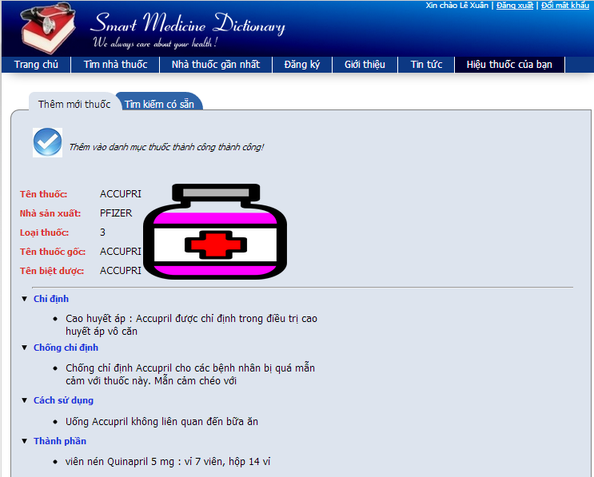

**Figure 6-24.3:** Add new medicine to sell list screen

#### Search medicine on Mobile

To use Search medicine function on mobile, the users do the steps below:

**Step 1**: Click on that application icon on mobile

**Step 2**: Type medicine name into search box on home page

**Step 3**: Click “Search” button

**Step 4**: Click on a medicine name 🡪 Displays medicine detail information

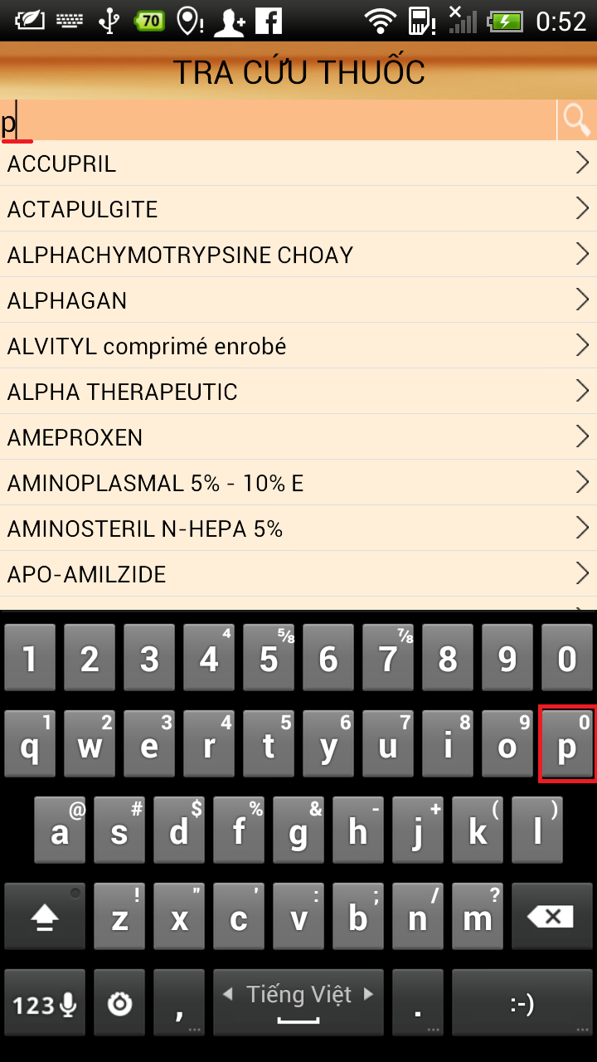

**Figure 6-25:** Search medicine on mobile screen

#### Find the nearest pharmacy on mobile

To use find the nearest pharmacy function on mobile, the users do the steps below:

**Step 1**: Click on “Nhà Thuốc” submenu on the Home screen

**Step 2**: Typing their location on “Location” text box

**Step 3**: Click “Search” button 🡪 Show your current location and path to the nearest pharmacy location

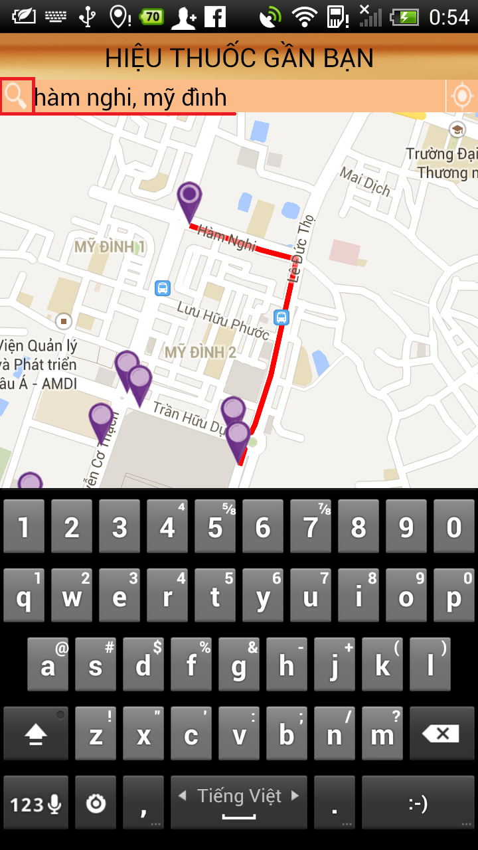

**Figure 6-26:** Find nearest pharmacy on mobile screen

#### Medical Usage Diary

To use medical usage diary function on mobile, the users do the steps below:

**Step 1**: Click on “Đơn Thuốc” submenu on Home screen

**Step 2**: Click on “Thêm mới” button

**Step 3**: Fill all fields

**Step 4**: Click “Lưu lại” button

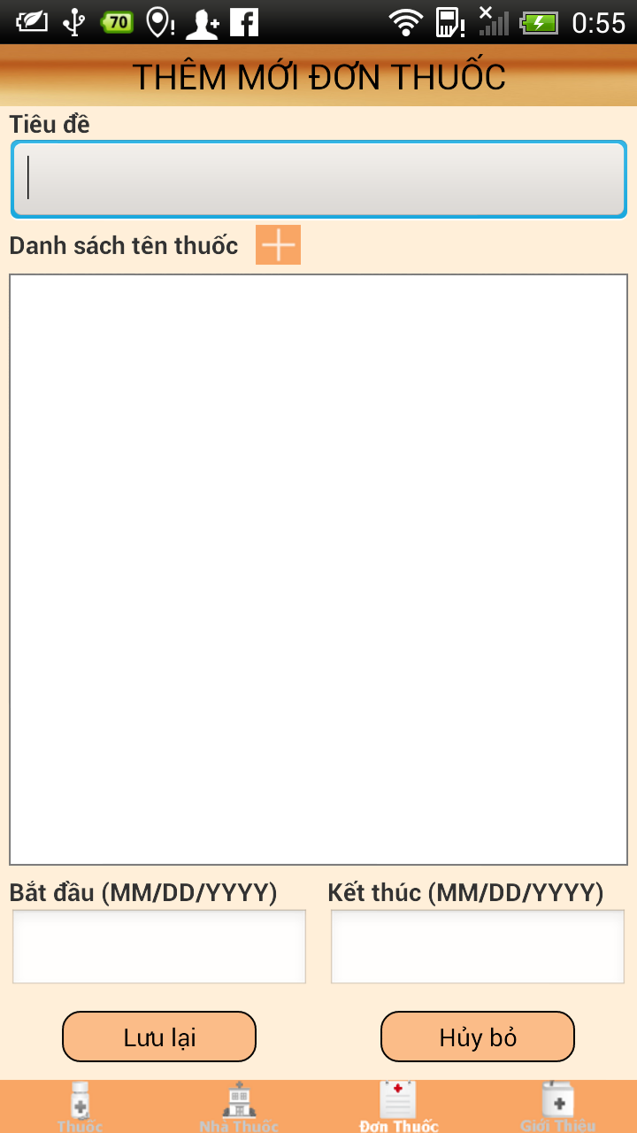

**Figure 6-27:** Medical usage diary on mobile screen

**REPORT #7:**

**PROJECT RESULT REPORT**

# Project Result Report

## Product Judging

### Advantage of SMD System

The idea of the SMD project is to develop a new product that inherits the advantages and improve issues and learns from other products. And the new product would have the opportunity to add a lot of enhancements.

As the goals that we have set before started the project, the SMD system has been developed in a right direction. And what it provides to users is in the list below:

* Find information about the medicines easily, quickly and accurately.
* Find the nearest pharmacy and path to the nearest pharmacy location.
* Promote the image of the pharmacy, enhanced reputation and brand with users
* Manage information about medicines easily and accurately.
* Read and update News about medical
* Easy to use and can be installed and use on Smartphone ( Android Os )
* Diary function on mobile helps remind users use medicine on time.

### Current Limitations

* GUI, Test case and Report structure is still in upgrading
* Not have account for put up SMD application to Play Store

### Expectation in Future

* First, continuously develop this module, improve the way interact with user (through GUI, report…).
* Second, develop and add function diagnose the diseases online. User can enter symptoms and answer some questions, system will diagnose and give treatments with high accuracy.
* Put up SMD application to Play Store, easy to download and install on mobile.

## Product Summary

|  |  |  |  |
| --- | --- | --- | --- |
| **Project Title** | | Smart Medicine Dictionary | |
| **Project Supervisor** | | Nguyễn Văn Sang | |
| Committers (5) | | | |
| 1 | Project Manager | Lê Thị Xuân | [XuanLT01913@fpt.edu.vn](mailto:XuanLT01913@fpt.edu.vn) |
| 2 | Configuration Manager | Phạm Huy Khôi | [KhoiPH01888@fpt.edu.vn](mailto:KhoiPH01888@fpt.edu.vn) |
| 3 | Designer | Phạm Minh Tú | [TuPM01770@fpt.edu.vn](mailto:TuPM01770@fpt.edu.vn) |
| 4 | QA + Tester | Phạm Hà Hải | [HaiPH01727@fpt.edu.vn](mailto:HaiPH01727@fpt.edu.vn) |
| 5 | QA + Tester | Ngô Hà Thu | [ThuNH01522@fpt.edu.vn](mailto:ThuNH01522@fpt.edu.vn) |
| Main objective | | Develop medicine dictionary online, help user lookup information about medicines easily, quickly and accurately. Find the nearest pharmacy and path to the nearest pharmacy location. Diary function on mobile helps remind users use medicine on time | |
| Purpose | | Provide a SMD online on website and a SMD application on mobile. | |
| Source Repository | | [https://fu-se509-mdp.googlecode.com/svn/trunk/Source](https://fu-se509-mdp.googlecode.com/svn/trunk/Source%20) | |
|  | | **Plan** | **Actual** |
| Releases Date | | 15/08/2013 | 15/08/2013 |
| Releases version | | 1.0 | 1.0 |
| Days | | 89 days | 89 days |
| Test cases | |  |  |
| Defects | |  |  |
| Document pages | | ~ 200 (include appendix) | > 200 (include appendix) |
| Lines of code | | ~30000 | ~ 50000 |

## Lesson Learn

* Have experience and deeply understand about SMD System
* Understand about the general process or work flow of test processes.
* Improve skill
  + Technical: Struts 2, Spring 3, Hibernate 3, Javascript, css, Json, Android, Webservice.
  + Database : MySQL
  + Soft skill: brainstorm, teamwork, research and self-study, plan management, time management and project management.
* Risk and issues management
  + Technique :
    - No members have experiences work with some framework as Struts 2, Spring 3, Hibernate 3, and Android. So before start this project, we divided the project into two separate arrays are web and mobile and assign some members to take responsibility for researching and training the others.
    - Not understanding about general / detail technical: researching internet, asking for supporting from community.
  + Human resources:
    - Some members are lazy for a while so we define detail schedules, and often reminding each other.
    - Laptop of a member was stolen so need to buy new laptop and setup environment to continues task
    - One member had an accident and cannot join the project for some days so the others (who have free time) replaced him for these days.
    - Members were lack of project information, so we use many method to prevent this issue, we use the general SVN from sourceforce.com; everyone can keep up with the project.

🡪 Meeting for brainstorming

🡪 Scheduling and reporting

* + Over time, because of:
    - Risk: technique, resources.
    - Not pay attention at the beginning, lazy